**KSR COLLEGE OF ENGINEERNG**

Tiruchengode

Department of Electronics and Communication Engineering

**Nalaiya Thiran**

Cloud assignment –01

Code:

<!DOCTYPE html>

<html lang="en">

<head>

<meta charset="UTF-8">

<title>Curriculum Vitae</title>

<style>

div.a{

left: 200px;

width: 100px;

height :120px;

}

</style>

</head>

<body>

<center>

<h1>

<u>Curriculum Vitae</u>

</h1>

</center>

<right>

<h3><b>NAME: TAMILARASU M</b></h3>

<h3><b>ID NO :73151915009</b></h3>

<h3><b> DEGREE:BE</b></h3>

<h3><b>BRANCH: ECE</b></h3>

<h3><b>COLLEGE :</b> KSR college of engineering</h3>

</right>

<h2><b>OBJECTIVES</b></h2>

<p> To pursue a challenging career and be part of a progressing organization that give scope to enhance my knowledge , skills and to reach the pinnacle in a computing field with the sheer determination, dedication and hardwork</p>

<h2><b>ACADEMIC DETAILS</b></h2>

<table border="1">

<tr>

<td><b> COURSE</b></td>

<td><b>INSTITUTION</b></td>

<td><b>BOARD/UNIVERSITY</b></td>

<td><b>YEAR</b></td>

<td><b>PERCENTAGE</b></td>

</tr>

<tr>

<th><p>BE-ECE</p></th>

<th>KSR college of engineering</th>

<th>Anna university</th>

<th>pursing</th>

<th>85%</th>

</tr>

<tr>

<th><p>HSC</p></th>

<th> srm matric hr sec school</th>

<th>state board</td>

<th>2019</th>

<th>70%</th>

</tr>

<tr>

<th><p>SSLC</p></th>

<th>srm matric hr sec school</th>

<th>state board</th>

<th>2017</th>

<th>82%</th>

</tr>

</table>

<br>

<lh><h2><b>PROGRAMMING SKILLS</b></h2> </lh>

<ul type =bullet>

<li>html</li>

<li>CSS</li>

<li>java</li>

</ul>

<lh><h2><b>PERSONAL STRENGTH</b></h2> </lh>

<ul type =bullet>

<li>Time manner,self control</li>

<li>Able to handle the situation of conflicts and beleives <b>Teamwork</b></li>

<li>Ability to produce the best quality results in pressure situations</li>

</ul>

<lh><h2><b>EXTRA-CURRICULAR ACTIVITIES</b></h2> </lh>

<ul type =bullet>

<li>active member in NSS</li>

<li>football player</li>

</ul>

<lh><h2><b>HOBBIES</b></h2> </lh>

<ul type =bullet>

<li>Spending time with family and friends</li>

<li>lisenting music</li>

</ul>

<h2><b>PERSONAL DETAILS</b></h2>

<p> Name : TAMILARASU M<br> Father Name : murugan E<br>Date of brith:30/03/2001<br>Gender : Female <br> Nationality : Indian<br>Language Known : Tamil,English<br>Permantent Address : 17/6/72A, teacher colony ,salem-02 </p>

<h2><b>DECALRATION</b></h2>

<P>I hereby declare that all the information given above is true and correct to the best of my knowledge</P>

<rigth>you

<p>Date: 09/10/2022 <br> Place:Salem</p>

</rigth>

<div class="a">Tamilarasu M</div>

</table>

</body>

</html>

Program

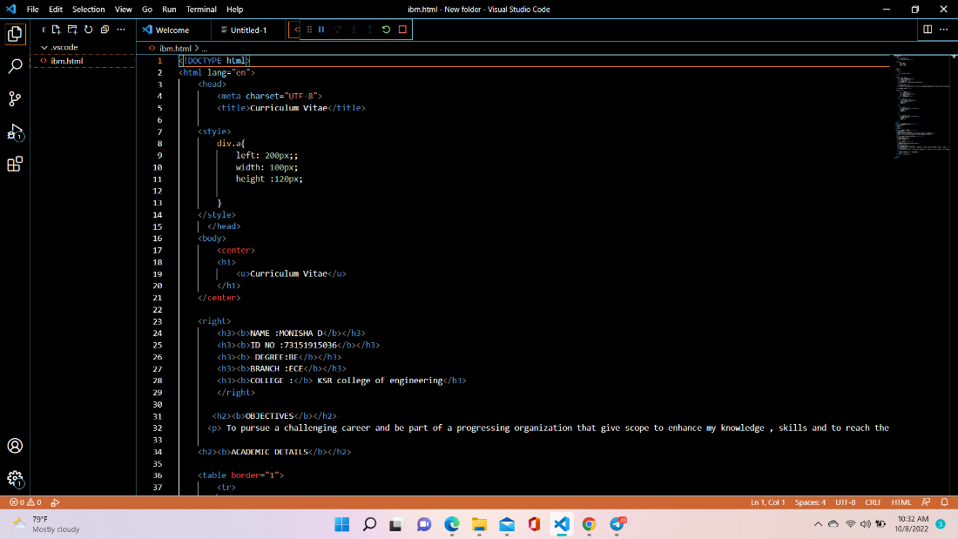

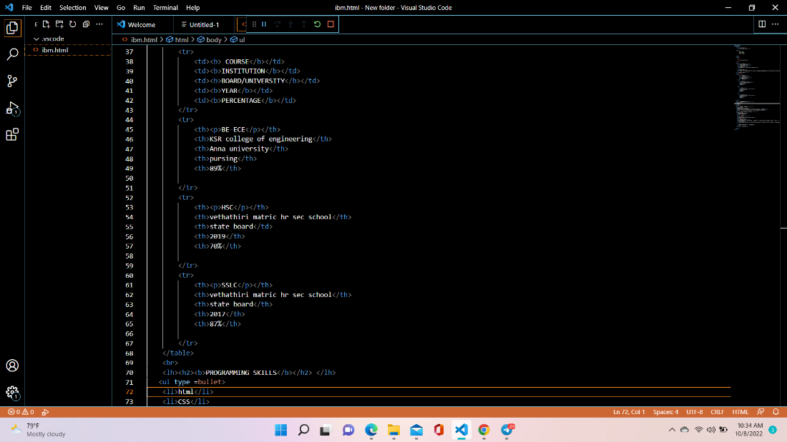

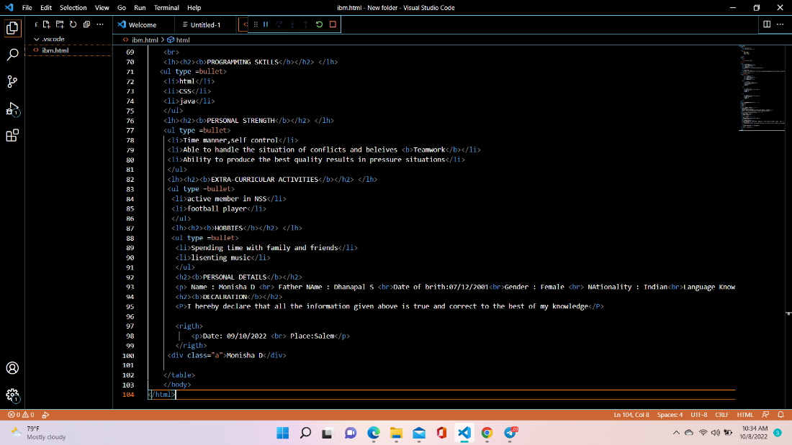

Output:

