**prerequisites**

|  |  |
| --- | --- |
| **Team id** | PNT2022TMID26854 |
| **Project name** | Smart crop protection system for agriculture |

1. IBM CLOUD SERVICES

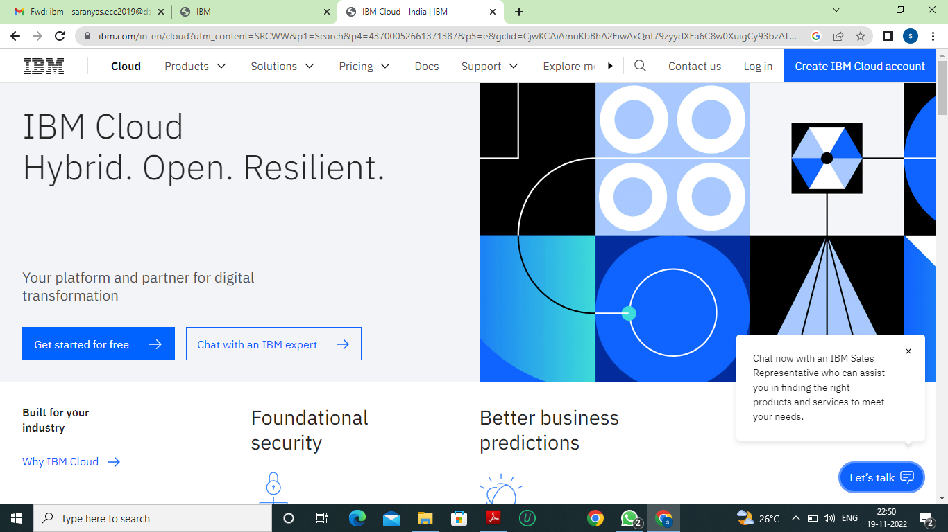

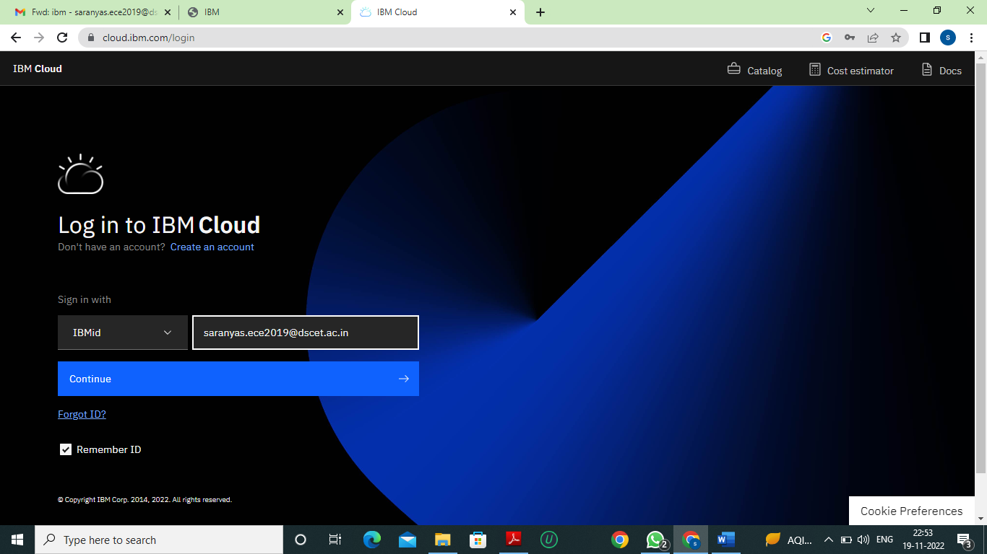

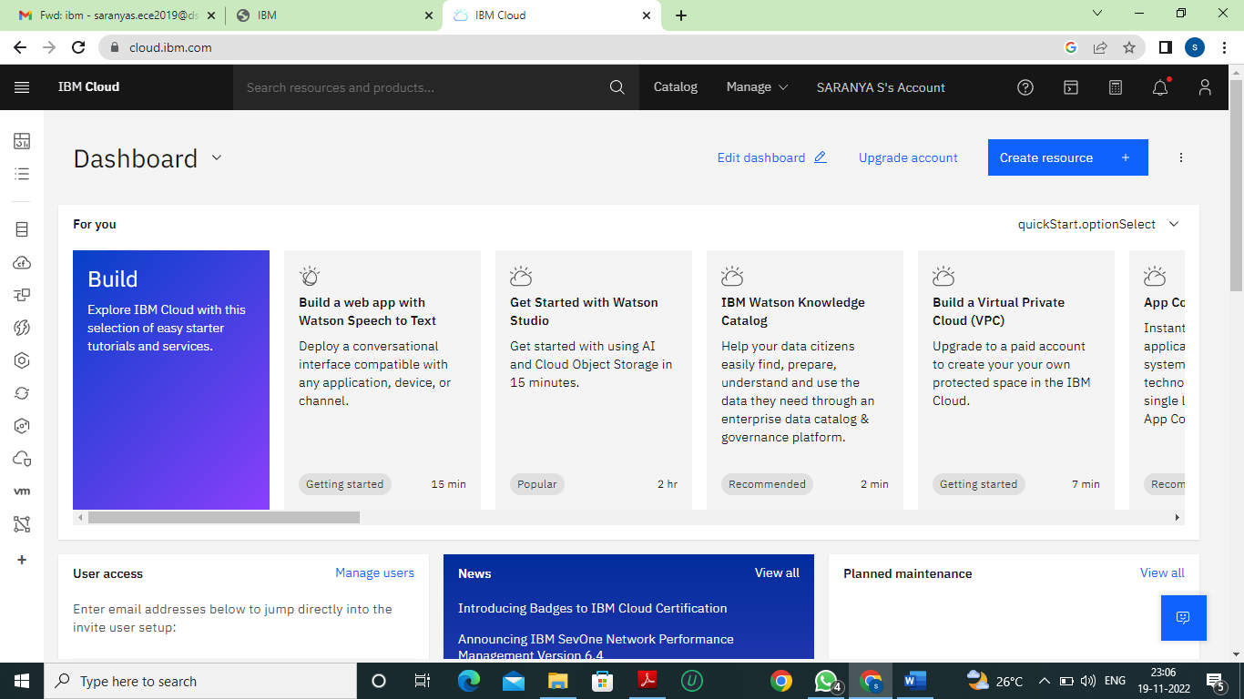

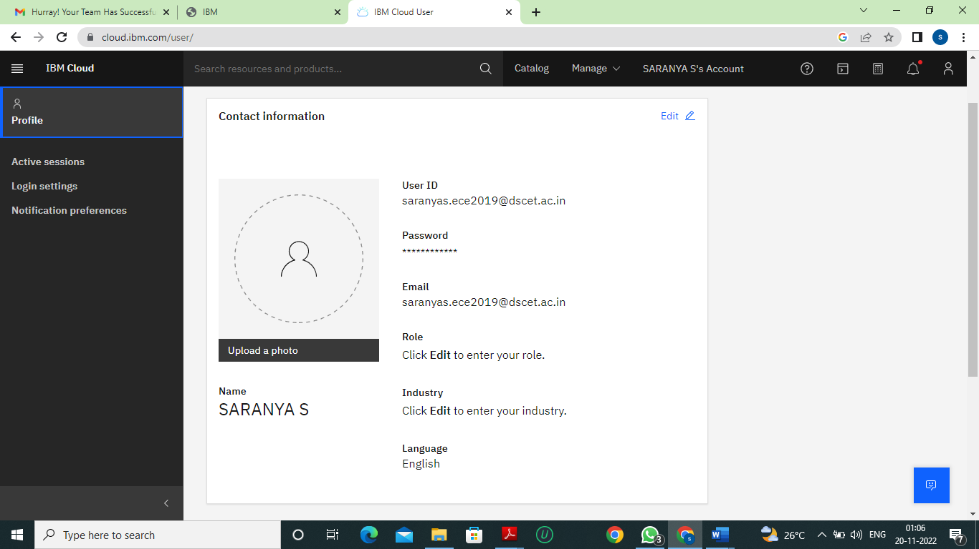

2.SOFTWARE

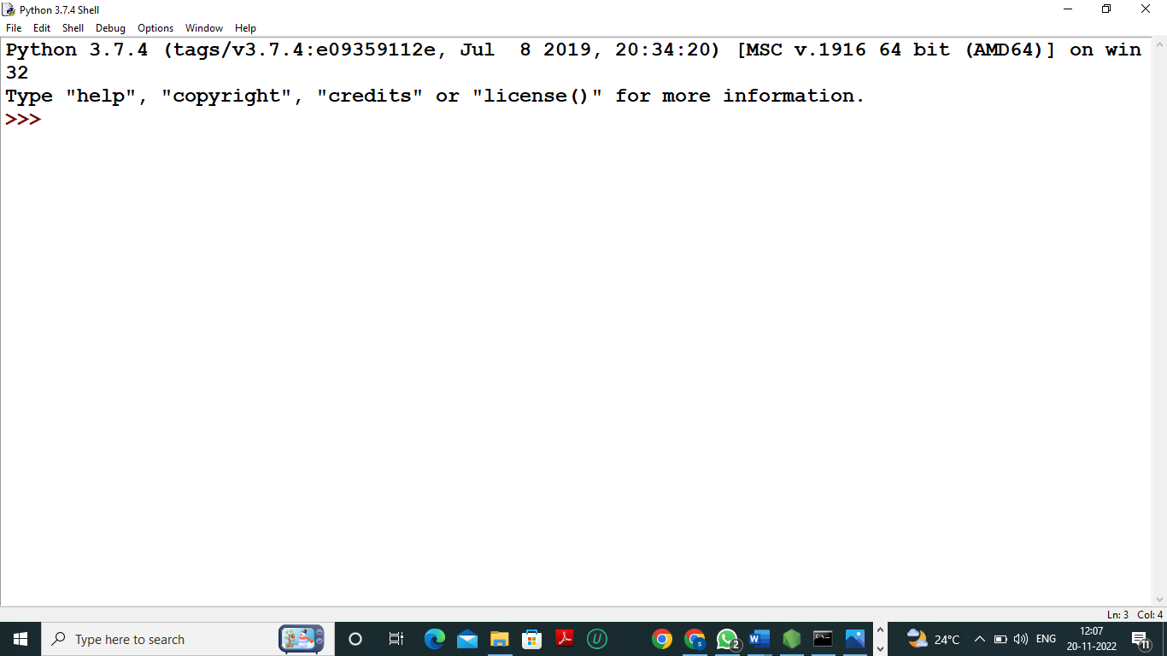

3.CREATE AN ACCOUNT IN CLARIFAI

