**IBM ASSIGNMENT-1**

TOPIC : Home Automation.

NAME: k.P.Sushmita

REG NO: 910619104092

**Screen shot:**

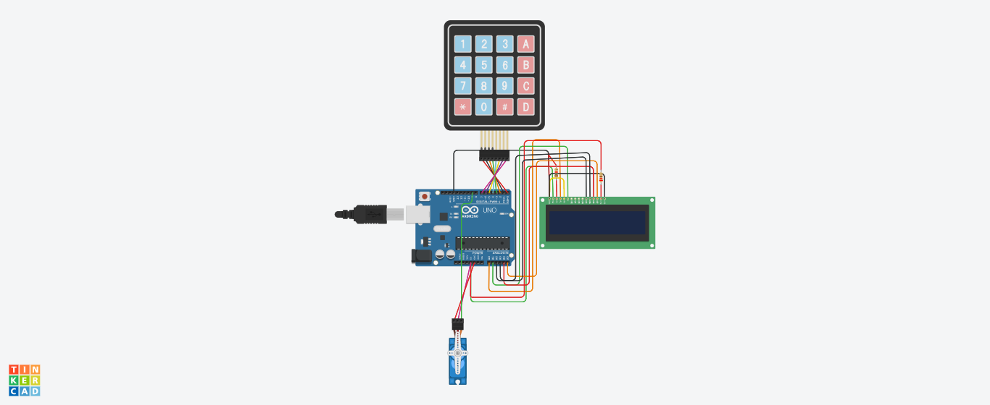

**Code:**

#include <Keypad.h>

#include <LiquidCrystal.h>

#include <Servo.h>

#define Password_Length 5

Servo myservo;

LiquidCrystal lcd(A0, A1, A2, A3, A4, A5);

int pos = 0;

char Data[Password_Length];

char Master[Password_Length] = "1234";

byte data_count = 0, master_count = 0;

bool Pass_is_good;

bool door = false;

char customKey;

/*---preparing keypad---*/

const byte ROWS = 4;

const byte COLS = 4;

char keys[ROWS][COLS] = {

{'1', '2', '3', 'A'},

{'4', '5', '6', 'B'},

{'7', '8', '9', 'C'},

{'*', '0', '#', 'D'}

};

byte rowPins[ROWS] = {0, 1, 2, 3};

byte colPins[COLS] = {4, 5, 6, 7};

Keypad customKeypad( makeKeymap(keys), rowPins, colPins, ROWS, COLS);

/*--- Main Action ---*/

void setup()

{

myservo.attach(9, 2000, 2400);

ServoClose();

lcd.begin(16, 2);

lcd.print("Protected Door");

loading("Loading");

lcd.clear();

}

void loop()

{

if (door == true)

{

customKey = customKeypad.getKey();

if (customKey == '#')

{

lcd.clear();

ServoClose();

lcd.print("Door is closed");

delay(3000);

door = false;

}

}

else

Open();

}

void loading (char msg[]) {

lcd.setCursor(0, 1);

lcd.print(msg);

for (int i = 0; i < 9; i++) {

delay(1000);

lcd.print(".");

}

}

void clearData()

{

while (data_count != 0)

{

Data[data_count--] = 0;

}

return;

}

void ServoClose()

{

for (pos = 90; pos >= 0; pos -= 10) {

myservo.write(pos);

}

}

void ServoOpen()

{

for (pos = 0; pos <= 90; pos += 10) {

myservo.write(pos);

}

}

void Open()

{

lcd.setCursor(0, 0);

lcd.print("Enter Password");

customKey = customKeypad.getKey();

if (customKey)

{

Data[data_count] = customKey;

lcd.setCursor(data_count, 1);

lcd.print(Data[data_count]);

data_count++;

}

if (data_count == Password_Length - 1)

{

if (!strcmp(Data, Master))

{

lcd.clear();

ServoOpen();

lcd.print(" Door is Open ");

door = true;

delay(5000);

loading("Waiting");

lcd.clear();

lcd.print(" Time is up! ");

delay(1000);

ServoClose();

door = false;

}

else

{

lcd.clear();

lcd.print(" Wrong Password ");

door = false;

}

delay(1000);

lcd.clear();

clearData();

}

}

**TINKERCAD LINK:**

[Circuit design home automation | Tinkercad](https://www.tinkercad.com/things/3AabRLQcp1u-home-automation/editel)