**PREREQUISITES:**

**TEAM ID: 38185-1660374533**

**IBM – CLOUD ACCOUNT CREATION:**

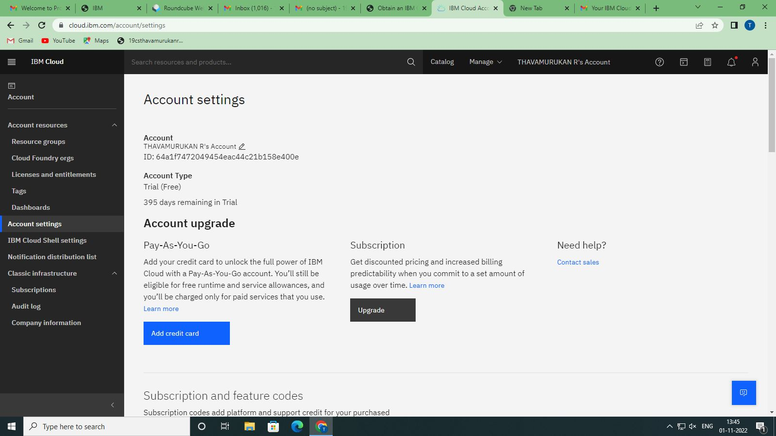

**PYTHON INSTALLATION:**

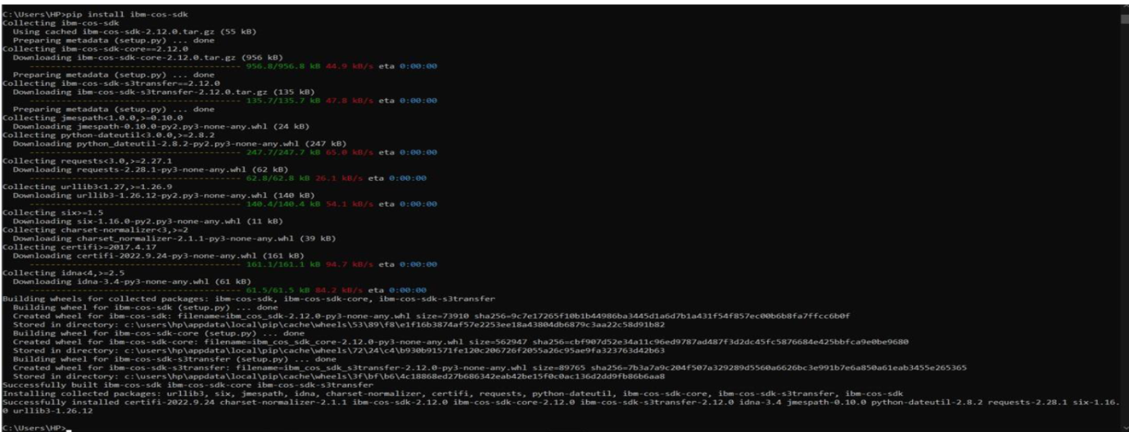

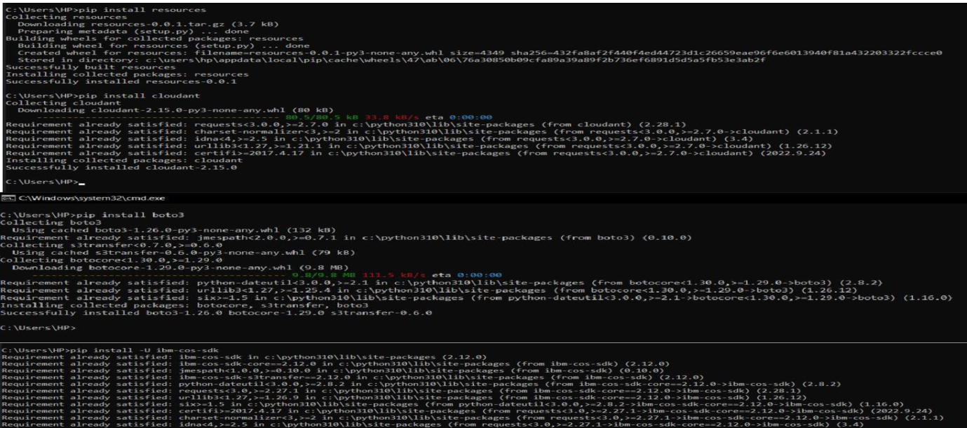

**ACCOUNT CREATION IN CLARIFAI:**



