**Assignment -1**

Basic Python

|  |  |
| --- | --- |
| Assignment Date | 12 September 2022 |
| Student Name | Mr. E.A.Hyagiriva |
| Student Roll Number | 2127190801030 |
| Maximum Marks | 2 Marks |

# Split this string

**s = "Hi there Sam!"**

**Solution:**

s.split(" ")

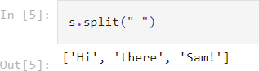

# Use .format() to print the following string.

**Output should be: The diameter of Earth is 12742 kilometers.** **planet = "Earth"diameter = 12742**

**Solution:**

txt = "The diameter of {planet} is {diameter} kilometers.".format(planet = planet, diameter = diameter)

txt

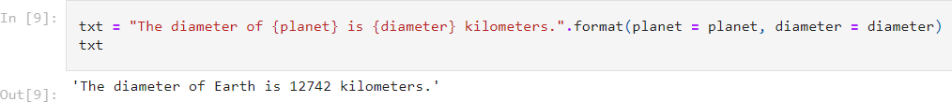

# In this nest dictionary grab the word "hello"

**d =**

**{'k1':[1,2,3,{'tricky':['oh','man','inception',{'target':[1,2,3,'hello']}]}]}**

**Solution:**

print(d["k1"][3]["tricky"][3]["target"][3])

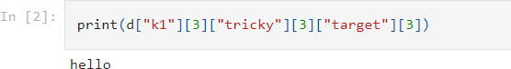

**Import Numpy**

**Solution:**

import numpy as np

# Create an array of 10 zeros?

**Solution:**

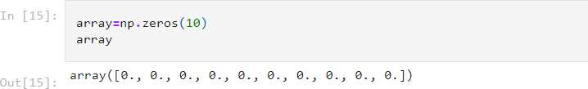array=np.zeros(10)array

# Create an array of 10 fives?

**Solution:**

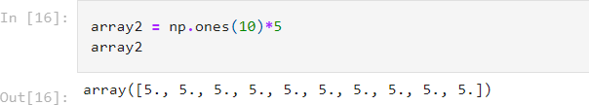array2 = np.ones(10)*5array2

# 5. Create an array of all the even integers from 20 to 35

**Solution:**

even_nos = []for i in range(20,36):

if(i % 2 == 0):

even_nos.append(i)

array3 = np.array(even_nos)array3

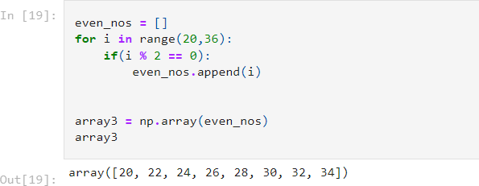

# 4. Create a 3x3 matrix with values ranging from 0 to 8

**Solution:**

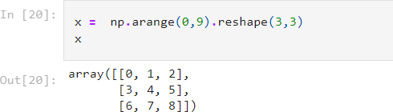x = np.arange(0,9).reshape(3,3) x

# Create a 3x3 matrix with values ranging from 0 to 8

**Solution:**

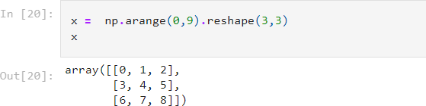x = np.arange(0,9).reshape(3,3) X

# Concatenate a and b

**a = np.array([1, 2, 3]), b = np.array([4, 5, 6])**

**Solution:**

a = np.array([1, 2, 3])b = np.array([4, 5, 6]) c = np.concatenate((a, b))c

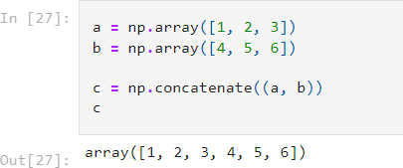

**Pandas**

# Create a dataframe with 3 rows and 2 columns

**Solution:**

import pandas as pd

data = [['Cr7', 7], ['Lm10', 10], ['Ney', 11]] df = pd.DataFrame(data, columns=['footie', 'no']) df

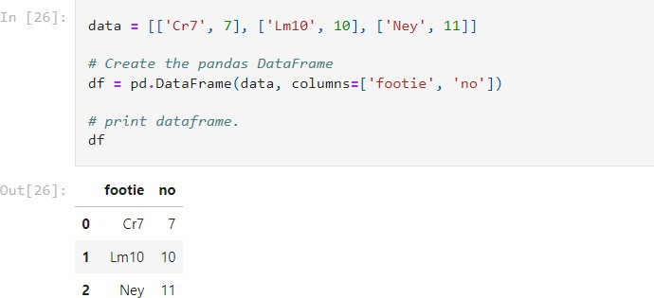

# Generate the series of dates from 1st Jan, 2023 to 10th Feb, 2023

**Solution:**

base = datetime.datetime(2023, 1, 1)

date_list = [base + datetime.timedelta(days=x) for x in range(41)]

series = pd.Series(date_list) Series

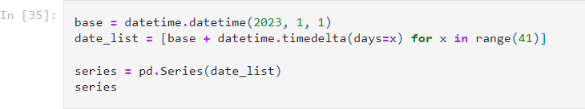

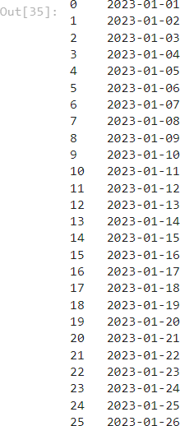 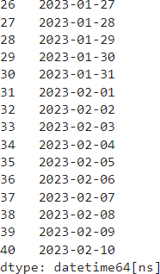

# Create 2D list to DataFrame

**lists = [[1, 'aaa', 22], [2, 'bbb', 25], [3, 'ccc', 24]]**

**Solution:**

df1 = pd.DataFrame(lists, columns = ["Col1", "Col2", "Col3"])

df1

