**ASSIGNMENT – 1**

Integrate PIR, piezo and temperature sensor in a single circuit, such that when a motion is detected a certain sound is produced and when temperature raise above 60-degree Celsius different sound is produced.

**Circuit:**

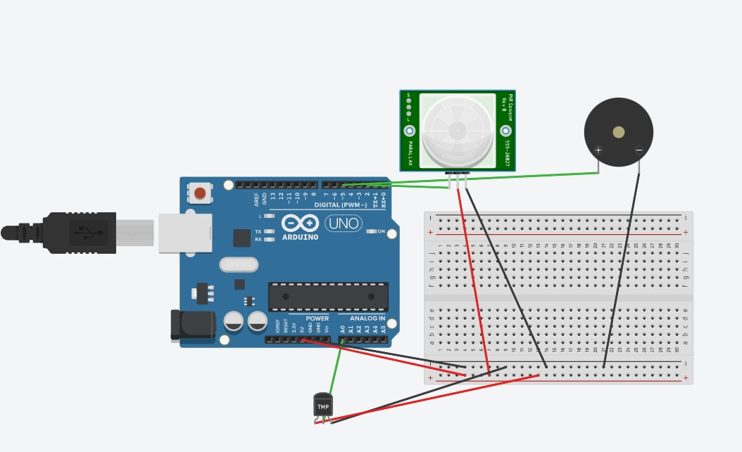

**Circuit with text code:**

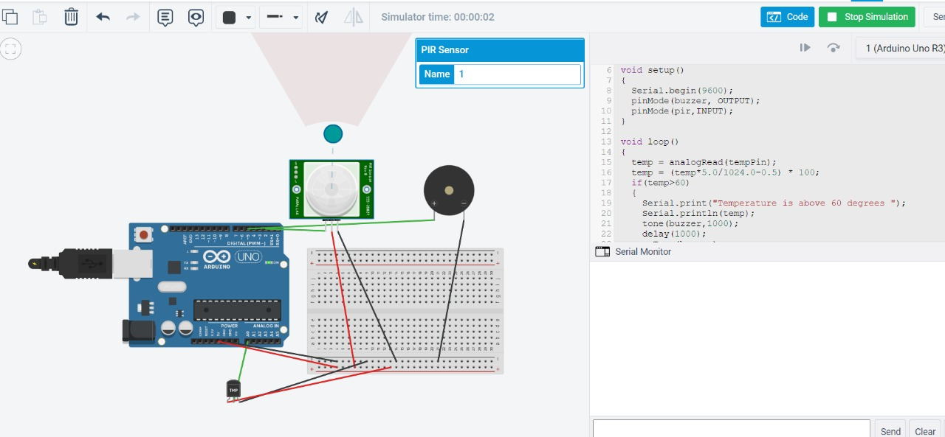

**Sensing motion:**

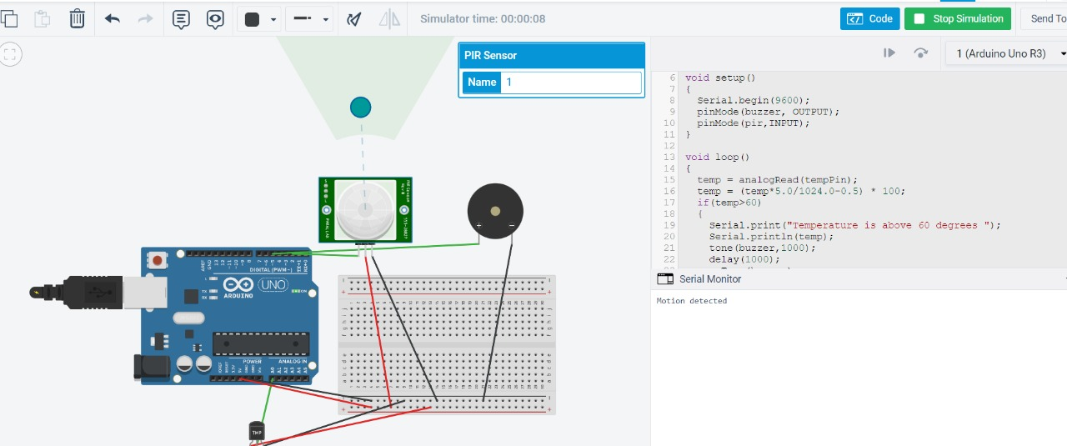

**Sensing temperature:**

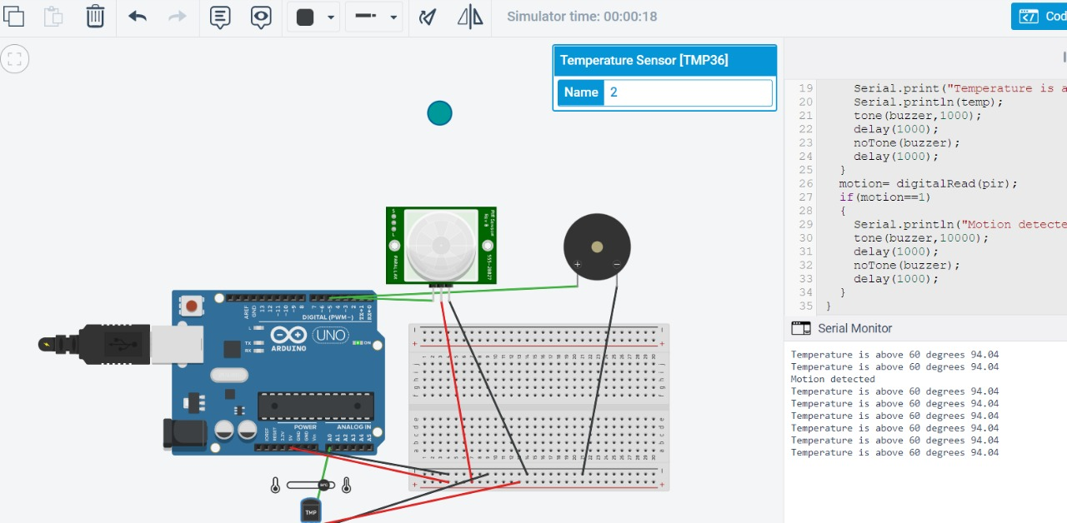

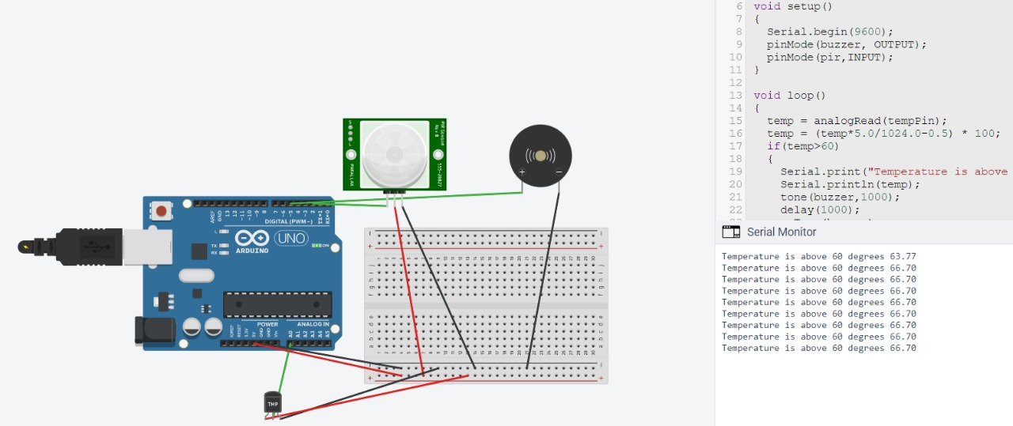

**Code:**

float temp;

int motion;

int pir=2;

int tempPin = A0;

int buzzer = 5;

void setup()

{

Serial.begin(9600);

pinMode(buzzer, OUTPUT);

pinMode(pir,INPUT);

}

void loop()

{

temp = analogRead(tempPin);

temp = (temp*5.0/1024.0-0.5) * 100;

if(temp>60)

{

Serial.print("Temperature is above 60 degrees");

Serial.println(temp);

tone(buzzer,1000);

delay(1000);

noTone(buzzer);

delay(1000);

}

motion= digitalRead(pir);

if(motion==1)

{

Serial.println("Motion detected");

tone(buzzer,10000);

delay(1000);

noTone(buzzer);

delay(1000);

}

}