Name : **SILAMBARASAN K**

College : **DR. MAHALINGAM COLLEGE OF ENGINEERING AND TECHNOLOGY**

Batch-Num : **B8-2A4E**

**Program 1**: Write a python program to test a given number is prime or not.

Code

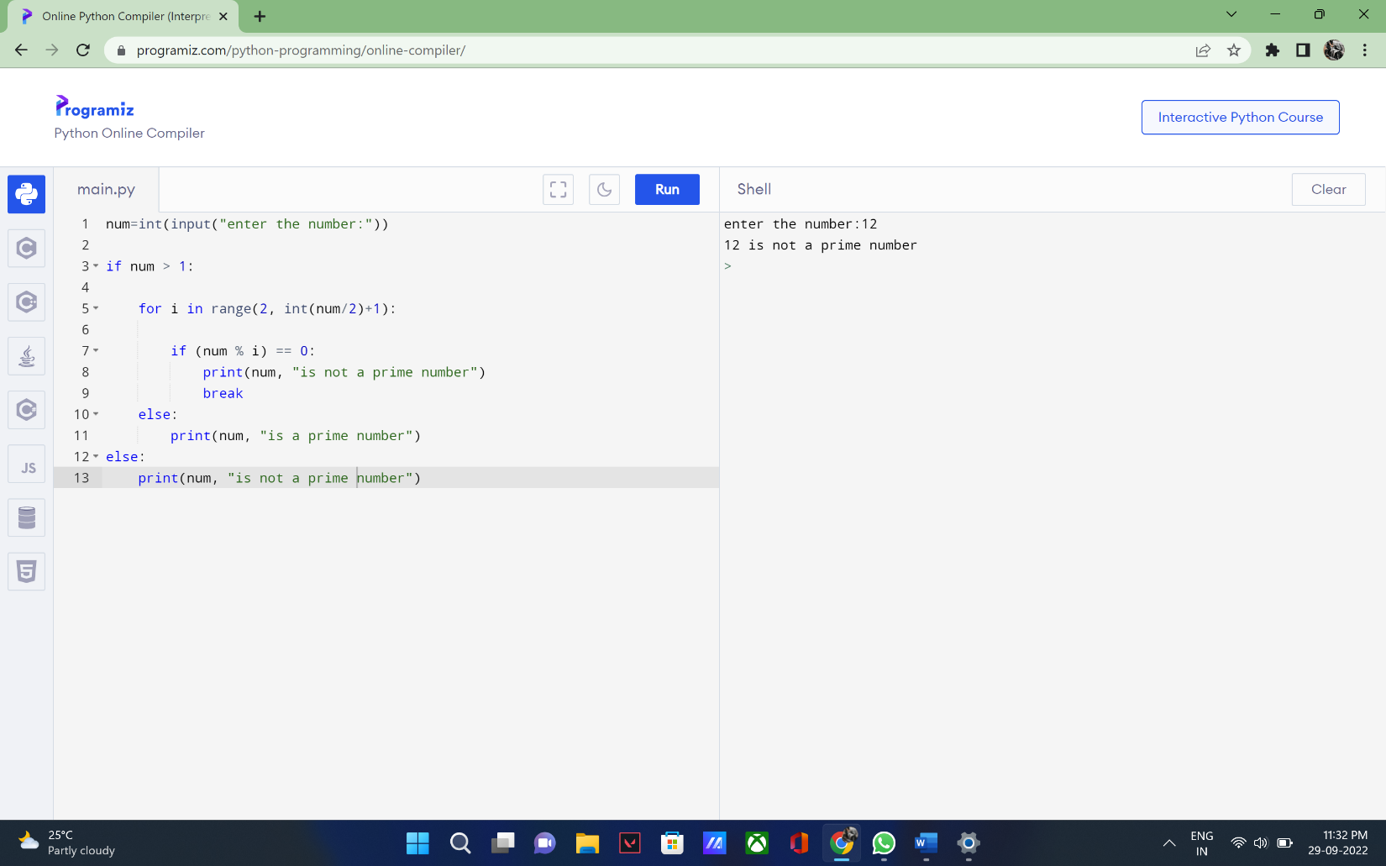

Output

 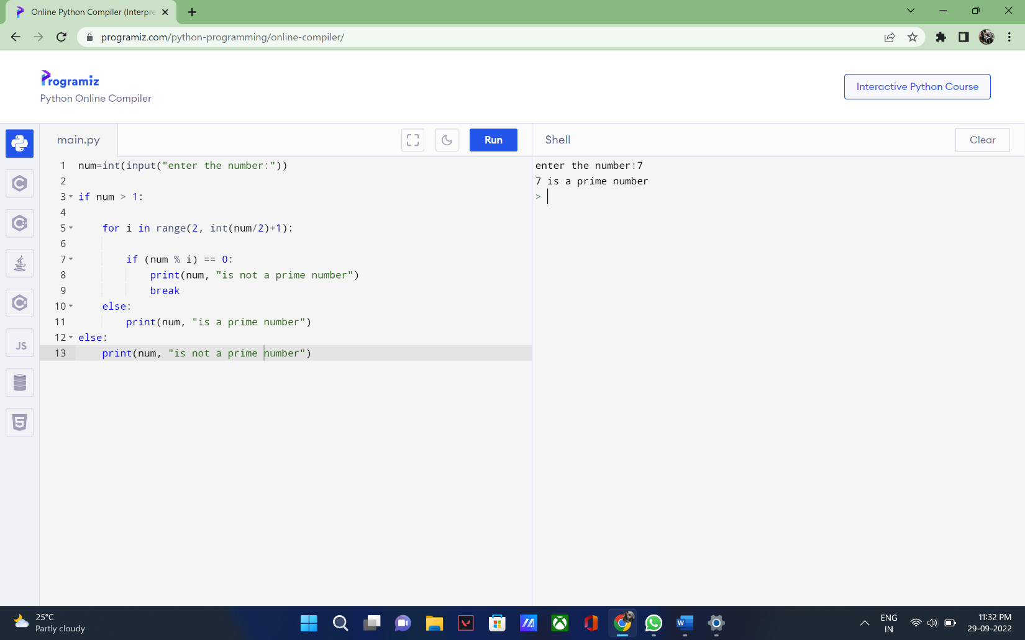

**Program 2**: Write a program to generate odd numbers from m to n using while loop

Code

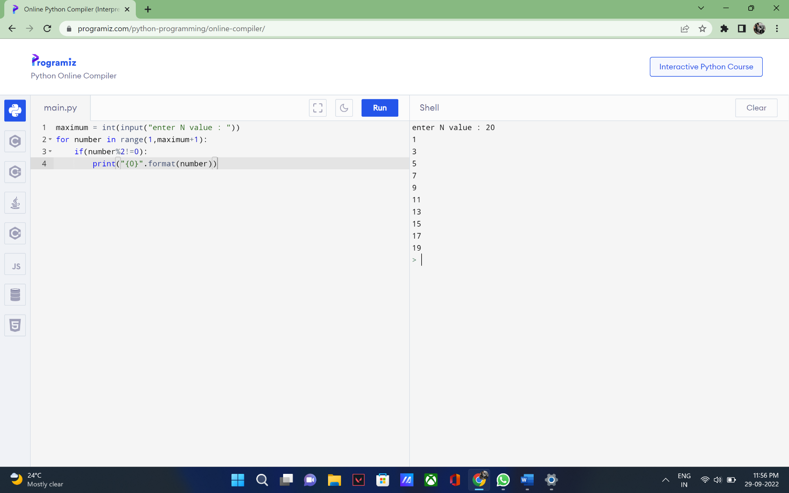

Output



**Program 3**: Write a Python program to display prime number series up to given number.

Code

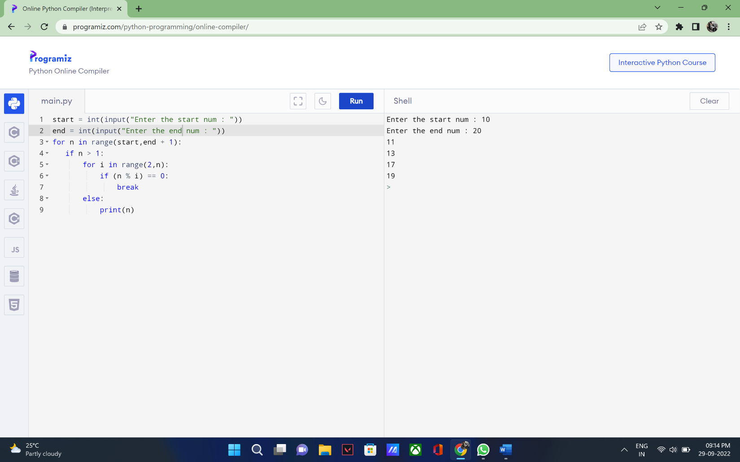

Output



**Program 4**: Write a Python program to generate Fibonacci series.

Code

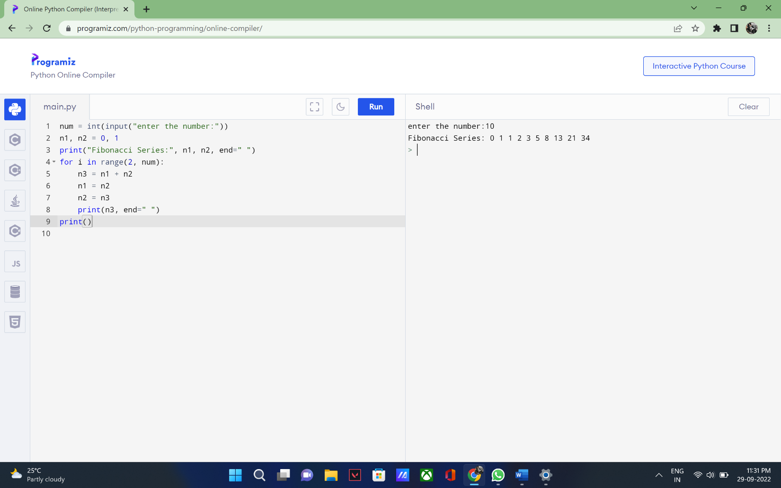

Output

