# ASSIGNMENT-4

|  |  |
| --- | --- |
| Assignment Date | November 2 - 2022 |
| Student Name | Umamaheswari D |
| Student Roll No | 922519205117 |
| Maximum Marks | 2 Marks |

**Question 1:**

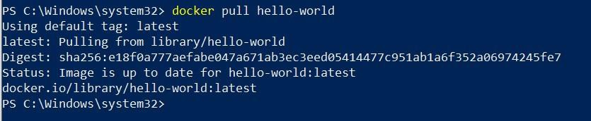Pull an Image from docker hub and run it in docker playground.

# Question 2:

Create a docker file for the job portal application and deploy it in Docker Desktop Application

FROM

helloworld:

latest WORKDIR

~/Desktop/ ADD .

helloworld/ WORKDIR

~/Desktop/htmlfile RUN pip install -r requirements RUN chmod +x app.sh

CMD["/bin/sh","app.s"]

# Question 3:

Create an IBM container registry and deploy helloworld app or Job portal app.

# Question 4:

Create a Kubernetes cluster in IBM cloud and deploy helloworld image or job portal image and also expose the same app to run in node port.

