PREREQUISTIES

PYTHONINSTALLATIONINWINDOWS11

|  |  |
| --- | --- |
| **TEAMID** | **PNT2022TMID51290** |
| **PROJECTNAME** | **IOTBASEDSMARTCROPPROTECTIONSYSTEMFORAGRICULTURE** |

STEP1:

Download python 3.7.0 using <https://www.python.org/downloads/release/python-370/>thislink.

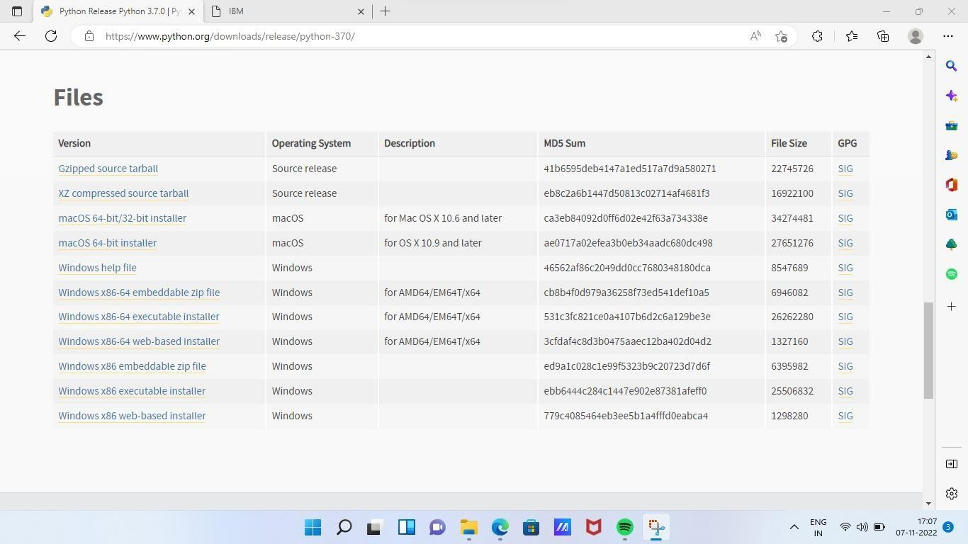

STEP2:

Double click to install the python3.7.0 version and click next, then wait some time to installthesoftware.Last it shows finish buttonto finishthe installation.

Note:whileinstalling pleasecheckadd path3.7.0 topath.

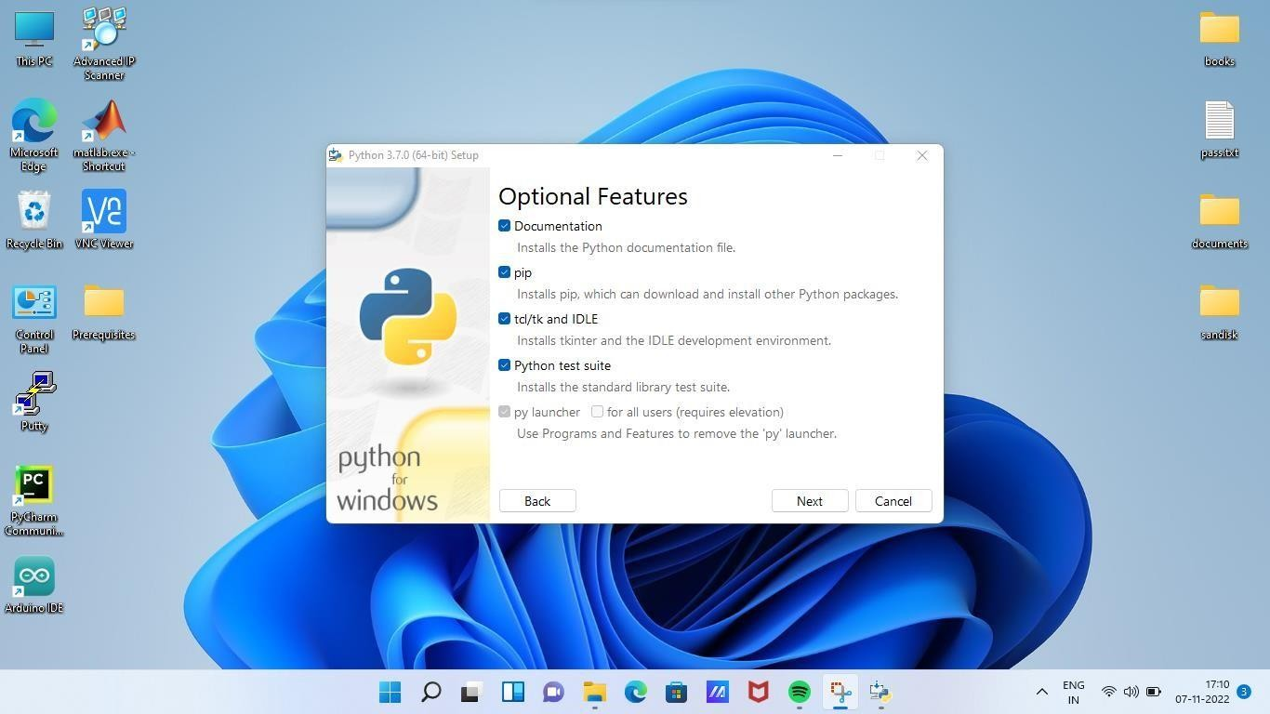

STEP3:

Search IDLEin searchbarthenclickIDLE(Python3.764-bit)toopenpythonIDLE.

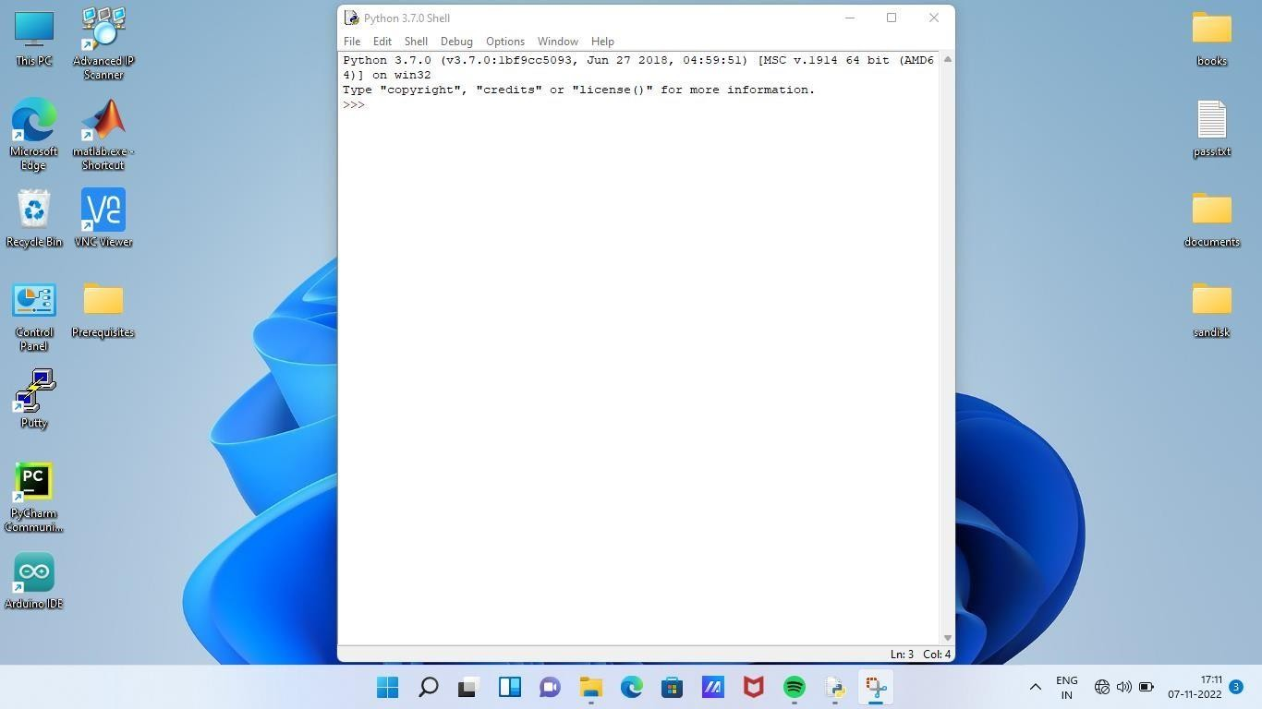

STEP4:

Typepython -m pip install–upgradepip in cmdthen enterto upgradepip in python.

