**Assignment –1**

**TINKERCAD CIRCUIT**

|  |  |
| --- | --- |
| Assignment Date | 15 September 2022 |
| Student Name | S EVANGELINE |
| Student Roll Number | 812419106018 |
| Maximum Marks | 2 Marks |

**Problem:**

**Build a smart home in Tinker cad use at least two sensors, LED, buzzer in a circuit. Simulate in a single code.**

**Solution:**

**Circuit:**

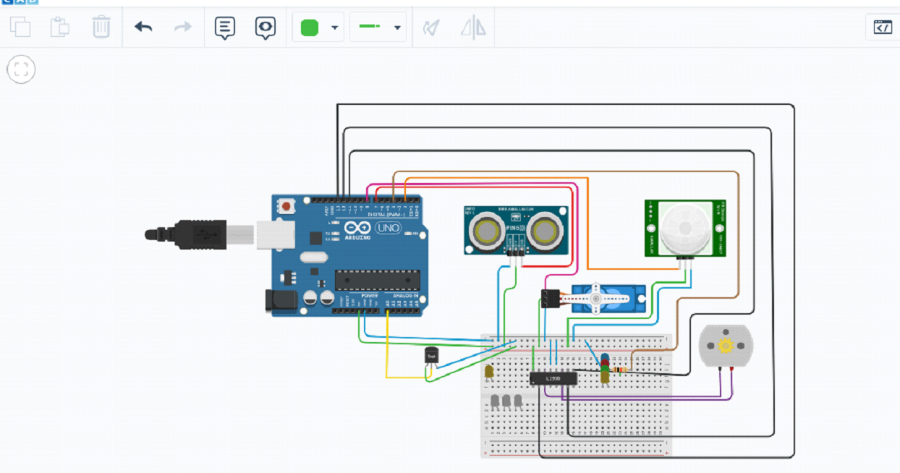

**Code:**

#include<Servo.h>

const int Pingping = 7;

int servo Pin = 8;

Servo servo1;

void setup () {

// initialize serial communication:

Serial. begin(9600);

servo1.attach(servoPin);

pinMode(2,INPUT);

pinMode(4,OUTPUT);

pinMode(11,OUTPUT);

pinMode(12,OUTPUT);

pinMode(13,OUTPUT);

pinMode(A0,INPUT);

digitalWrite(2,LOW);

digitalWrite(11,HIGH);

}

void loop() {

long duration, inches, cm;

pinMode(pingPin, OUTPUT);

digitalWrite(pingPin, LOW);

delayMicroseconds(2);

digitalWrite(pingPin, HIGH);

delayMicroseconds(5);

digitalWrite(pingPin, LOW);

// The same pin is used to read the signal from the PING))): a HIGH pulse

// whose duration is the time (in microseconds) from the sending of the ping

// to the reception of its echo off of an object.

pinMode(pingPin, INPUT);

duration = pulseIn(pingPin, HIGH);

// convert the time into a distance

inches = microsecondsToInches(duration);

cm = microsecondsToCentimeters(duration);

//Serial.print(inches);

//Serial.print("in, ");

//Serial.print(cm);

//Serial.print("cm");

//Serial.println();

//delay(100);

servo1.write(0);

if(cm < 40)

{

servo1.write(90);

delay(2000);

}

else

{

servo1.write(0);

}

// PIR with LED starts

int pir = digitalRead(2);

if(pir == HIGH)

{

digitalWrite(4,HIGH);

delay(1000);

}

else if(pir == LOW)

{

digitalWrite(4,LOW);

}

//temp with fan

float value=analogRead(A0);

float temperature=value*0.48;

Serial.println("temperature");

Serial.println(temperature);

if(temperature > 20)

{

digitalWrite(12,HIGH);

digitalWrite(13,LOW);

}

else

{

digitalWrite(12,LOW);

digitalWrite(13,LOW);

}

}

long microseconds ToInches(long microseconds) {

return microseconds / 74 / 2;

}

long microseconds ToCentimeters(long microseconds) {

return microseconds / 29 / 2;

}