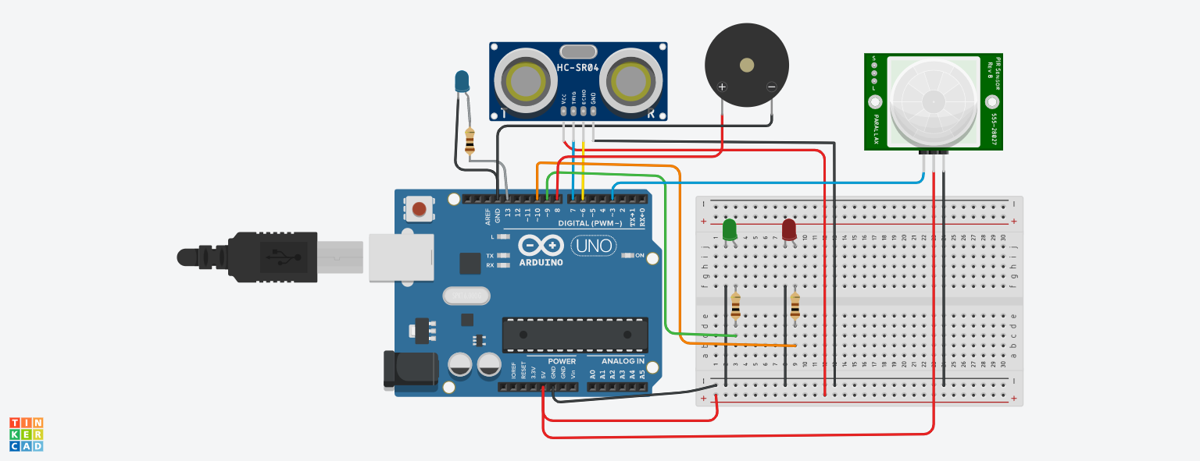#define Trigpin 7

#define Echopin 8

#define low_led 9

#define high_led 10

float distance;

int duration;

int ll = 700;

void setup() {

pinMode (Trigpin, OUTPUT);

pinMode (low_led, OUTPUT);

pinMode (high_led, OUTPUT);

pinMode (Echopin, INPUT);

Serial.begin(9600);

Serial.println ("Welcome To Distance Meter");

Serial.println ("Coded By Jevins Annson");

digitalWrite (low_led, LOW);

digitalWrite (high_led, LOW);

}

void loop() {

digitalWrite(Trigpin, LOW);

delayMicroseconds(2);

digitalWrite(Trigpin, HIGH);

delayMicroseconds(10);

digitalWrite(Trigpin, LOW);

duration = pulseIn(Echopin, HIGH);

distance = duration * 0.034 / 2;

delay (ll);

Serial.println (" ");

Serial.print ("Distance = ");

Serial.print (distance);

Serial.print (" CM");

Serial.println (" ");

if (distance>=30)

{

Serial.println ("Nobody Is Infront Of the Sensor");

digitalWrite (low_led, HIGH);

delay (500);

digitalWrite (low_led, LOW);

delay (500);

digitalWrite (low_led, HIGH);

}

else

{

Serial.println ("Someone Is Infront Of the Sensor");

digitalWrite (high_led, HIGH);

delay (100);

digitalWrite (high_led, LOW);

delay (100);

digitalWrite (high_led, HIGH);

delay (100);

}

}