Face Recognition using Eigenfaces.

Haripriya Ganta and Pinky Tejwani.
ECE 847 Project Report.
Fall 2004, Clemson University.

Abstract
We have implemented an efficient system to recognize faces from images with some near real-time variations. Our approach essentially was to implement and verify the algorithm Eigenfaces for Recognition [1], which solves the recognition problem for 2-D image of faces, using the principal component analysis.The face images are projected onto a face space(feature space) which best defines the variation the known test images. The face space is defined by the ‘eigenfaces’ which are the eigenvectors of the set of faces.These eigenfaces do not necessarily correspond to the distinct features perceived like ears, eyes and noses.The projections of the new image in this feature space is then compared to the available projections of training set to identify the person.Further, the algorithm is extended to recognize the identity and gender of a person with different orientations and certain variations like scaling.

Introduction
Face recognition can be applied for a wide variety of problems like image and film processing, human-computer interaction, criminal identification etc.This has motivated researchers to develop computational models to identify the faces, which are relatively simple and easy to implement. The model developed in [1] is simple, fast and accurate in constrained environments.Our goal is to implement the model for a particular face and distinguish it from a large number of stored faces with some real-time variations as well.
The scheme is based on an information theory approach that decomposes face images into a small set of characteristic feature images called ‘eigenfaces’, which are actually the principal components of the initial training set of face images. Recognition is performed by projecting a new image into the subspace spanned by the eigenfaces(‘face space’) and then classifying the face by comparing its position in the face space with the positions of the known individuals.
Recognition under widely varying conditions like frontal view, a 45° view, scaled frontal view, subjects with spectacles etc. are tried, while the training data set covers a limited views.Further this algorithm can be extended to recognize the gender of a person or to interpret the facial expression of a person. The algorithm models the real-time varying lighting conditions as well. But this is out of scope of the current implementation.

Eigenface Approach
The information theory approach of encoding and decoding face images extracts the relevant information in a face image, encode it as efficiently as possible and compare it with database of similarly encoded faces.The encoding is done using features which may be different or independent than the distinctly perceived features like eyes, ears, nose, lips, and hair.
Mathematically, principal component analysis approach will treat every image of the training set as a vector in a very high dimensional space. The eigenvectors of the covariance matrix of these vectors would incorporate the variation amongst the face images. Now each image in the training set would have its contribution to the eigenvectors (variations). This can be displayed as an ‘eigenface’ representing its contribution in the variation between the images. These eigenfaces look like ghostly images and some of them are shown in figure 2.In each eigenface some sort of facial variation can be seen which deviates from the original image.
The high dimensional space with all the eigenfaces is called the image space (feature space). Also, each image is actually a linear combination of the eigenfaces. The amount of overall variation that one eigenface counts for, is actually known by the eigenvalue associated with the corresponding eigenvector. If the eigenface with small eigenvalues are neglected, then an image can be a linear combination of reduced no of these eigenfaces. For example, if there are M images in the training set, we would get M eigenfaces. Out of these, only M’ eigenfaces are selected such that they are associated with the largest eigenvalues. These would span the M’-dimensional subspace ‘face space’ out of all the possible images (image space).
When the face image to be recognized (known or unknown), is projected on this face space (figure 1), we get the weights associated with the eigenfaces, that linearly approximate the face or can be used to reconstruct the face. Now these weights are compared with the weights of the known face images so that it can be recognized as a known face in used in the training set. In simpler words, the Euclidean distance between the image projection and known projections is calculated; the face image is then classified as one of the faces with minimum Euclidean distance.

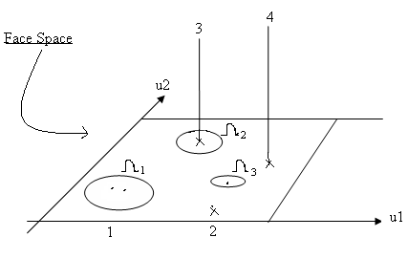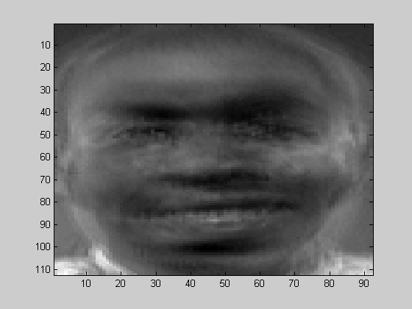
(a) (b)
Figure 1.
- The face space and the three projected images on it. Here u1 and u2 are the eigenfaces.
- The projected face from the training database.

Mathematically calculations.
Let a face image I(x,y) be a two dimensional N by N array of (8-bit) intensity values. An image may also be considered as a vector of dimension N², so that a typical image of size 256 by 256 becomes a vector of dimension 65,536 or equivalently a point in a 65,536-dimensional space. An ensemble of images, then, maps to a collection of points in this huge space. Principal component analysis would find the vectors that best account for the distribution of the face images within this entire space.
Let the training set of face images be T₁,T₂,T₃,….T_{M.} This training data set has to be mean adjusted before calculating the covariance matrix or eigenvectors.The average face is calculated as Ψ = (1/M) Σ₁^{M}T_{i} Each image in the data set differs from the average face by the vector Ф = T_{i} – Ψ. This is actually mean adjusted data. The covariance matrix is
C = (1/M) Σ ₁^{M} Φ_{i} Φ_{i}^{T} (1)
= AA^{T}
where A = [ Φ_{1,} Φ_{2,} …. Φ_{M}]. The matrix C is a N² by N² matrix and would generate N² eigenvectors and eigenvalues. With image sizes like 256 by 256, or even lower than that, such a calculation would be impractical to implement.
A computationally feasible method was suggested to find out the eigenvectors. If the number of images in the training set is less than the no of pixels in an image (i.e M < N²⁾, then we can solve an M by M matrix instead of solving a N² by N² matrix. Consider the covariance matrix as A^{T}A instead of AA^{T}. Now the eigenvector v_{i} can calculated as follows, A^{T}Av_{i} = μ_{i}v_{i} (2)
where μ_{i} is the eigenvalue. Here the size of covariance matrix would be M by M.Thus we can have m eigenvectors instead of N². Premultipying equation 2 by A, we have
AA^{T}Av_{i =} μ_{i} Av_{i} (3)
The right hand side gives us the M eigenfaces of the order N² by 1.All such vectors would make the imagespace of dimensionality M.
Face Space
As the accurate reconstruction of the face is not required, we can now reduce the dimensionality to M’ instead of M. This is done by selecting the M’ eigenfaces which have the largest associated eigenvalues. These eigenfaces now span a M’-dimensional subspace instead of N².
Recognition
A new image T is transformed into its eigenface components (projected into ‘face space’) by a simple operation,
w_{k =} u_{k}^{T} (T - ψ) (4)
here k = 1,2,….M’. The weights obtained as above form a vector Ω^{T} = [w_{1,} w_{2,} w_{3,….} w_{M’}] that describes the contribution of each eigenface in representing the input face image. The vector may then be used in a standard pattern recognition algorithm to find out which of a number of predefined face class, if any, best describes the face.The face class can be calculated by averaging the weight vectors for the images of one individual. The face classes to be made depend on the classification to be made like a face class can be made of all the images where subject has the spectacles. With this face class, classification can be made if the subject has spectacles or not. The Euclidean distance of the weight vector of the new image from the face class weight vector can be calculated as follows,
ε_{k} = || Ω – Ω_{k}|| (5)
where Ω_{k} is a vector describing the kth face class.Euclidean distance formula can be found in [2]. The face is classified as belonging to class k when the distance ε_{k} is below some threshold value θε. Otherwise the face is classified as unknown. Also it can be found whether an image is a face image or not by simply finding the squared distance between the mean adjusted input image and its projection onto the face space.
ε² = || Ф - Ф_{f} || (6)
where Ф_{f} is the face space and Ф = T_{i} – Ψ is the mean adjusted input.
With this we can classify the image as known face image, unknown face image and not a face image.

Recognition Experiments
24 images were trained with four individuals having 6 images per individual. The 6 images had different lighting conditions, orientations and scaling. These images were recognized successfully with the accuracy of 100% for lighting variations, 90% for orientation variations, and 65% for size variations. The lighting conditions don’t have any effect of the recognition because the correlation over the image doesn’t change. The orientation conditions would affect more because of the image would have more hair into it than it had for training. Scaling affects the recognition significantly because the overall face data in the image changes. This is because the background is not subtracted for training. This effect can be minimized by background subtraction.



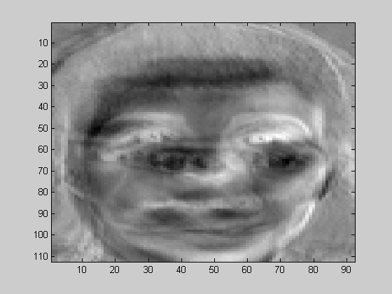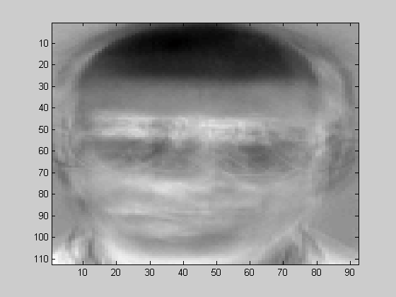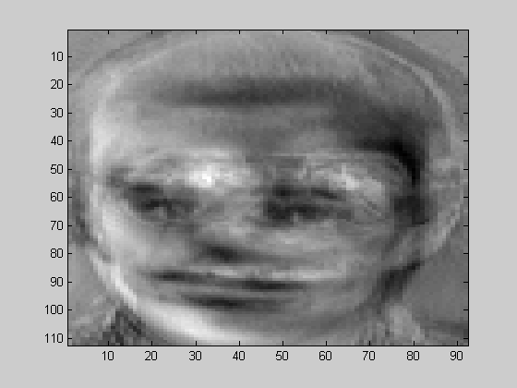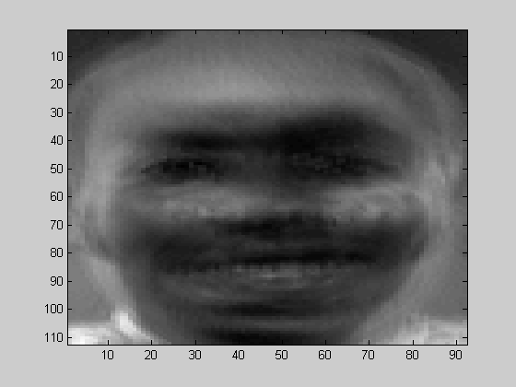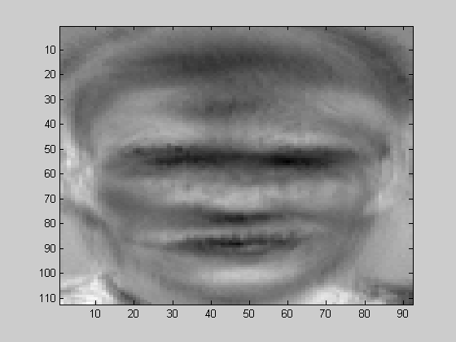

Figure 2
The first row is some of the images used for training while the second row shows the eigenfaces with significant eigenvectors.

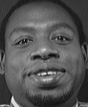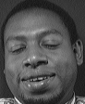
Figure 3
The first image is the frontal image, while the second and third are the images of the same subject with different scaling and orientation.

Conclusion
The approach is definitely robust, simple, and easy and fast to implement compared to other algotithms. It provides a practical solution to the recognition problem. We are currently investigating in more detail the issues of robustness to changes in head size and orientation. Also we are trying to recognize the gender of a person using the same algorithm.

References

[1] Matthew A. Turk and Alex P. Pentland. “Eigenfaces for recognisation”. Journal of cognitive nerosciences, Volume 3, Number 1, Nov 27, 2002.

[2] Dimitri PISSARENKO. “Eigenface-based facial recognition”. Dec1, 2202.

[3] Matthew A. Turk and Alex P. Pentland. “Face recognition using eigenfaces”. Proc. CVPR , pp 586-591. IEEE, June 1991.

[4] L.I.Smith. “A tutorial on princal component analysis”. Feb 2002.

[5] M.Kirby and L.Sirovich. “Application of the karhunen-loeve procedure for the characterization of human faces”. IEEE trans. on Pattern analysis and machine intelligence, Volume 12, No.1, Jan 1990.

[6] URL http://www.cs.dartmouth.edu/~farid/teaching/cs88/kimo.pdf

[7] URL http://www.cs.virginia.edu/~jones/cs851sig/slides

