PROJECT REPORT

|  |  |
| --- | --- |
| **Date** |  |
| **Team ID** | **PNT2022TMID50013** |
| **Project Name** | **Classification of Arrhythmia by Using Deep Learning with 2-D ECG Spectral Image**  **Representation** |

# INTRODUCTION

* 1. **Project Overview**

According to the World Health Organization (WHO), cardiovascular diseases (CVDs) are the number one cause of death today. Over 17.7 million people died from CVDs in the year 2017 all over the world which is about 31% of all deaths, and over 75% of these deaths occur in low and middle-income countries. Arrhythmia is a representative type of CVD that refers to any irregular change from the normal heart rhythms. There are several types of arrhythmia including atrial fibrillation, premature contraction, ventricular fibrillation, and tachycardia. Although a single arrhythmia heartbeat may not have a serious impact on life, continuous arrhythmia beats can result in fatal circumstances. In this project, we build an effective electrocardiogram (ECG) arrhythmia classification method using a convolutional neural network (CNN), in which we classify ECG into seven categories, one being normal and the other six being different types of arrhythmia using deep two-dimensional CNN with grayscale ECG images. We are creating a web application where the user selects the image which is to be classified. The image is fed into the model that is trained and the cited class will be displayed on the webpage.

# Purpose

* + - The main purpose of this application is to make people awareness on their general health.
    - Know fundamental concepts and techniques of the Artificial Neural Network and Convolution Neural Networks
    - Gain a broad understanding of image data.
    - Work with Sequential type of modeling
    - Work with Keras capabilities
    - Work with image processing techniques
    - know how to build a web application using the Flask framework.

# LITERATURE SURVEY

* 1. **Existing problem**
     + https://apps.apple.com/us/app/ecg/id1459546745

# References

* + - https://[www.researchgate.net/publication/341623436\_Classification\_o](http://www.researchgate.net/publication/341623436_Classification_o) f\_Arrhythmia\_by\_Using\_Deep\_Learning\_with\_2-D\_ECG\_Spectral\_Imag e\_Representation

# Problem Statement Definition

* + - According to the World Health Organization (WHO), cardiovascular diseases (CVDs) are the number one cause of death today.
    - The annual number of deaths from CVD in India is projected to rise from 2.26 million (1990) to 4.77 million (2020).
    - Arrhythmia is a representative type of CVD that refers to any irregular change from the normal heart rhythms.

# IDEATION & PROPOSED SOLUTION

* 1. **Empathy Map Canvas**

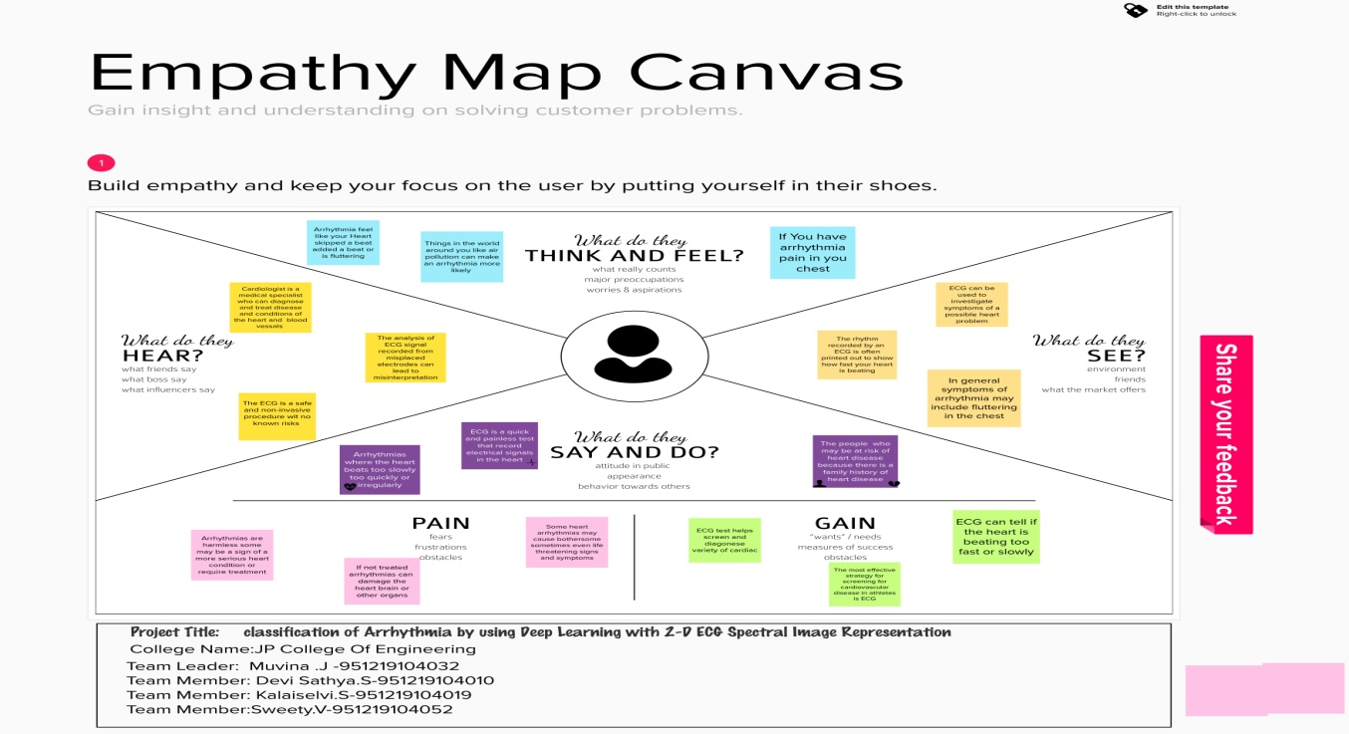

# Ideation & Brainstoming

# 

# Ideation_page-0001.jpg

**Proposed Solution**

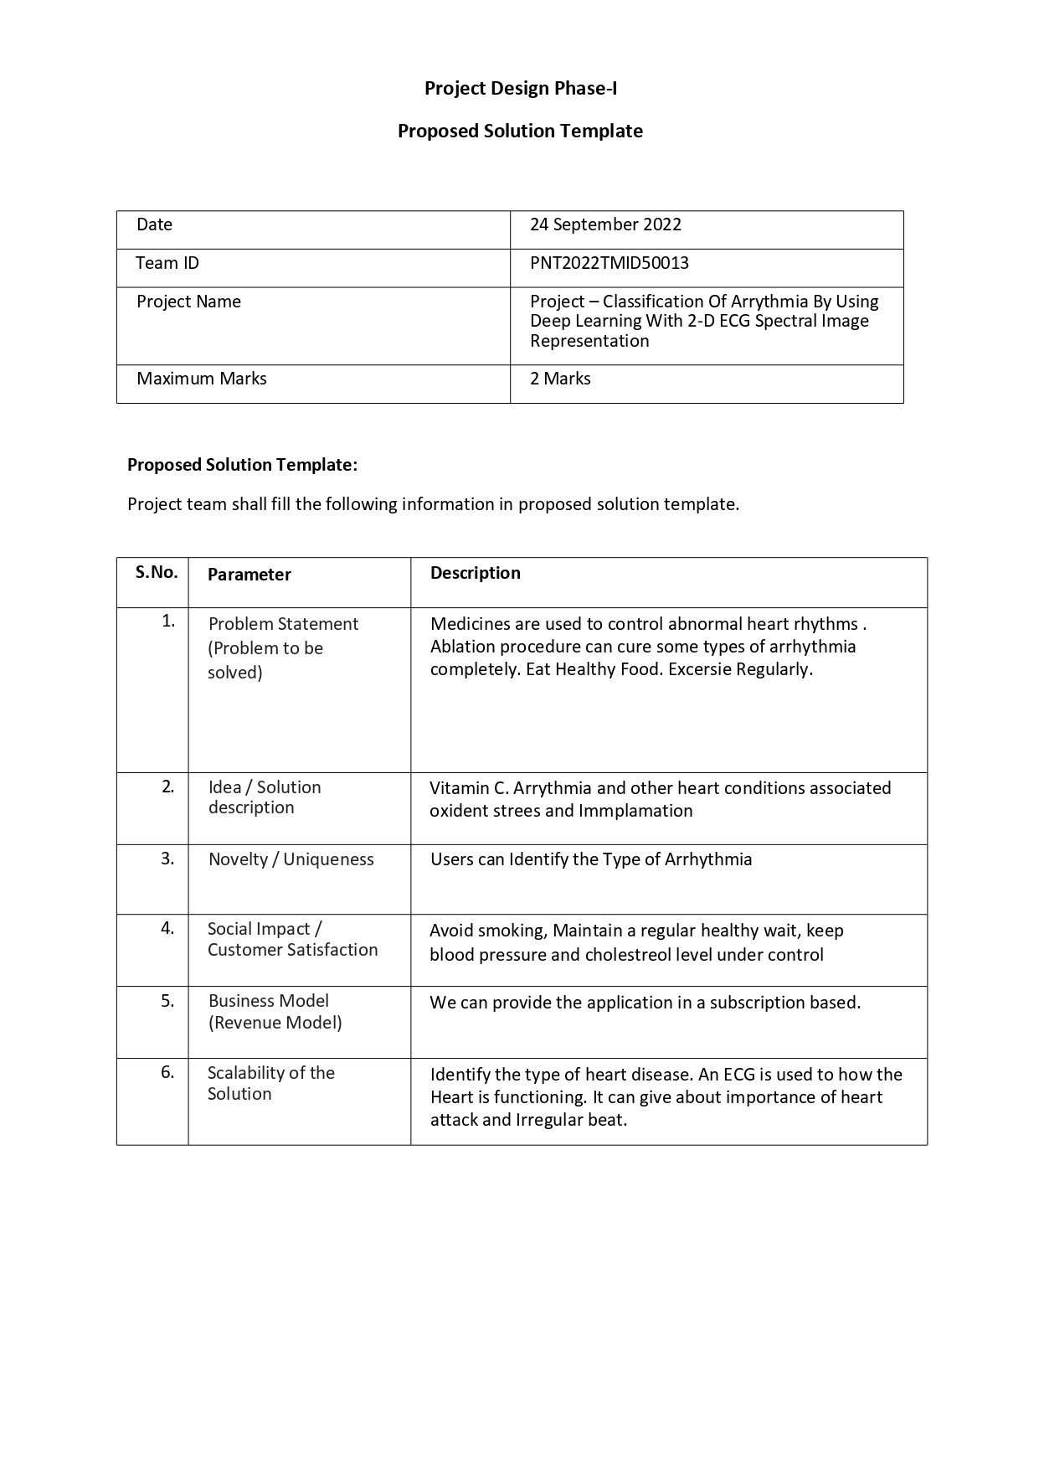

# Problem Solution fit

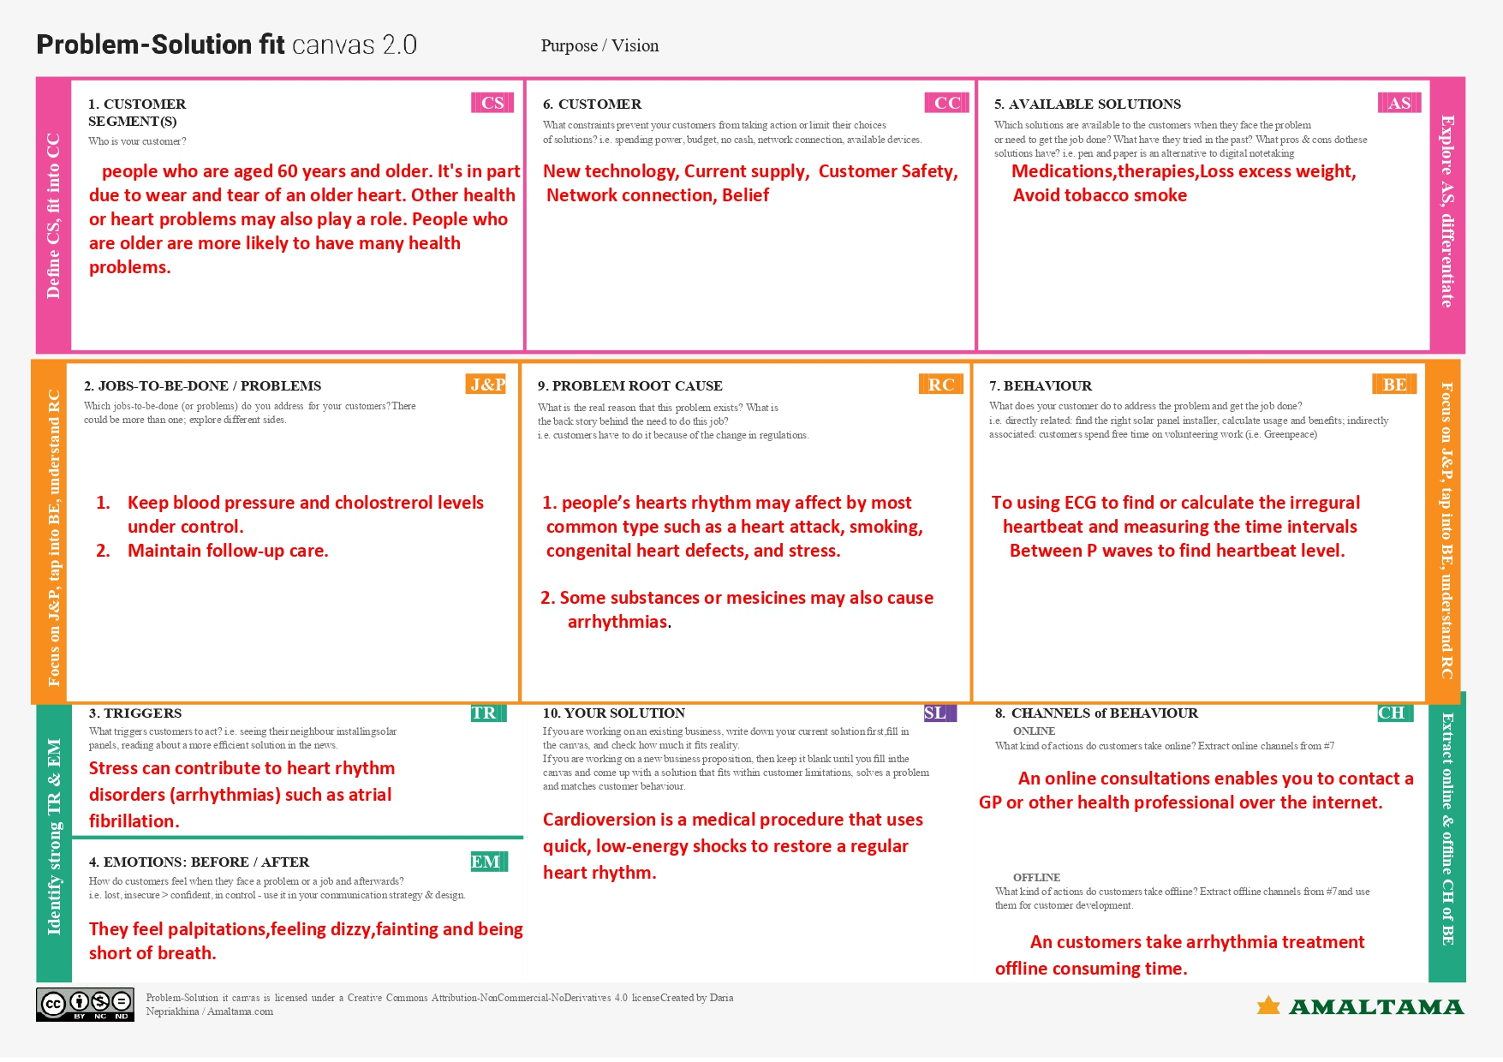

1. **REQUIREMENT ANALYSIS**

# Functional requirement

|  |  |  |
| --- | --- | --- |
| **FR No.** | **Functional Requirement (Epic)** | **Sub Requirement (Story / Sub-Task)** |
| FR 1 | User Registration | Registration through Form Registration through Gmail Registration through LinkedIn |
| FR 2 | User Confirmation | Confirmation via Email  Confirmation via OTP |
| FR 3 | User interface | Check your profile Choose your file Sign Out your account and change your  password. |
| FR 4 | Data processing | Evaluating the model using test data Training DL algorithm for a accuracy result Trained CNN model  using Tensorflow,Kearas. |
| FR 5 | Predict ECG image | User ECG images in our web application Collection of datasets Database read ECG  images. |

* 1. **Non-Functional requirements**
  2. **Non-Functional requirements**

|  |  |  |
| --- | --- | --- |
| **FR NO.** | **Non Functional Requirement** | **Description** |
| NFR-1 | Usability | Wireless ECG body sensor Savvy is a feasible solution for reliable and accurate long- term heart rhythm monitoring However there were on  studies dealing with usability of this sensor ion field testing |

|  |  |  |
| --- | --- | --- |
| NFR-2 | Security | The work presented ion this paper is applicable for encrypting and decrypting personalized Electrocardiograph ECG  signals for secure transmission |
| NFR-3 | Reliability | The extent to the consistently  performs the specified functions without failure |
| NFR-4 | Performance | It essentially specifies how the system should behave and that it constrains the ECG wavelength of accurate  disease information gathering |
| NFR-5 | Availability | Availability describes how likely the system is accessible to a user at a given point on  time and the periodically for a solutions |
| NFR-6 | Scalability | The ability of the user problem ion arrhythmia disease to handle on increase ion workload without performance degradation or  its ability to quickly enlarge |

# PROJECT DESIGN

**Data Flow Diagrams**

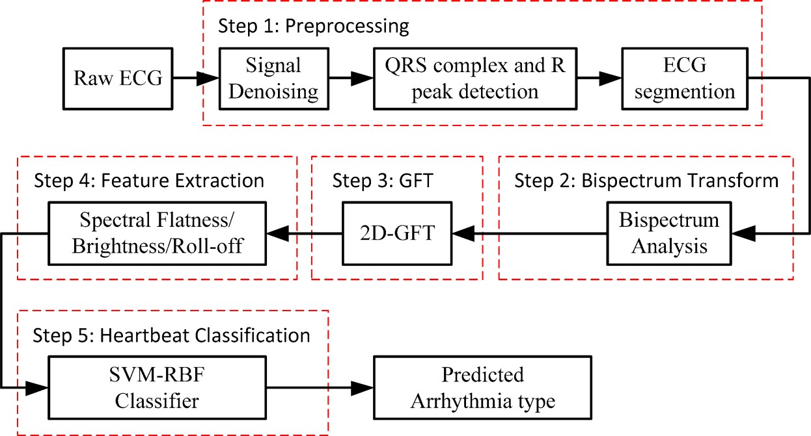

* + - A Data Flow Diagram (DFD) is a traditional visual representation of the information flows within a system.
    - A neat and clear DFD can depict the right amount of the system requirement graphically.
    - It shows how data enters and leaves the system, what changes the information, and where data is stored

# Solution & Technical Architecture

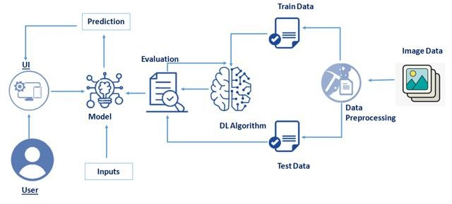

* 1. **User Stories**

# 5.PROJECT PLANNING & SCHEDULING

* 1. **Sprint Planning & Estimation**

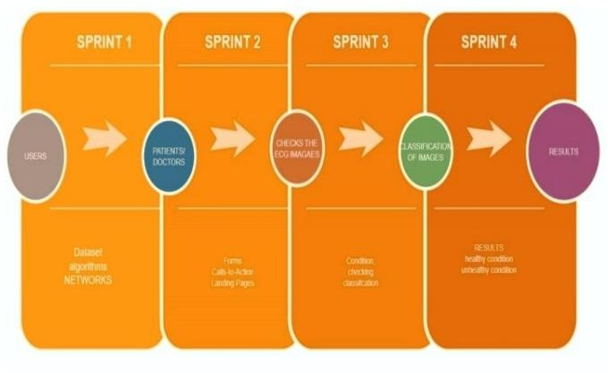

# Sprint Delivery Schedule

SPRINT 1:

* + - The team should conduct a survey of the project developed.
    - The team should have a proof of the results been executed.
    - The team should start by completing the milestones. SPRINT 2:
    - The team should monitor the efficiency of the process.
    - The team should show a demo to the team mentors.
    - The team should analyse the project specifications. SPRINT 3:
    - The team-mates should always work in coordination.
    - The team-mates should understand the project work flow and structure.
    - The team-mates should have a complete knowledge of the project. SPRINT 4:
    - The team should always be updating the project as per the recent trends and requirements.
    - The team should finally deploy and train the project.
    - The team should always have a check on the result of the projects.

# Reports from JIRA

1. **CODING AND SOLUTIONING**

# Feature 1

# import os

# import numpy as np #used for numerical analysis

# from flask import Flask,request,render\_template

# # Flask-It is our framework which we are going to use to run/serve our application.

# #request-for accessing file which was uploaded by the user on our application.

# #render\_template- used for rendering the html pages from tensorflow.keras.models import

# load\_model#to load our trained model from tensorflow.keras

# .preprocessing import image app=Flask(\_\_name\_\_)#our flask app

# model=load\_model('ECG.h5')#loading the model @app.route

# ("/") #default route def about(): return render\_template("home.html")

# #rendering html page @app.route("/home")

# #default route def home(): return render\_template("home.html")#rendering html page

# @ app.route("/info")

# #default route def information(): return render\_template("info.html")

# #rendering html page @app.route("/upload") #default route def test(): return render\_template("predict.html")

# #rendering html page @app.route("/predict",methods=["POST","GET"])

# #route for our prediction def upload():

# if request.method=='POST':

# f=request.files['file'] #requesting the file basepath=os.path.dirname('\_\_file\_\_')

# #storing the file directory filepath=os.path.join(basepath,"uploads",f.filename)

# #storing the file in uploads folder f.save(filepath)

# #saving the file print("file save") img=image.load\_img(filepath,target\_size=(64,64))

# #load and reshaping the image x=image.img\_to\_array(img)

# #converting image to array x=np.expand\_dims(x,axis=0) #changing the dimensions of the image

# ## pred=model.predict(x) #predicting classes

# ## y\_pred = np.argmax(pred) ##print("prediction",y\_pred)#printing the prediction

# preds=model.predict(x)#predicting classes

# pred=np.argmax(preds,axis=1)#predicting classes

# print("prediction",pred)#printing the prediction

# index=['Left Bundle Branch Block','Normal','Premature Atrial Contraction','Premature Ventricular Contractions', 'Right Bundle Branch Block','Ventricular Fibrillation']

# ## result=str(index[y\_pred])result=str(index[pred[0]])return result #resturing the result return None #port = int(os.getenv("PORT")) if \_\_name\_\_=="\_\_main\_\_": app.run(debug=False)#running our app #app.run(host='0.0.0.0', port=8000)

# Feature 2

# <!DOCTYPE html>

# <html> <head> <meta charset="UTF-8"> <meta http-equiv="X-UA-Compatible" content="IE=edge"> <meta name="viewport" content="width=device-width, initial-scale=1.0"> <title>Home</title> <style>

# body { margin: 0px; padding: 0px; font-family: sans-serif; } /\* .pd {

# padding-bottom: 100%; } \*/

# .navbar { padding: 20px 0px 40px; ;

# background-color: #222;

# font-size: 25px;

# text-align: center; } .

# navbar a { color: #eee; float: right;

# text-decoration: none; font-style: normal; font-family: sans-serif; padding-right: 10px; } .navbar a:hover { background-color: rgb(0, 0, 0); color: rgb(17, 194, 238); border-radius: 5px; padding: 5px; } .content{ background-image: url("https://thumbs.gfycat.com/ChiefHeftyBasil-small.gif");

# background-size: cover; background-repeat: no-repeat; height: 87vh; margin-top: -21px; } .dic p { color: white; text-align: center; font-family: sans-serif; font-size: 30px; }

# 

# 

# footer{ display: flex; justify-content: center; background-color: #222; margin-top: -10px; color: white; } </style> </head> <body> <div class="navbar"> <a href="/upload">Predict</a> <a href="/info">Info</a> <a href="/home">Home</a> </div> <div class="content"> <h2 style="display: flex;justify-content: center; color:white;size:15;font-family:comic Sans MS"> ECG arrhythmia classification using CNN </h2> <div class="dic"> <p>According to the World Health Organization (WHO), cardiovascular diseases (CVDs) are the number one cause of death today. Over 17.7 million people died from CVDs in the year 2017 all over the world which is about 31% of all deaths, and over 75% of these deaths occur in low and middle income countries. Arrhythmia is a representative type of CVD that refers to any irregular change from the normal heart rhythms. There are several types of arrhythmia including atrial fibrillation, premature contraction, ventricular fibrillation, and tachycardia. Although single arrhythmia heartbeat may not have a serious impact on life, continuous arrhythmia beats can result in fatal circumstances.Electrocardiogram (ECG) is a non-invasive medical tool that displays the rhythm and status of the heart. Therefore, automatic detection of irregular heart rhythms from ECG signals is a significant task in the field of cardiology. </p> </div>

# <footer> <h4>@All Rights Reserved</h4>

# </footer> </body> </html>

# 2.png

# 

1. **TESTING**

**Test Cases**

**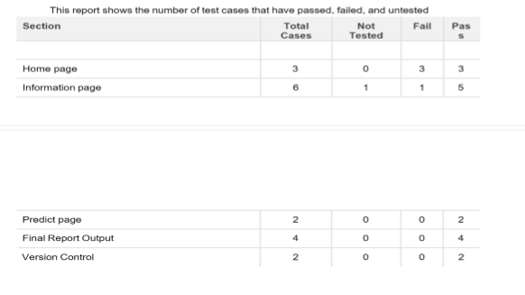**

* 1. **User Acceptance Testing**

**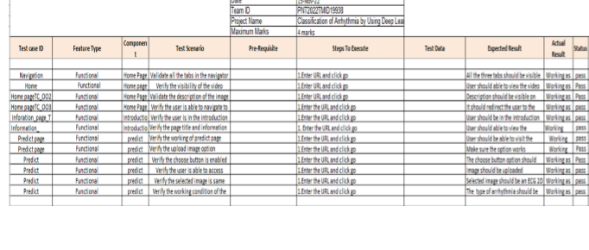**

# ADVANTAGES & DISADVANTAGES

* 1. **ADVANTAGES**
     + The proposed model predicts Arrhythmia in images with a high accuracy rate of nearly 96%
     + The early detection of Arrhythmia gives better understanding of disease causes, initiates therapeutic interventions and enables developing appropriate treatments.

# DISADVANTAGES

* + - Not useful for identifying the different stages of Arrhythmia disease.
    - Not useful in monitoring motor symptoms.

# CONCLUSION

* In this project, we proposed a 2-D ECG-based classiﬁcation model for automatic classiﬁcation of cardiac arrhythmias using ECG signals.
* An accurate taxonomy of ECG signals is extremely helpful in the prevention and diagnosis of CVDs.

These results indicate that the prediction and classiﬁcation of arrhythmia with 2-D ECG representation spectrograms and the CNN model is a reliable operative technique in the diagnosis of CVDs.

* It is endowed with an ability to effectively process the non-filtered dataset with its potential anti-noise features. Besides that, ten-fold cross-validation is implemented in this work to further demonstrate the robustness of the network.

# FUTURE SCOPE

* For future work, it would be interesting to explore the use of optimization techniques to find a feasible design and solution.
* The limitation of our study is that we have yet to apply any optimization techniques to optimize the model parameters and we believe that with the implementation of the optimization, it will be able to further elevate the performance of the proposed solution to the next level.

# APPENDIX

## Demo Link: [IBM-Project-41147-1660639817](https://github.com/IBM-EPBL/IBM-Project-41147-1660639817)/****Demo video.mp4****