Prerequisites

|  |  |
| --- | --- |
| Date | 07 November 2022 |
| Team ID | PNT2022TMID33581 |
| Project Name | AI-Powered Nutrition Analyzer for Fitness Enthusiasts |

ANACONDA NAVIGATOR :

Anaconda Navigator is a free and open-source distribution of the Python and R programming languages for data science and machine learning-related applications. It can be installed on Windows, Linux, and macOS. Conda is an open-source, cross-platform, package management system. Anaconda comes with great tools like JupyterLab, Jupyter Notebook, QtConsole, Spyder, Glueviz, Orange, Rstudio, Visual Studio Code.

For this project, we will be using a Jupyter notebook and Spyder.

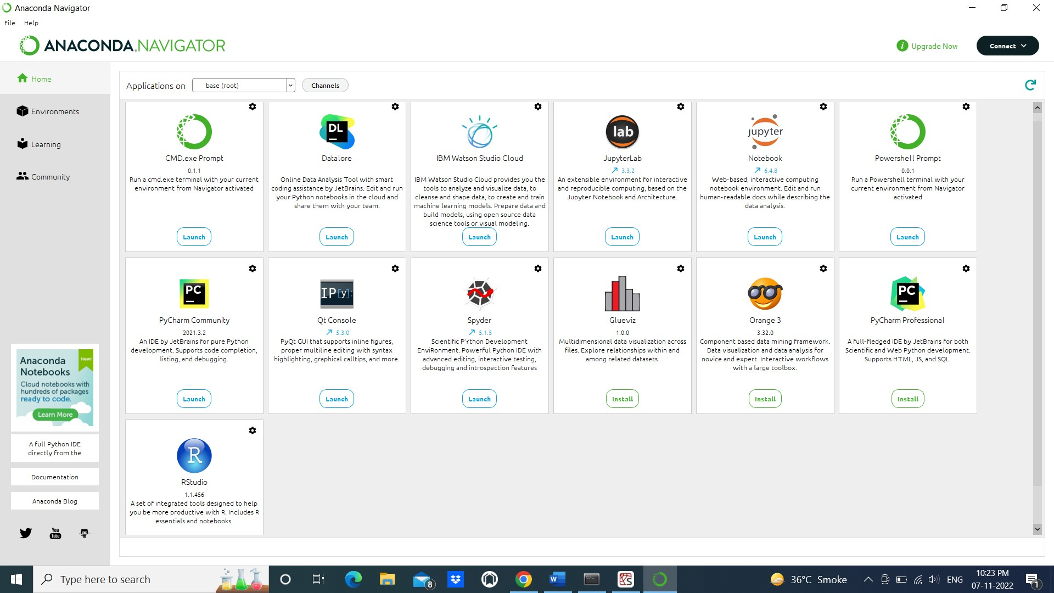

* Python packages:

* open anaconda prompt as administrator

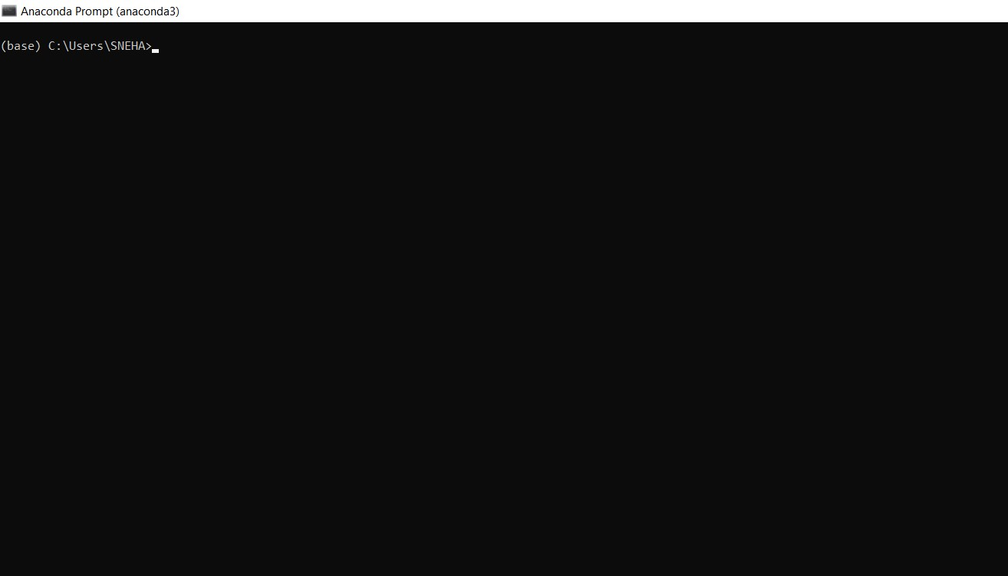

* Type “pip install numpy” and click enter

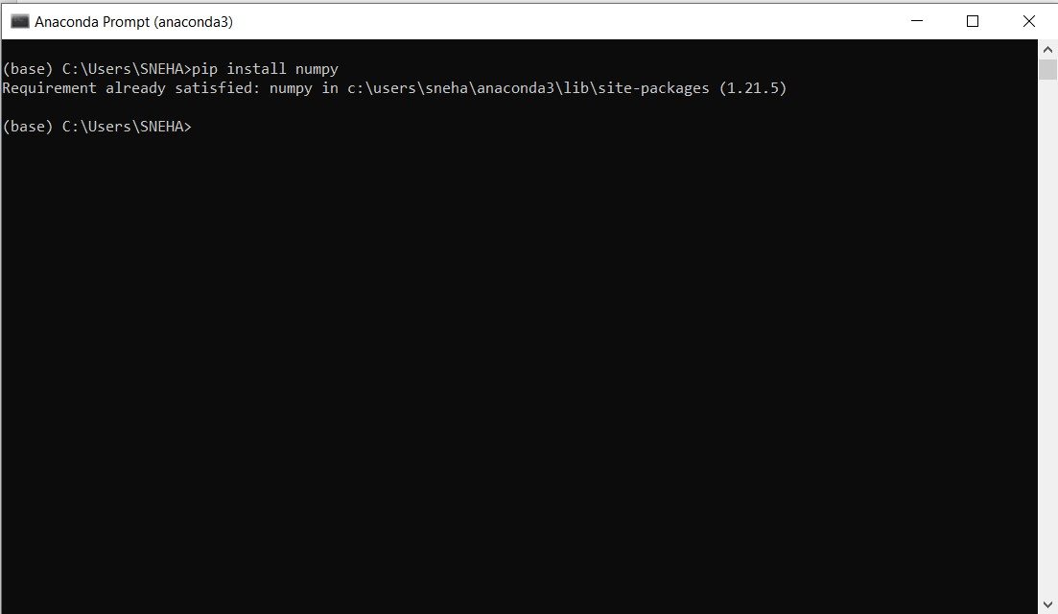

* Type “pip install pandas” and click enter.

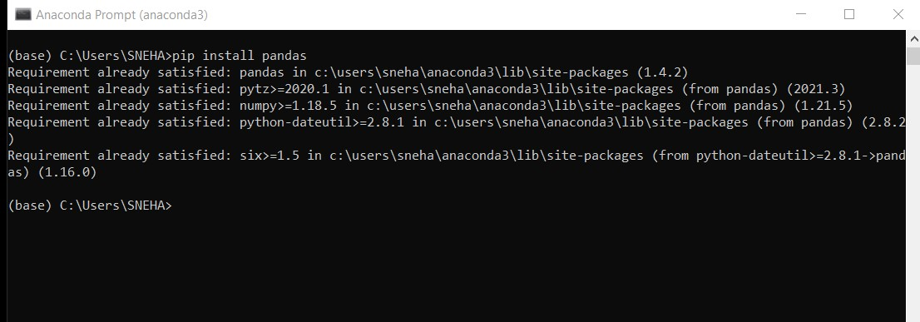

* Type “pip install scikit-learn” and click enter.

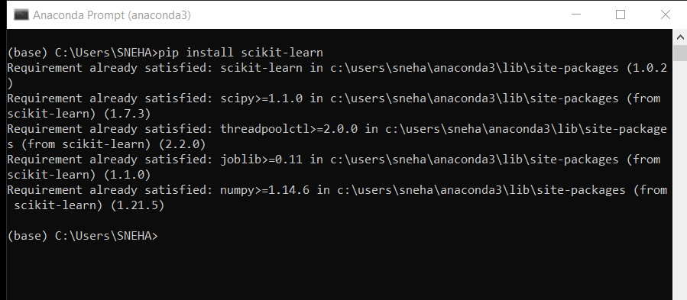

* Type “pip install tensorflow==2.3.0” and click enter.

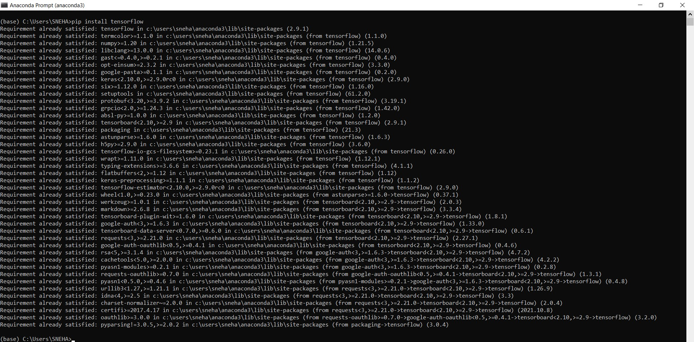

* Type “pip install keras==2.4.0” and click enter.

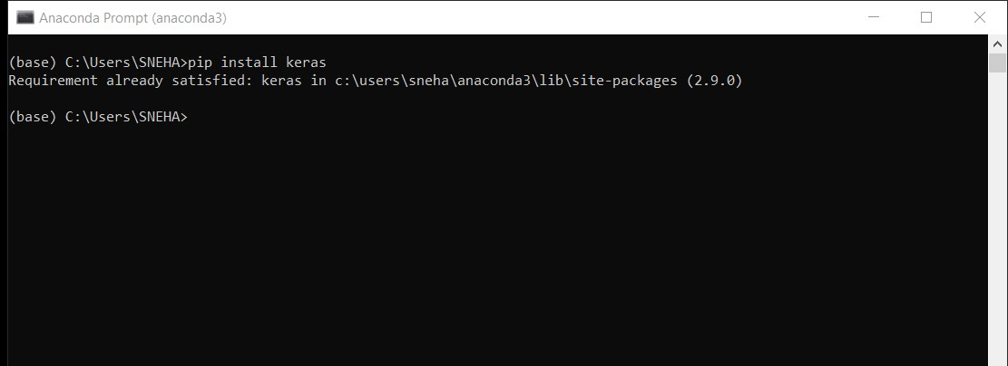

* Type “pip install Flask” and click enter

