**ASSIGNMENT-1**

HTML & PYTHON PROGRAMMING

|  |  |
| --- | --- |
| Assignment Date | 26 September 2022 |
| Student Name | K. Arul Selvi |
| Student Roll Number | 913319104005 |
| Maximum Marks | 2 Marks |

Question-1:

Create User table with user Time Table

Solutions:

<td></td>

</tr>

<tr>

<th>User 4</th>

<td></td>

<td></td>

<td></td>

<td></td>

</table><table border="1">

<tr>

<th></th>

<th> name</th>

<th> email</th>

<th>Roll number</th>

<th>Password</th>

</tr>

<tr>

<th>User 1</th>

<td></td>

<td></td>

<td></td>

<td></td>

</tr>

<tr>

<th>User 2</th>

<td></td>

<td></td>

<td></td>

<td></td>

</tr>

<tr>

<th>User 3</th>

<td></td>

<td></td>

<td></td>

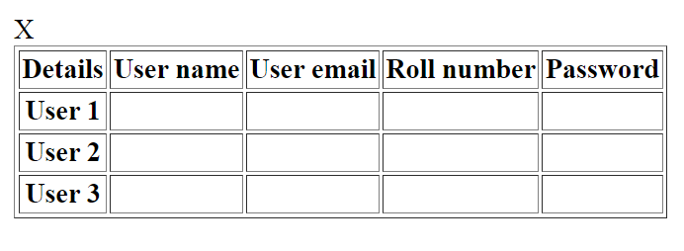

Question-2:

Perform UPDATE, DELETE Queries with user table.

Solution:

<div>

<h1>Update Data and Delete Data In HTML</h1>

<input type="hidden" id="id" />

<b>User name:</b><input type="text" id="firstName" /><br />

<b>User Email:</b><input type="text" id="lastName" /><br />

<b>Roll Number:</b><input type="text" id="city" /><br />

<b>Password:</b><input type="text" id="state" /><br />

<button onclick="UpdateData()">Update Data</button>

<button onclick="ClearData()">Clear</button>

<br />

<br />

<br />

<div id="details"></div>

</div>

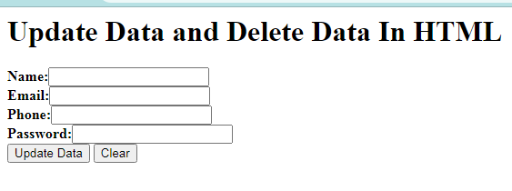

Question-3:

Connect python code to db2.

Solution:

dsn_driver = connection_data['dsn_driver']

dsn_database = connection_data['dsn_database']

dsn_hostname = connection_data['dsn_hostname']

dsn_port = connection_data['dsn_port']

dsn_protocol = connection_data['dsn_protocol']

dsn_uid = connection_data['dsn_uid']

dsn_pwd = connection_data['dsn_pwd']

dsn = (

"DRIVER={0};"

"DATABASE={1};"

"HOSTNAME={2};"

"PORT={3};"

"PROTOCOL={4};"

"UID={5};"

"PWD={6};").format(dsn_driver, dsn_database, dsn_hostname,

dsn_port, dsn_protocol, dsn_uid, dsn_pwd)

try:

connection = ibm_db.connect(dsn, "", "")

print("Connected to database: ", dsn_database,

"as user: ", dsn_uid, "on host: ", dsn_hostname)

return connection

except:

print("Unable to connect: ", ibm_db.

Question-4:

Create a flask app with registration page, login page and welcome page. By default load the registration page once the user enters all the fields store the data in database and navigate to login pageauthenticate user username and password. If the user is valid show the welcome page.

Solution:

<!-- Store this code in 'login.html' file inside the 'templates' folder -->

<html>

<head>

<meta charset="UTF-8">

<title> Login </title>

<link rel="stylesheet" href="{{ url_for('static', filename='style.css') }}">

</head>

<body></br></br></br></br></br>

<div align="center">

<div align="center" class="border">

<div class="header">

<h1 class="word">Login</h1>

</div></br></br></br>

<h2 class="word">

<form action="{{ url_for('login') }}" method="post">

<div class="msg">{{ msg }}</div>

<input id="username" name="username" type="text" placeholder="Enter Your Username"

class="textbox"/></br></br>

<input id="password" name="password" type="password" placeholder="Enter Your

Password" class="textbox"/></br></br></br>

<input type="submit" class="btn" value="Sign In"></br></br>

</form>

</h2>

<p class="bottom">Don't have an account? <a class="bottom" href="{{url_for('register')}}"> Sign

Up here</a></p>

</div>

</div>

</body> </html>

Solution 1:

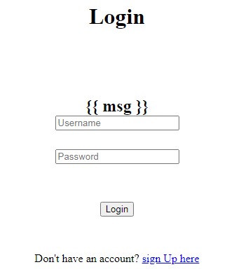

Solution 2:

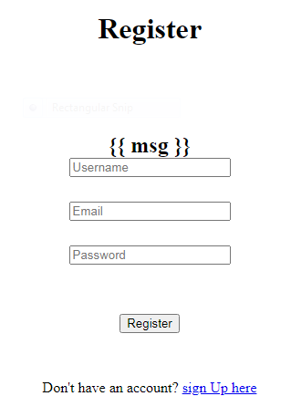

Solution 3:

