**IBM Cloud Service**

|  |  |
| --- | --- |
| Date | 19 November 2022 |
| Team ID | PNT2022TMID47580 |
| Project Name | Smart Solutions for Railways |

**Python IDLE :**

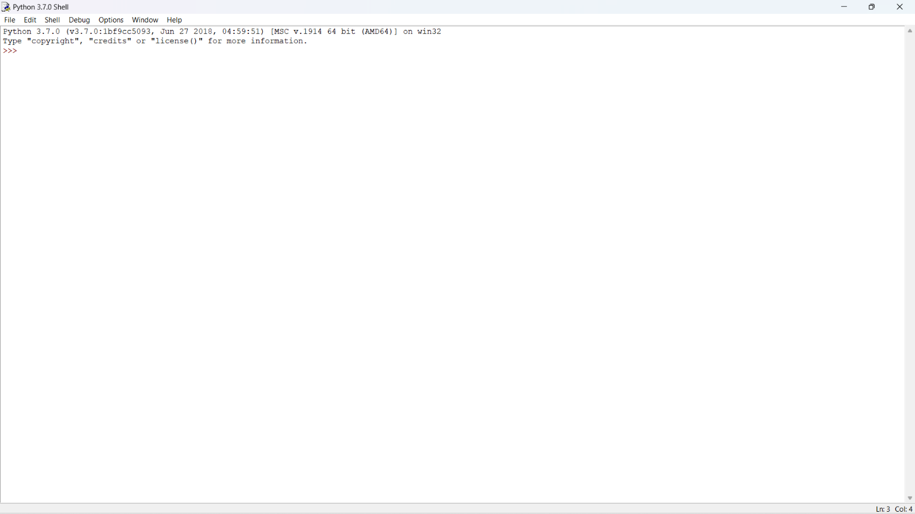

**wiotp-sdk:**

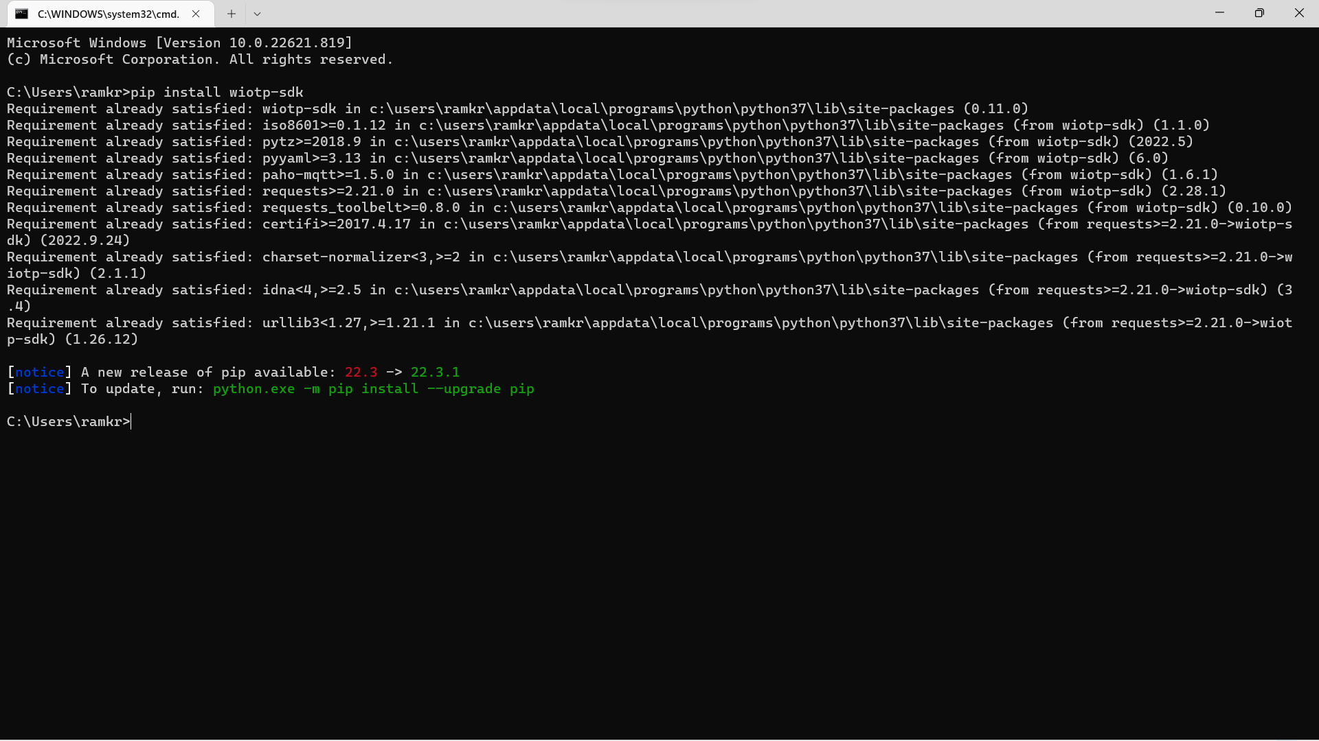

**ibmcloudant:**

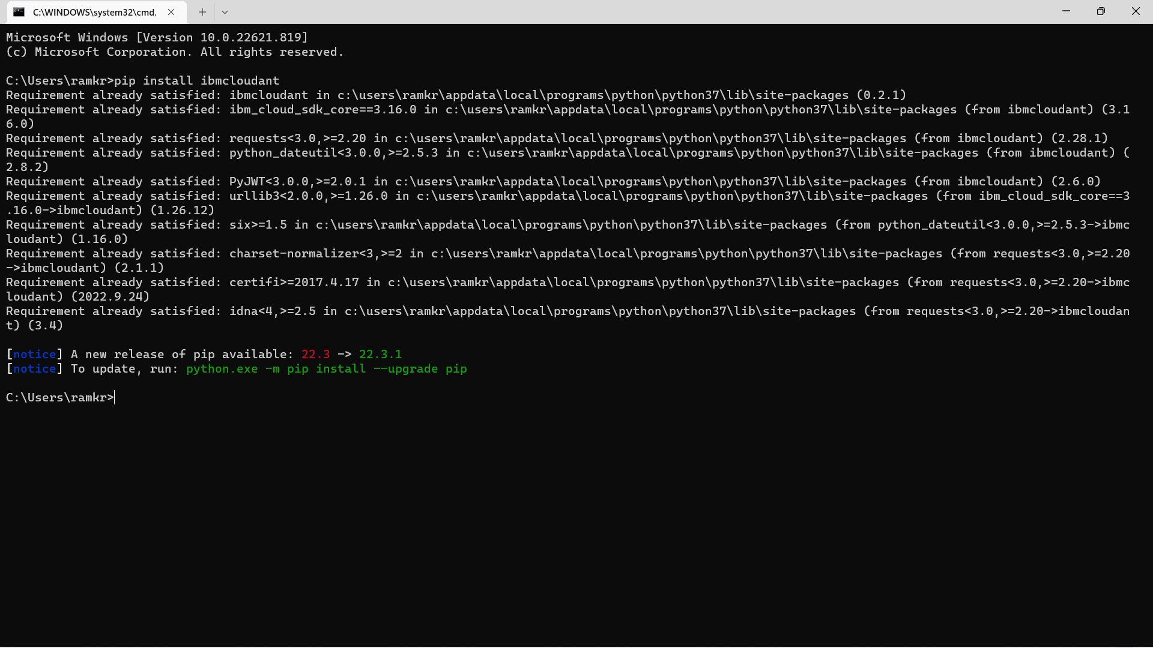

**Opencv-python:**

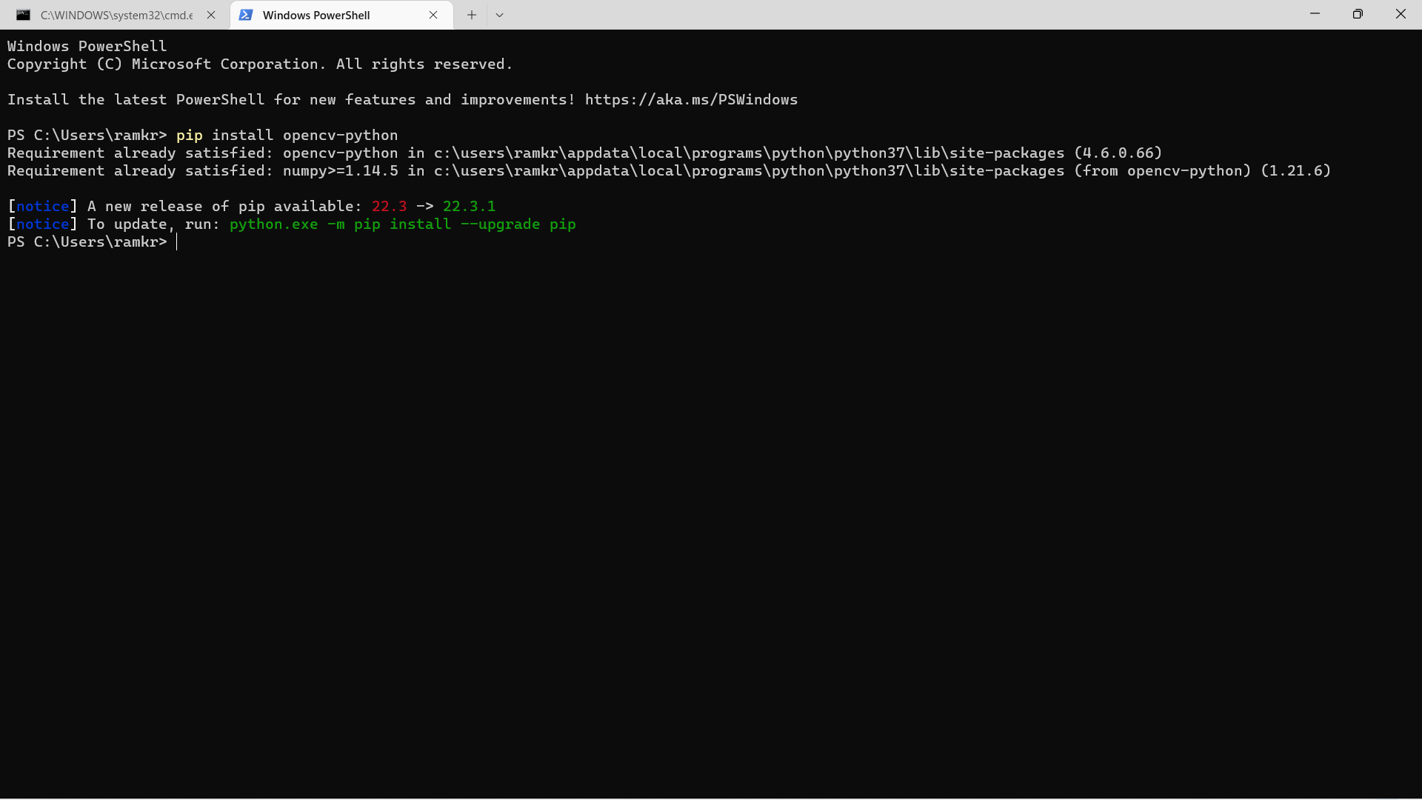**pyzbar:**

