**Ideation:**

Plasma Donor Application is a blood donation app that connects potential donors to patients in need of blood. It makes reaching out to potential donors simple and helps people to become voluntary donors. In addition, donors can track the impact of their donations and create awareness around blood donation.

Every human being requires blood; hence it is essential to all human life and the world over. This seems obvious because blood constitutes approximately 8 percent of body weight, and the average male’s volume is between 5 -6 litres, and in the average female is between 4–5 litres.

A donor who wants to donate plasma can simply upload their recovered medical certificate and can donate the plasma to a blood bank. The blood bank after checking the donor certificate can make a request to the donor when the donor accepts the request, they can add the required number of units they need. The hospital can send a request to the blood bank that needs the patient's emergency plasma and to get the plasma from the blood bank.

The Planned system consists of the subsequent modules:

* Android Application: This component is used to maintain feasibility of the user. By using this component user can able to easily access the data related to the path labs, hospitals, tests, etc. It provides user interface and increases the portability of the user.
* Cloud: This is the second component of three tier architecture. It includes server and Database and handles them in cloud. Server plays the main role in the overall system as the whole authentication is done by server only and it also include the whole database.
* Client Portal: It is the third component of three tier architecture. As the system is able to provide the path labs then the client portal helps to register themselves with the system.

**Data Flow:**

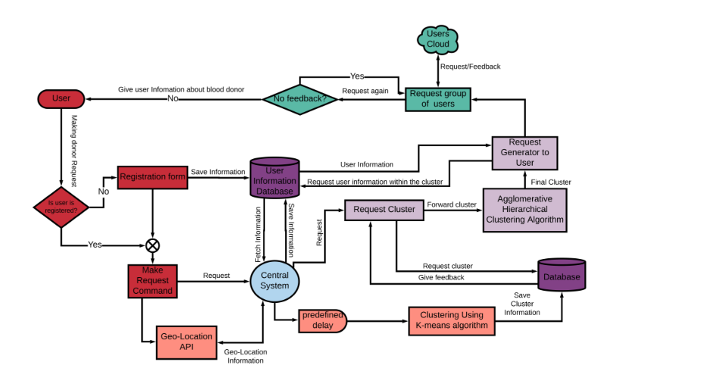

**Flow Diagram:**

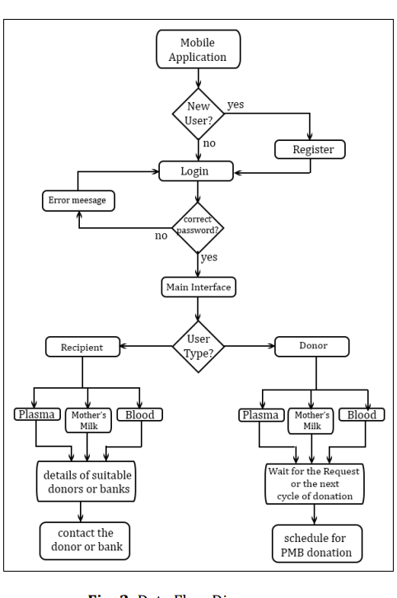

**Application Overview:**

