**IBM-Project-41969-1660646664**

Personal Expense Tracker Application

Team ID: PNT2022TMID45814

Team Leader: KAVIYA B

Team Member 1:PRIYA S

Team Member 2: THEERTHANA K

Team Member 3: PRIYADHARSHINI K

**Introduction**

When it comes to tracking expenses, you can make your system as simple as collecting receipts and organizing them once a month.

You might get a little more information from other expense tracking systems (listing them in a spreadsheet, using money management software or even choosing an online application), but all methods have one thing in common: you have to get in the habit of thinking about your expenses.

It’s very easy to misplace a receipt or forget about any cash you spent. You may even think that a cup of coffee or a trip to the vending machine isn’t worth tracking — although those little expenses can add up amazingly fast.

There are all sorts of opportunities to throw a kick into your plan to track expenses. You have to get in the habit of doing so, to reduce those lapses, and make sure that the data you’re basing financial decisions on is solid.

This project will request the clients to add their expenses and in view of their costs ,wallet status will be refreshed which will be noticeable to the client.

**Motivation**

Many people in India live on a fixed income, and they find that towards the end of the month they don’t have sufficient money to meet their needs. While this problem can arise due to low salary, invariably it is due to poor money management skills

Using a daily expense tracker can help you keep track of how much you spend every day and on what. At the end of the month, we will have a clear picture of where our money is going

This project will request the clients to add their expenses and in view of their costs ,wallet status will be refreshed which will be noticeable to the client

**Project Workflow**

* The user interacts with the application.
* Application will ask users to add their expenses and based on their expenses wallet balance will be updated which will be visible to the user.
* Also, users can get an analysis of their expenditure in graphical forms.
* They have an option to set a limit for the amount to be used for that particular month if the limit is exceeded the user will be notified with an email alert
* Setting up Application Environment
  + Create Flask project
  + Work with IBM Cloud CLI, Docker CLI, Sendgrid
* Implementation of Web Application
  + Create UI to Interact with the application
  + Connect IBM DB2 with Python
* Integration of Sendgrid Service with Python
* Deployment of Cloud Application
  + Containerize the application
  + Upload Image in IBM container directory
  + Deploy on Kubernetes Cluster

**Objective**

* Help the people to track their expenses.
* Alert users when they exceed the limit of their budget.
* A personal finance app will not only help you with budgeting and accounting but also give you helpful insights about financial management

**Technical Architecture**

[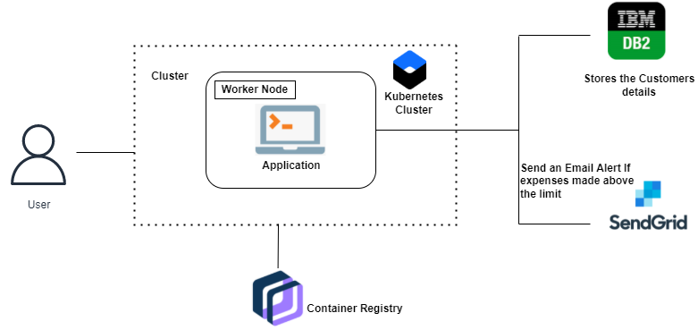](https://user-images.githubusercontent.com/78342430/190962811-1d95e7be-92c5-4f7a-8e4a-e6991ea12449.png)