Project Design Phase-II
Data Flow Diagram & User Stories
Date | 15 October 2022
Team ID | PNT2022TMID40190
Project Name | Web Phishing Detection
Maximum Marks | 4 Marks

Data Flow Diagrams:
A Data Flow Diagram (DFD) is a traditional visual representation of the information flows within a system. A neat and clear DFD can depict the right amount of the system requirement graphically. It shows how data enters and leaves the system, what changes the information, and where data is stored.
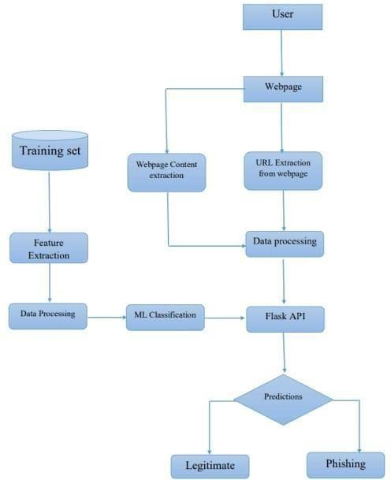
User Stories
User Type | Functional Requirement (Epic) | User Story Number | User Story / Task | Acceptance criteria | Priority | Release
Customer (Mobile user) | Registration | USN-1 | As a user, I can register for the application by entering my User Id, password, confirming my password and other personal details | I can access my account / dashboard | High | Sprint-1
 |  | USN-2 | As a user, I will receive confirmation email once I have registered for the application | I can receive confirmation email & click confirm | High | Sprint-1
 |  | USN-3 | As a user, I can register for the application through Facebook | I can register & access the dashboard with Facebook Login | Low | Sprint-2
 |  | USN-4 | As a user, I can register for the application through Gmail | I can register & access the dashboard with Gmail Login | Medium | Sprint-1
 | Login | USN-5 | As a user, I can log into the application by entering User id & password |  | High | Sprint-1
 | Dashboard | USN-6 | As a user, I can easily navigate through dashboard and I can use the dashboard to get details about app and instruction to use the app. | Using dashboard i can easily access the application. | High | Sprint-1
Customer (Web user) | Login & Dashboard | USN-7 | As a web user, I can login into application by using my User id and password. I can access all resources same as mobile users. | I can login to the application using the same User id and password to access the resource. | High | Sprint-1
Customer Care Executive | Login | CCE1 | As a CCE I can login to application using User id & Password and I can interact with user. | I can login using my mail and password | High | Sprint-1
 | Dasshboard | CCE-2 | As a CCE I can access dashboard using User id and Password. I can see all user queries, explain app usage and rectify user queries. | I can login using my User id and password | High | Sprint-1
Administrator | Login and Dashboard | A-1 | As an administrator, I can login and access dashboard and manage and direct activities | I can login using my User id and Password | High | Sprint-1

