1. INTRODUCTION

1.1 Project Overview

Phishing is one of the most severe cyber-attacks where researchers are interested to find a solution. In phishing, attackers lure end-users and steal their personal in-formation. To minimize the damage caused by phishing must be detected as early as possible. There are various phishing attacks like spear phishing, whaling, vishing, smishing, pharming and so on. There are various phishing detection techniques based on white-list, black-list, content-based, URL-based, visual-similarity and machine-learning. In this paper, we discuss various kinds of phishing attacks, attack vectors and detection techniques for detecting the phishing sites.

1.2 Purpose

In order to detect and predict e-banking phishing websites, we proposed an intelligent, flexible and effective system that is based on using classification algorithms. We implemented classification algorithms and techniques to extract the phishing datasets criteria to classify their legitimacy. The e-banking phishing website can be detected based on some important characteristics like URL and domain identity, and security and encryption criteria in the final phishing detection rate. Once a user makes a transaction online when he makes payment through an e-banking website our system will use a data mining algorithm to detect whether the e-banking website is a phishing website or not.

2. LITERATURE SURVEY

2.1 Existing Problem

2.1.1 Protecting user against phishing using Antiphishing: -

Anti Phish is used to avoid users from using fraudulent web sites which in turn may lead to phishing attack. Here, AntiPhish traces the sensitive information to be filled by the user and alerts the user whenever he/she is attempting to share his/her information to a untrusted web site. The much effective elucidation for this is cultivating the users to approach only for trusted websites. However, this approach is unrealistic. Anyhow, the user may get tricked. Hence, it becomes mandatory for the associates to present such explanations to overcome the problem of phishing. Widely accepted alternatives are based on the creepy websites for the identification of “clones” and maintenance of records of phishing websites which are in hit list.

2.1.2 Learning to Detect Phishing Emails:

An alternative for detecting these attacks is a relevant process of reliability of machine on a trait intended for the reflection of the besieged deception of user by means of electronic communication. This approach can be used in the detection of phishing websites, or the text messages sent through emails that are used for trapping the victims. Approximately, 800 phishing mails and 7,000 nonphishing mails are traced till date and are detected accurately over 95% of them along with the categorization on the basis of 0.09% of the genuine emails. We can just wrap up with the methods for identifying the deception, along with the progressing nature of attacks .

2.1.3 Phishing detection system for e-banking using fuzzy data mining: -

Phishing websites, mainly used for e-banking services, are very complex and dynamic to be identified and classified. Due to the involvement of various ambiguities in the detection, certain crucial data mining techniques may prove an effective means in keeping the e-commerce websites safe since it deals with considering various quality factors rather than exact values. In this paper, an effective approach to overcome the “fuzziness” in the e-banking phishing website assessment is used an intelligent resilient and effective model for detecting e-banking phishing websites is put forth. The applied model is based on fuzzy logics along with data mining algorithms to consider various effective factors of the e-banking phishing website.

2.1.4 Collaborative Detection of Fast Flux Phishing Domains:-

Here, two approaches are defined to find correlation of evidences from multiple servers of DNS and multiple suspects of FF domain. Real life examples can be used to prove that our correlation approaches expedite the detection of the FF domain, which are based on an analytical model which can quantify various DNS queries that are required to verify a FF domain. It also shows implementation of correlation schemes on a huge level by using a distributed model, that is more scalable as compared to a centralized one, is publish N subscribe correlation model known as LARSID. In deduction, it is quite difficult to detect the FF domains in a accurate and timely manner, as the screen of proxies is used to shield the FF Mother ship. A theoretical approach is used to analyze the problem of FF detection by calculating the number of DNS queries required to get back a certain amount of unique IP addresses

2.1.5 A Prior-based Transfer Learning Method for the Phishing Detection: -

A logistic regression is the root of a priority based transferrable learning method, which is presented here for our classifier of statistical machine learning. It is used for the detection of the phishing websites depending on our selected characteristics of the URLs. Due to the divergence in the allocation of the features in the distinct phishing areas, multiple models are proposed for different regions. It is almost impractical to gather enough data from a new area to restore the detection model and use the transfer learning algorithm for adjusting the existing model. An appropriate way for phishing detection is to use our URLbased method. To cope with all the prerequisites of failure of detecting characteristics, we have to adopt the transferring method to generate a more effective model

2.2 Reference

[1]. “Protecting Users Against Phishing Attacks with AntiPhish” Engin Kirda and Christopher Kruegel Technical University of Vienna
[2]. “Learning to Detect Phishing Emails” Ian Fette School of Computer Science Carnegie Mellon University Pittsburgh, PA, 15213, USA icf@cs.cmu.edu Norman Sadeh School of Computer Science Carnegie Mellon University Pittsburgh, PA, 15213, USA Anthony Tomasic School of Computer Science Carnegie Mellon University Pittsburgh, PA, 15213, USA
[3]. Modeling and Preventing Phishing Attacks by Markus Jakobsson, Phishing detection system for e -banking using fuzzy data mining by Aburrous, M. ; Dept. of Comput., Univ. of Bradford, Bradford, UK ; Hossain, M.A. ; Dahal, K. ; Thabatah, F.
[4] M. Chandrasekaran, et al., ”Phishing email detection based on structural properties”, in New York State Cyber Security Conference (NYS) , Albany, NY ,” 2006
[5] P. R. a. D. L. Ganger, ”Gone phishing: Evaluating anti-phishing tools for windows. Technical report, ,” September 2006
[6] M. Bazarganigilani, ”Phishing E-Mail Detection Using Ontology Concept and Nave Bayes Algorithm,” International Journal of Research and Reviews in Computer Science, vol. 2,no.2, 2011.
[7] M. Chandrasekaran, et al., ”Phoney: Mimicking user response to detect phishing attacks,” in In: Symposium on World of Wireless, Mobile and Multimedia Networks, IEEE Computer Society, 2006, pp. 668-672
[8] I. Fette, et al., ”Learning to detect phishing emails,” in Proc. 16th International World Wide Web Conference (WWW 2007), ACM Press, New York, NY, USA, May 2007, pp. 649-656
[9] A. Bergholz, et al., ”Improved phishing detection using model-based features,” in Proc. Conference on Email and Anti-Spam (CEAS). Mountain View Conf, CA, aug 2008
[10] L. Ma, et al.,”Detecting phishing emails using hybrid features,”IEEE Conf, 2009, pp. 493-497

2.3 Problem Statement Definition

Phishing is a fraudulent technique that is used over the internet to manipulate user to extract their personal information such as Username, Passwords, Credit Cards, Bank Account information etc. Phishing use multiple methods, including E-mail, Uniform Resource Locators(URL’s), Instant messages, Form posting, Telephone calls and Text messages to steal user information. Many cypher infiltrations are accomplished through phishing attacks where user are tricked into interacting with web pages that appear to be legitimate. This project aim tto develop these methods of defense utilizing various approaches to categorising Websites and narrow them down to the best Machine Learning algorithm by comparing the accuracy rate, false positive and false negative rate of each algorithm.

3. IDEATION & PROPOSED SOLUTION
3.1 Empathy Map Canvas

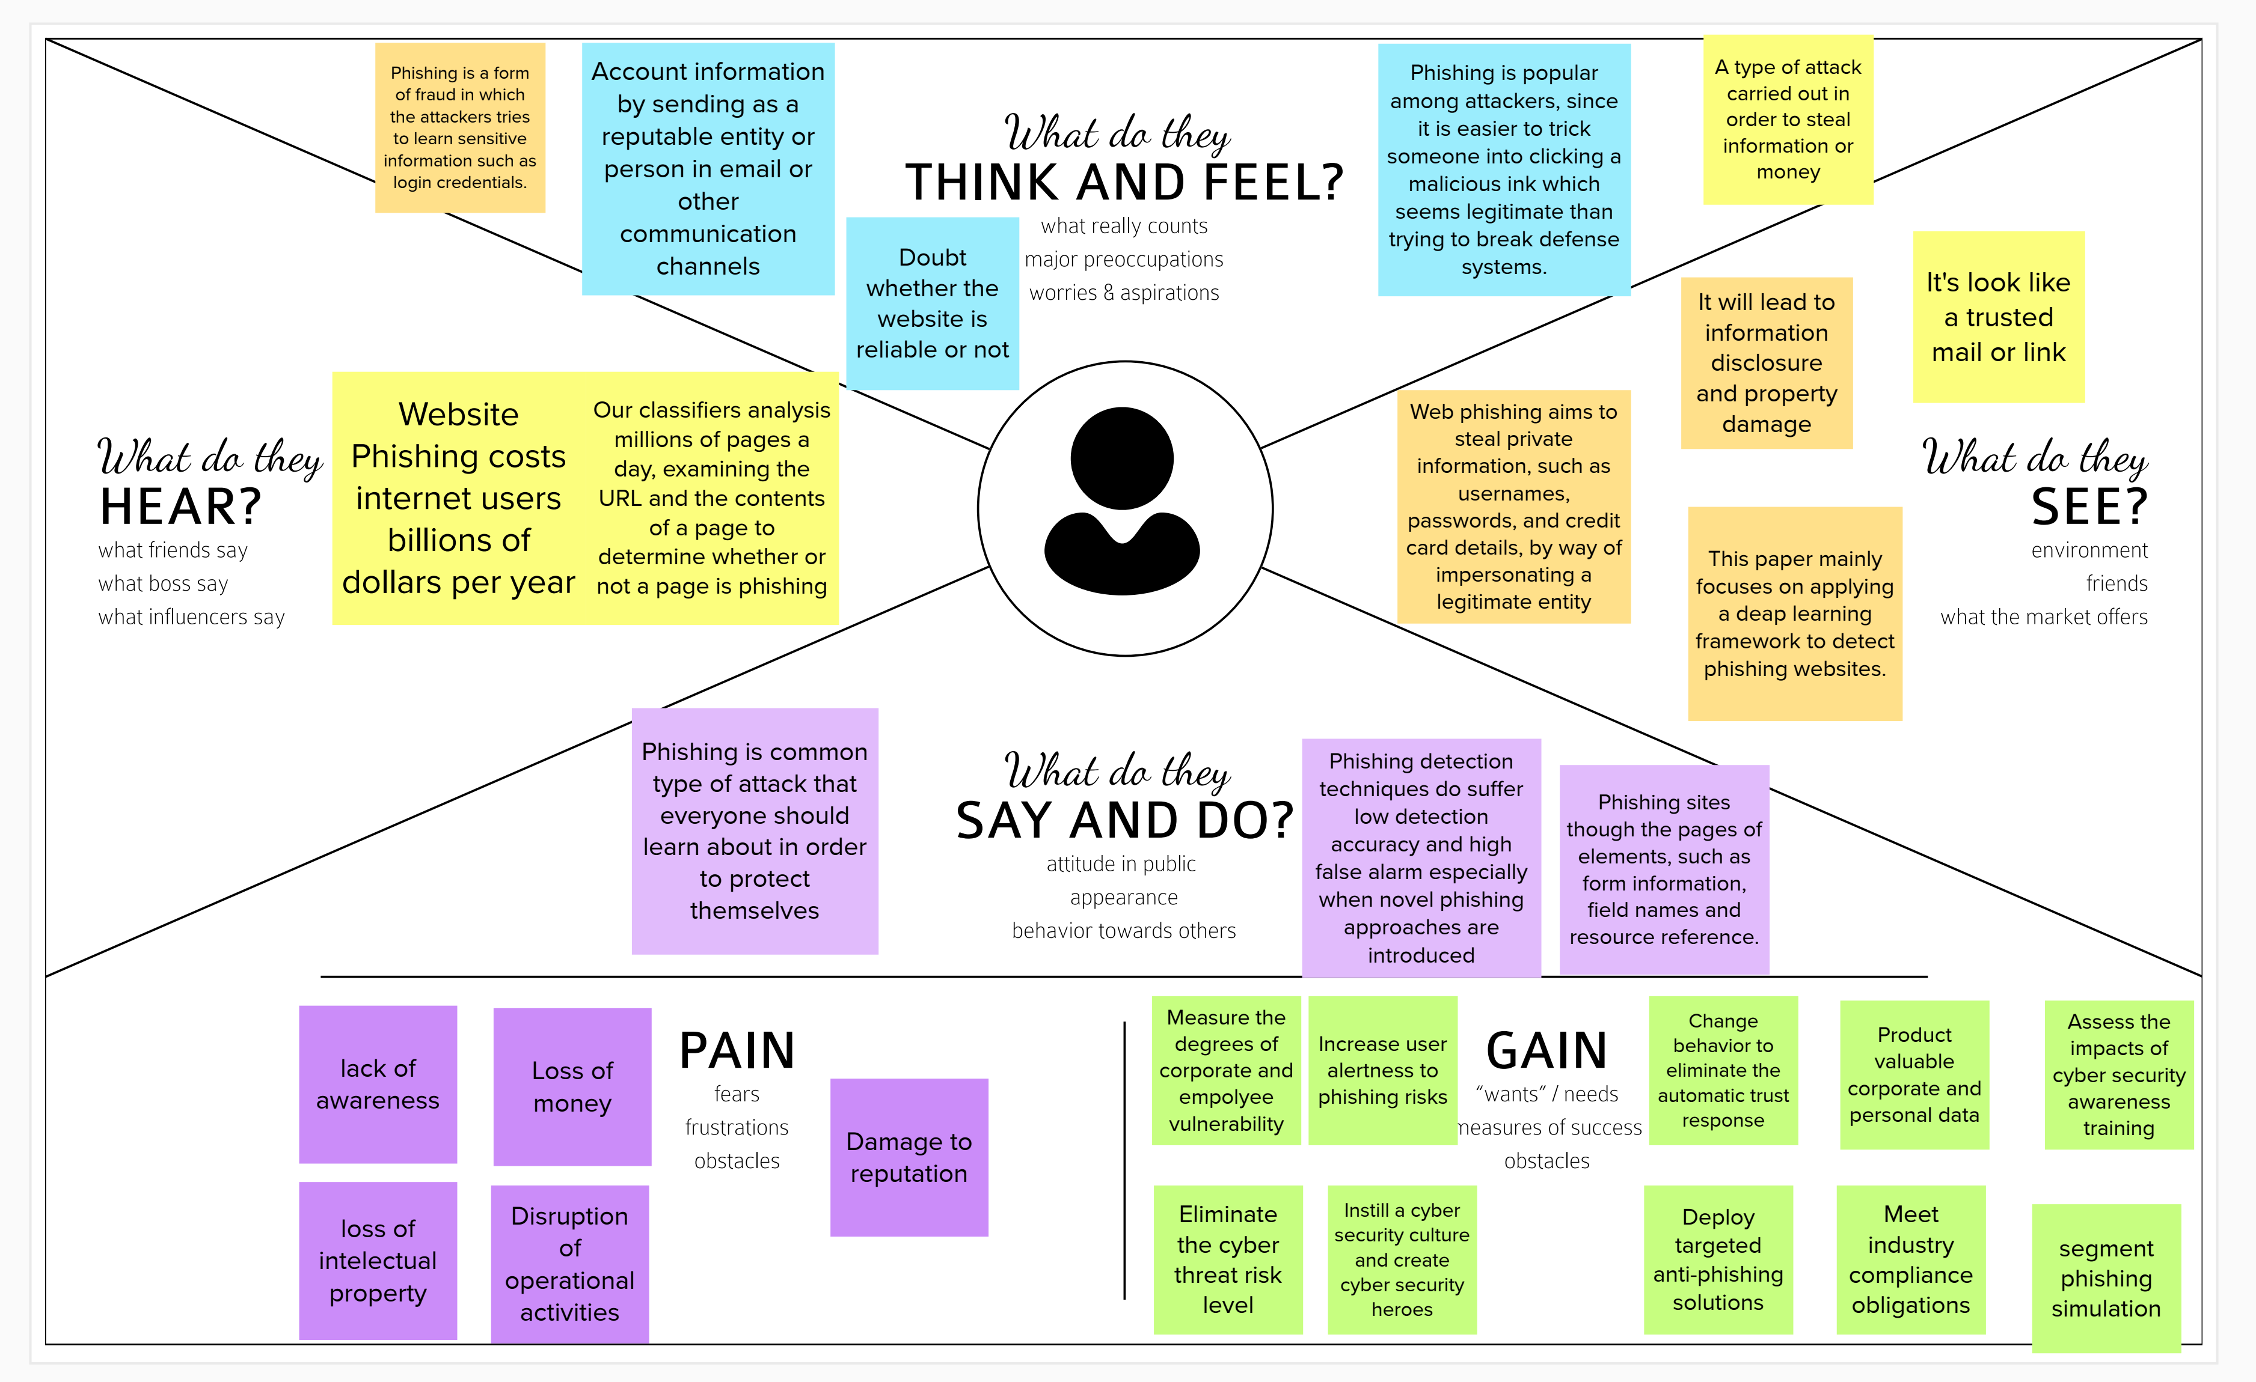

3.2 Ideation & Brainstorming

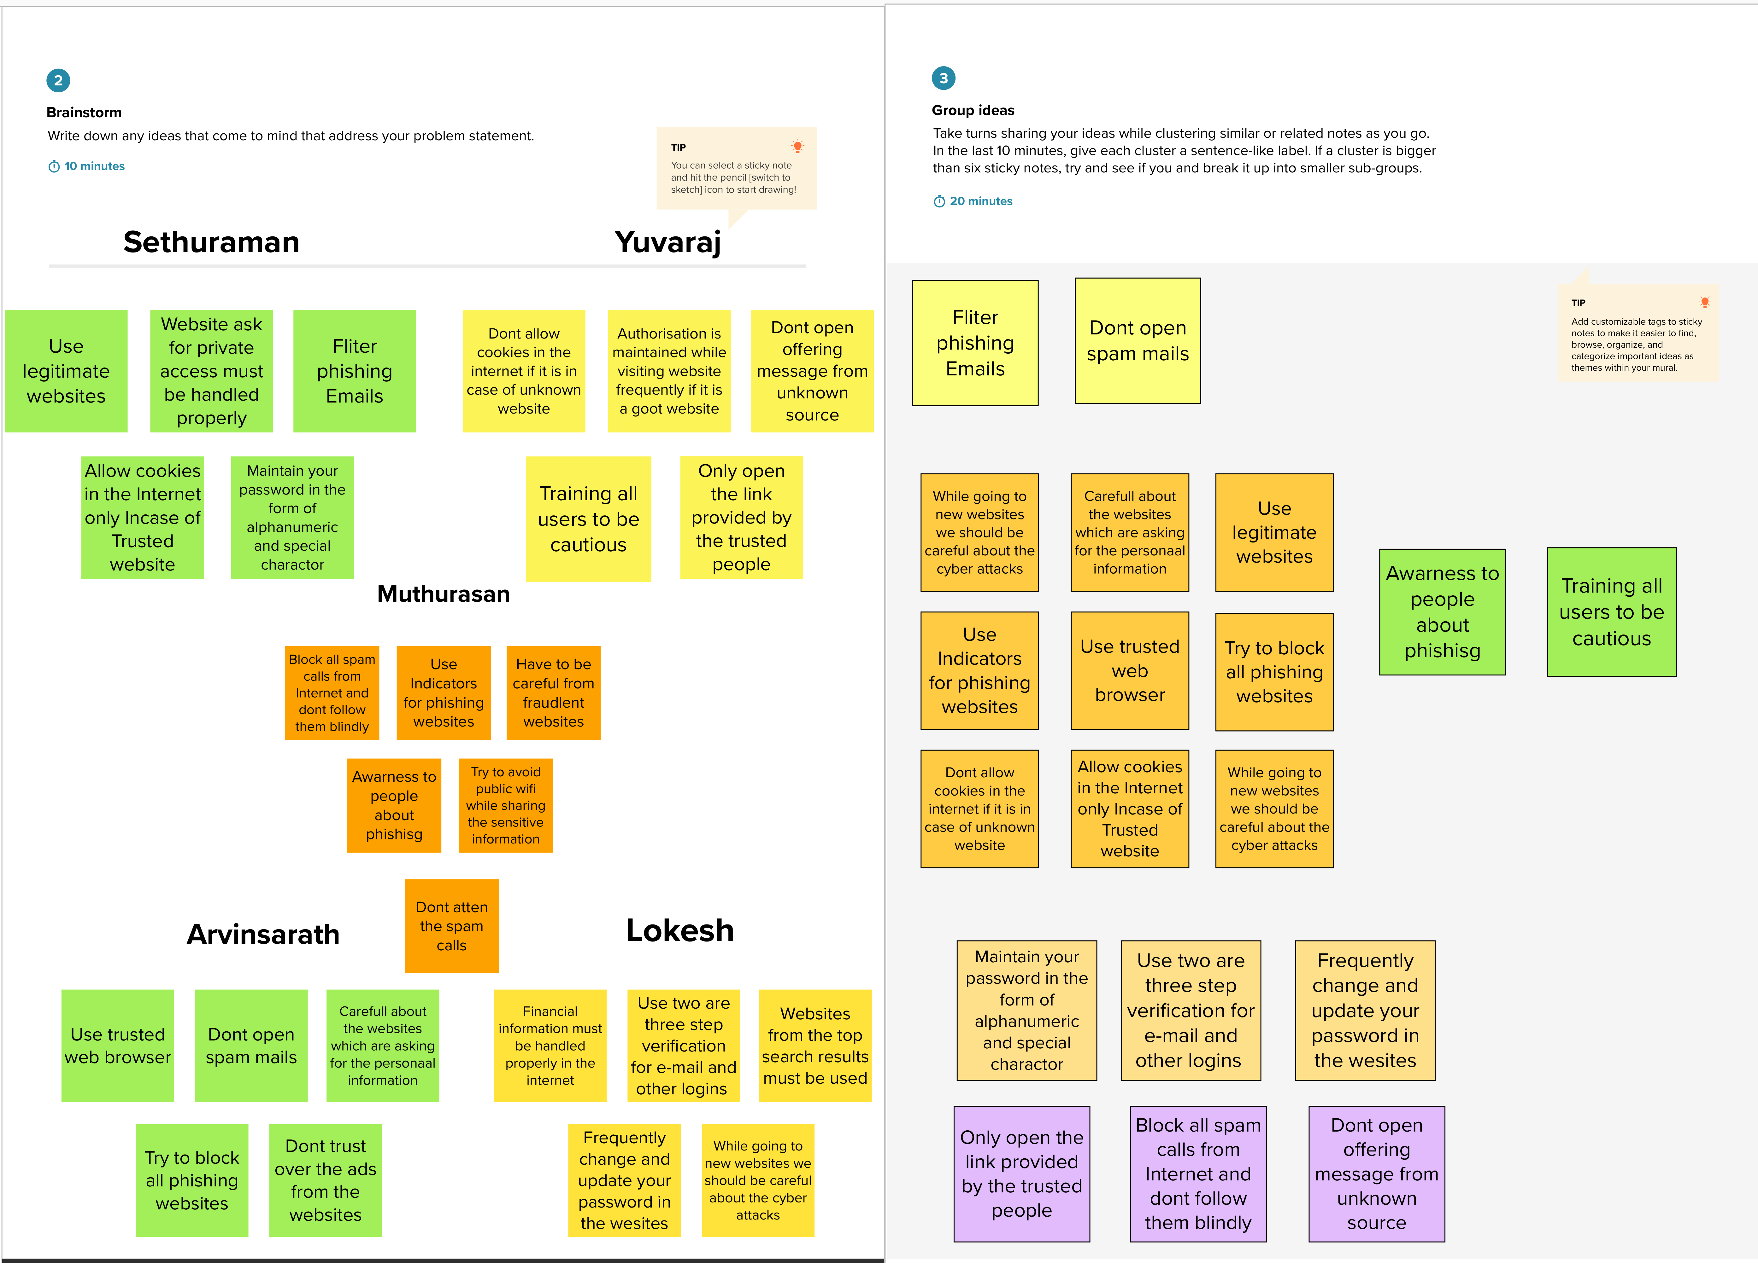

3.3 Proposed Solution

S.No | Parameter | Description
1. | Problem Statement (Problem to be solved) | Phishing is a fraudulent technique that is used over the internet to manipulate user to extract their personal information such as Username, Passwords, Credit Cards, Bank Account information etc.Phishing use multiple methods, including E-mail, Uniform Resource Locators(URL’s), Instant messages, Form posting, Telephone calls and Text messages to steal user information. Many cypher infiltrations are accomplished through phishing attacks where user are tricked into interacting with web pages that appear to be legitimate. This project aim tto develop these methods of defense utilizing various approaches to categorising Websites and narrow them down to the best Machine Learning algorithm by comparing the accuracy rate, false positive and false negative rate of each algorithm.
2. | Idea / Solution description | This project aim to develop these methods of defense utilizing various approaches to categorising Websites and narrow them down to the best Machine Learning algorithm by comparing the accuracy rate, false positive and false negative rate of each algorithm.To find unknown malicious urls copared to the blacklist approach. And Use anti-phishing protection and anti-spam software to protect yourself.
3. | Novelty / Uniqueness | Our model uses the power of Machine learning to detect phishing sites. Python serves as a powerful tool to execute the application with Low false positives, High accuracy. Uses the latest techniques that gives an efficient and great performance. It can easily differentiate the fake and safe URL’s. If it’s fake means, a warning message will be intimate to the users.
4. | Social Impact / Customer Satisfaction | According to recent research by Google, these was a 4505 increase in phishing websites from January to March 2021. Phishing has a list of negative effects on a business, including loss of money, loss of intellectual property, damage to reputation, and disruption of operational activities. As an impact of this model, people can able to find fraudulent websites of fake ones. So that, they can avoid sharing sensitive data with unrecognized websites.
5. | Business Model (Revenue Model) | Our model can be used by all user’s to secure their data from malicious websites. It’s an open source tool.
6. | Scalability of the Solution | A-part from E-Banking sector the idea proposed can be developed into platfrom independent model. Adapts to all sort of web application and ease of preventing users from scam.

3.4 Problem Solution fit

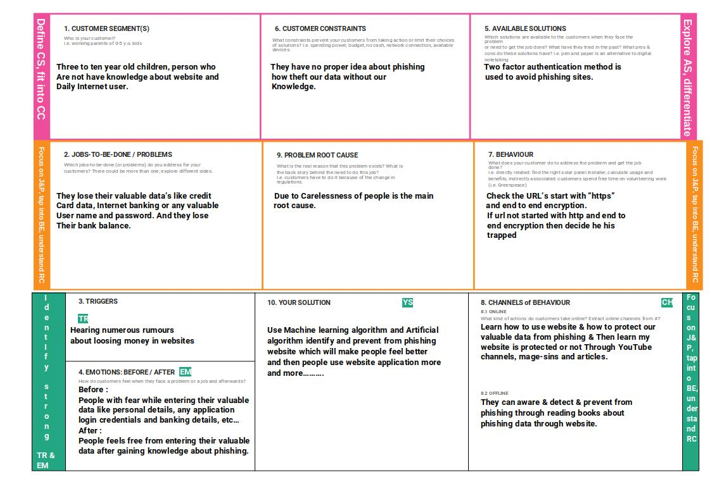
4. REQUIREMENT ANALYSIS
4.1 Functional requirement

Following are the functional requirements of the proposed solution.
FR No. | Functional Requirement (Epic) | Sub Requirement (Story / Sub-Task)
FR-1 | User Input | User input an URL to chech it is legal or phishing site.
FR-2 | Website Comparison | Model comparing the entered URL with the help of Blacklist and Whitelist.
FR-3 | Feature extraction | After comparing, if none found on comparison the it extracts feature using heuristic and visual similarity approach.
FR-4 | Prediction | Model Predicts the URL using Machine Learning algorithm such as Logistic Regression, KNN.
FR-5 | Classifier | Model sends output to classifier and it produce final result.
FR-6 | Announcement | Model the displays whether the website is a legal or phishing site.
FR-7 | Events | Model needs the capability of reetrieving and displaying accurate result for a website.

4.2 Non-Functional requirements

Following are the non-functional requirements of the proposed solution.
FR No. | Non-Functional Requirement | Description
NFR-1 | Usability | A set of specifications that describe the system’s operation capabilities and constraints and attempt to improve its functionality.
NFR-2 | Security | Assuring all data inside the system or its part will be protected against malware attacks or unauthorized access.
NFR-3 | Reliability | This approach gives more accuracy then existing system.
NFR-4 | Performance | Parameters for the proposed system gives accurate predicted value which is compared to the existing system.
NFR-5 | Availability | The system is accessible by user at any time using web browser.
NFR-6 | Scalability | The design will be suitable and performs with full efficieny according to rising demands.

5. PROJECT DESIGN
5.1 Data Flow Diagrams

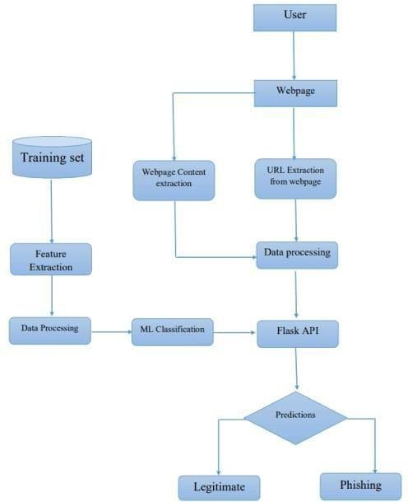

5.2 Solution & Technical Architecture

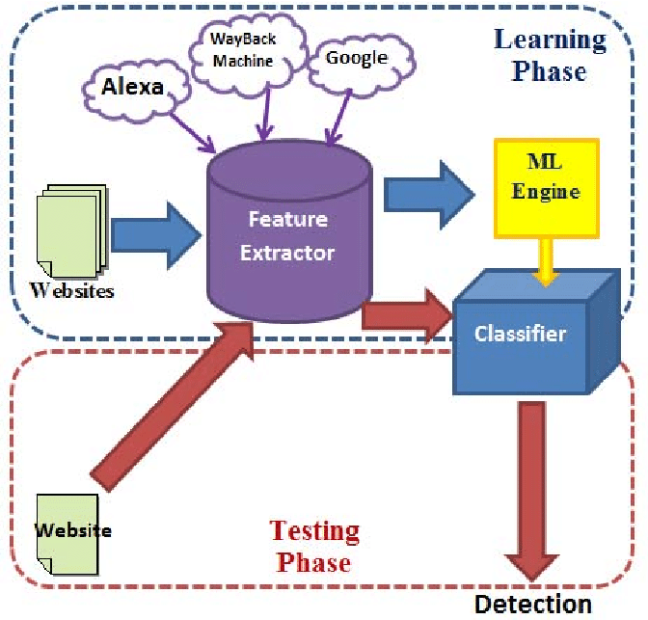

5.3 User Stories

User Type | Functional Requirement (Epic) | User Story Number | User Story / Task | Acceptance criteria | Priority | Release
Customer (Web user) | Dashboard | USN-1 | As a user, I can easily navigate through dashboard and I can use the dashboard to get details about app and instruction to use the app. | Using dashboard i can easily access the application. | High | Sprint-1
 | Url prediction and Result page | CCE-2 | As a user, i can able to enter the URL to predict and View the corresponding result to that entered URL. | I can enter the URL and able to view the result | High | Sprint-2
 | Add URL and Experience page and About page | USN-3 | As a user, i can share my perviously experienced Phishing site and View about page of the website | I can add or enter experience and submit it | High | Sprint-3
Model Buliding | Prediction of Phishing sites | M-1 | As an User, I can enter the url and Predict it as a Phishing site or not. | I can predict the URL is bad or good | High | Sprint-4
Model Testing | Testing of Model is worked as properly | MT-1 | If the model Predict the URL as Phishing site or not with accuracy rate above 95%. |  | High | Sprint-4

6. PROJECT PLANNING & SCHEDULING
6.1 Sprint Planning & Estimation

Sprint | Functional Requirement (Epic) | User Story Number | User Story / Task | Story Points | Priority | Team Members
Sprint-1 | Home Page | USN-1 | As a user, i can access the home page content | 2 | Medium | Lokesh V
Sprint-2 | Url prediction and Result page | USN-2 | As an User, I can enter the url and Predict it as a Phishing site or not. |  | High | Arvinsarath
Sprint-3 | Add URL and Experience page and About page | USN-3 | As an administrator, I can login and access the Experience form submitted by user. | 1 | High | Yuvaraj & mutharasan
Sprint-4 | Model Buliding and Model Testing | MB/MT -1 | If the model Predict the URL as Phishing site or not with accuracy rate above 95%. | 2 | High | Lokesh v & sethuraman
6.2 Sprint Delivery Schedule

Sprint | Total Story Points | Duration | Sprint Start Date | Sprint End Date (Planned) | Story Points Completed (as on Planned End Date) | Sprint Release Date (Actual)
Sprint-1 | 20 | 6 Days | 24 Oct 2022 | 29 Oct 2022 | 20 | 29 Oct 2022
Sprint-2 | 20 | 6 Days | 31 Oct 2022 | 05 Nov 2022 | 20 | 06 Nov 2022
Sprint-3 | 20 | 6 Days | 07 Nov 2022 | 12 Nov 2022 | 20 | 12 Nov 2022
Sprint-4 | 20 | 6 Days | 14 Nov 2022 | 19 Nov 2022 | 20 | 18 nov 2022

6.3 Reports from JIRA

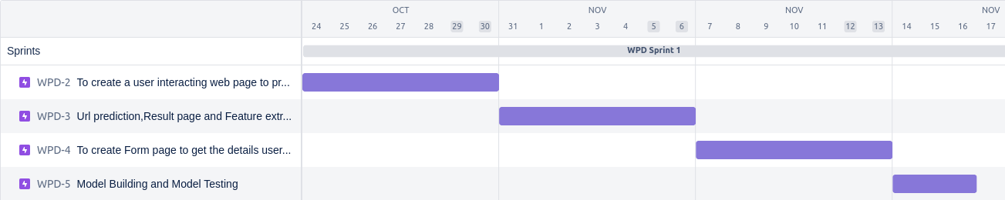

7. CODING & SOLUTIONING
7.1 Feature 1
7.2 Feature 2
7.3 Database Schema

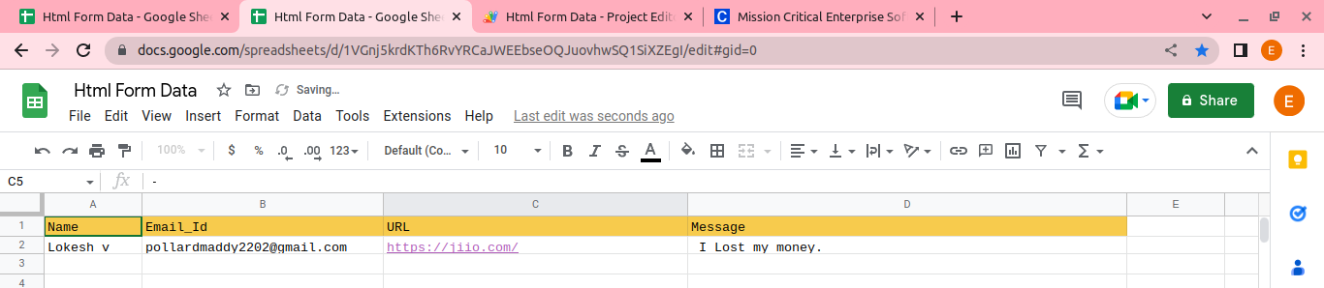

8. TESTING
8.1 Test Cases

Test Case ID | Test Case Description | Test Steps
TC01 | Check Predict button is rooted to Prediction page | In home page, Click Prediction URL button.
TC02 | In Prediction Page, Check prediction of url is done or not. | In prediction page,  1. Enter Url  2. Then press Prediction Button to predict URL
TC03 | In Prediction output page, check the “Predict another URL” button. | In result page, press Predict another URL button.
TC04 | In, Prediction Page, Check Prediction is done in positive and negative. | In prediction page,  1.Enter URL for good site and bad site.  2.then press Predict button.
TC05 | Check User experience form is submitted in google form or not. | In add URL page,  1.Enter the Rrequired fields.  2.press submit button.
TC06 | Check About button root to About page. | Press about button.
TC07 | Check project Details button root’s to Project details button. | Press Project details button
TC08 | Check all buttons are working properly or not | Press all button and check it root’s to corresponding page or not.

8.2 User Acceptance Testing

8.2.1 Purpose of Document
This document is to briefly explain the test coverage and open issues of the Web Phishing Detection project at the time of the release to User Acceptance Testing (UAT).

8.2.2 Defect Analysis
This report shows the number of resolved or closed bugs at each severity level, and how they were resolved
Resolution | Severity 1 | Severity 2 | Severity 3 | Severity 4 | Subtotal
By Design | 8 | 4 | 2 | 3 | 17
Duplicate | 1 | 0 | 3 | 0 | 4
External | 0 | 3 | 0 | 1 | 4
Fixed | 9 | 2 | 4 | 15 | 30
Not Reproduced | 0 | 0 | 1 | 0 | 1
Skipped | 0 | 0 | 1 | 1 | 2
Won't Fix | 0 | 5 | 2 | 1 | 8
Totals | 18 | 14 | 13 | 20 | 65

8.2.3 Test Case Analysis
This report shows the number of test cases that have passed, failed, and untested
Section | Total Cases | Not Tested | Fail | Pass
Print Engine | 2 | 0 | 0 | 2
Client Application | 2 | 0 | 0 | 4
Security | 1 | 0 | 0 | 1
Outsource Shipping | 1 | 0 | 0 | 1
Exception Reporting | 1 | 0 | 0 | 1
Final Report Output | 1 | 0 | 0 | 1
Version Control | 1 | 0 | 0 | 1

9. RESULTS
9.1 Performance Metrics

Our execution confirms that we had successfully implemented our project work and we had also tested them is different cases in the given timeline. Our project is distributes the work of design, implementation, testing and documentation in different levels so that we can complete our project on time. As the result, Our project Machine learning model predict Url is good or bad with 96% accuracy.

10. ADVANTAGES & DISADVANTAGES

Measure the degrees of corporate and employee vulnerability.Eliminate the cyber threat risk level. Increase user alertness to phishing risks. Instill a cyber security culture and create cyber security heroes.

11. CONCLUSION

Our execution confirms that we had successfully implemented our project work and we had also tested them in different cases in the given timeline. Our project is distributes the work of design, implementation, testing and documentation in different levels so that we can complete our project on time. The results generated are up to the expected marks from which we concluded that our project is accomplised effectively, As a proof of completion we had produce the Demo video link and Coding of the project in our Documentation.

12. FUTURE SCOPE

We were planning to create a Google extension to predict whether a URL is good or bad.

13. APPENDIX

Source Code
app_ibm.py

from flask import Flask,render_template,url_for,request
import inputScript
#import pymongo
from passlib.hash import pbkdf2_sha256
import json
import requests

# NOTE: you must manually set API_KEY below using information retrieved from your IBM Cloud account.
API_KEY = "46QJ_oRgPFuE2UcGhsleCwXBIk4R_m0unM7a87psbKT9"
token_response = requests.post('https://iam.cloud.ibm.com/identity/token', data={"apikey":
API_KEY, "grant_type": 'urn:ibm:params:oauth:grant-type:apikey'})
mltoken = token_response.json()["access_token"]

header = {'Content-Type': 'application/json', 'Authorization': 'Bearer ' + mltoken}

app = Flask(__name__,template_folder='templates')

@app.route("/")
def helloworld():
return render_template("/home.html")

@app.route("/predicturl")
def predicturl():
return render_template("/predict1.html")

@app.route("/predict" ,methods=["POST","GET"] )

def predict():
url = request.form['url']
checkprediction = inputScript.main(url)

print(url)
print(checkprediction)

# NOTE: manually define and pass the array(s) of values to be scored in the next line
payload_scoring = {"input_data": [{"fields": [['f0','f1','f2','f3','f4','f5','f6','f7','f8','f9','f9','f10','f11','f12','f13','f14','f15','f15','f16','f17','f18','f19','f20','f21','f22','f23','f24','f25','f26','f27']], "values":checkprediction }]}

response_scoring = requests.post('https://us-south.ml.cloud.ibm.com/ml/v4/deployments/62efb8db-e32e-4c70-bd7c-7f819762d9b7/predictions?version=2022-11-12', json=payload_scoring,headers={'Authorization': 'Bearer ' + mltoken})
print("Scoring response")
print(response_scoring.json())
pred = response_scoring.json()
output = pred['predictions'][0]['values'][0][0]

if output==1 :
return render_template("/output1.html")

elif output==-1 :
return render_template("/output.html")

@app.route("/project_details")
def support():
return render_template("/project_details.html")

@app.route("/addurl")
def addurl():
return render_template("/addurl.html")

@app.route("/about")
def about():
return render_template("/about.html")

if __name__ =="__main__":
app.run(debug=True)

Prediction.html

<!doctype html>
<html lang="en">
<head>
<link rel="stylesheet" type="text/css" href="{{url_for('static',filename='css/style.css')}}">
<meta charset="utf-8">
<meta name="viewport" content="width=device-width, initial-scale=1">
<title>URL Prediction</title>

<script>
function clearInput() {
document.getElementById("Form").reset();
}
</script>
<link href="https://cdn.jsdelivr.net/npm/bootstrap@5.2.2/dist/css/bootstrap.min.css" rel="stylesheet" integrity="sha384-Zenh87qX5JnK2Jl0vWa8Ck2rdkQ2Bzep5IDxbcnCeuOxjzrPF/et3URy9Bv1WTRi" crossorigin="anonymous">

</head>

<body class="bg-co">
<div class="bg-nav text-light d-flex flex-column flex-md-row align-items-center pb-3 mb-4 border-bottom">
<h5 class="my-0 mr-md-auto font-weight-bold mt-3" style="font-size:20px;opacity: 0.5; font-family: Georgia, serif; font-weight: bold; padding-left: 50px;">URL Prediction</h5>
<nav class="d-inline-flex mt-2 mt-md-0 ms-md-auto ">
<a class="me-3 py-2 text-light text-decoration-none mt-3" style="font-family: Georgia, serif;font-weight: bold;margin-right:20px; " href="/">Home</a>
<a class="me-3 py-2 text-light text-decoration-none mt-3" style="font-family: Georgia, serif;font-weight: bold;margin-right:20px; " href="/addurl">Add url</a>
<a class="me-3 py-2 text-light text-decoration-none mt-3" style="font-family: Georgia, serif;font-weight: bold; margin-right:20px;" href="/project_details">Project Details</a>
<a class="py-2 text-light text-decoration-none mt-3" style="font-family: Georgia, serif;font-weight: bold; margin-right:20px;" href="/about">About</a>
</nav>
</div>

<div class="bg-co" style="margin-top: 120px; margin-left: 400px;margin-right: 400px;">
<div class="card-body">
<form id="Form" action="/predict" method='post'class="form">
<img src="{{url_for('static', filename='code.png')}}" style="height: 20%; width: 20%;" class="img img-responsive img-circle mx-auto d-block" /><br>
<label><b>Enter URL to predict</b></label><br>
<input type="text" name="url" id= "myText" placeholder="Ex : https://google.com/" class="form-control" required><br>
<div class="w3-bar "><center>
<input type="submit" style="background-color: black; font-weight: bold; color: white;" class="btn " value="Predict URL" >
<input type= "button" style="background-color: black; font-weight: bold; color: white;" class=" btn " value= "Clear" onclick= "clearInput()">
</div>
</form>
</div>
</div>

<script src="https://cdn.jsdelivr.net/npm/@popperjs/core@2.11.6/dist/umd/popper.min.js" integrity="sha384-oBqDVmMz9ATKxIep9tiCxS/Z9fNfEXiDAYTujMAeBAsjFuCZSmKbSSUnQlmh/jp3" crossorigin="anonymous"></script>
<script src="https://cdn.jsdelivr.net/npm/bootstrap@5.2.2/dist/js/bootstrap.min.js" integrity="sha384-IDwe1+LCz02ROU9k972gdyvl+AESN10+x7tBKgc9I5HFtuNz0wWnPclzo6p9vxnk" crossorigin="anonymous"></script>
<script src="https://cdn.jsdelivr.net/npm/bootstrap@5.2.2/dist/js/bootstrap.bundle.min.js" integrity="sha384-OERcA2EqjJCMA+/3y+gxIOqMEjwtxJY7qPCqsdltbNJuaOe923+mo//f6V8Qbsw3" crossorigin="anonymous"></script>
</body>
</html>

Result.html

<!doctype html>
<html lang="en">
<head>
<link rel="stylesheet" type="text/css" href="{{url_for('static',filename='css/style.css')}}">
<meta charset="utf-8">
<meta name="viewport" content="width=device-width, initial-scale=1">
<title>Result</title>
<link href="https://cdn.jsdelivr.net/npm/bootstrap@5.2.2/dist/css/bootstrap.min.css" rel="stylesheet" integrity="sha384-Zenh87qX5JnK2Jl0vWa8Ck2rdkQ2Bzep5IDxbcnCeuOxjzrPF/et3URy9Bv1WTRi" crossorigin="anonymous">
</head>

<body class="bg-co">
<center>
<div style="color: green;margin-top: 180px;">
<img src="/static/trust.png" style="height: 100px; width: 100px; opacity: 1; " class="img img-responsive img-circle mx-auto d-block" />

<h4> <b>TRUSTED SITE</b><br><b>Entered Site or URL is Not a phishing. So don't worry about this site.<b></h4>
<a href="/predicturl"><input type="button" style="background-color: black; font-weight: bold; color: white;" class="btn " value="Predict Another URL" >

</a>
</div>
</center>

<script src="https://cdn.jsdelivr.net/npm/@popperjs/core@2.11.6/dist/umd/popper.min.js" integrity="sha384-oBqDVmMz9ATKxIep9tiCxS/Z9fNfEXiDAYTujMAeBAsjFuCZSmKbSSUnQlmh/jp3" crossorigin="anonymous"></script>
<script src="https://cdn.jsdelivr.net/npm/bootstrap@5.2.2/dist/js/bootstrap.min.js" integrity="sha384-IDwe1+LCz02ROU9k972gdyvl+AESN10+x7tBKgc9I5HFtuNz0wWnPclzo6p9vxnk" crossorigin="anonymous"></script>
<script src="https://cdn.jsdelivr.net/npm/bootstrap@5.2.2/dist/js/bootstrap.bundle.min.js" integrity="sha384-OERcA2EqjJCMA+/3y+gxIOqMEjwtxJY7qPCqsdltbNJuaOe923+mo//f6V8Qbsw3" crossorigin="anonymous"></script>
</body>
</html>

GitHub & Project Demo Link

