Assignment-3

|  |  |
| --- | --- |
| Date | 19 October 2022 |
| Team ID | PNT2022TMID54477 |
| Project Name | Project – Plasma Donor Application |
| Maximum Mark | 4 Marks |
| Name | R.V.Akash |

1.Create a Bucket in IBM object storage.

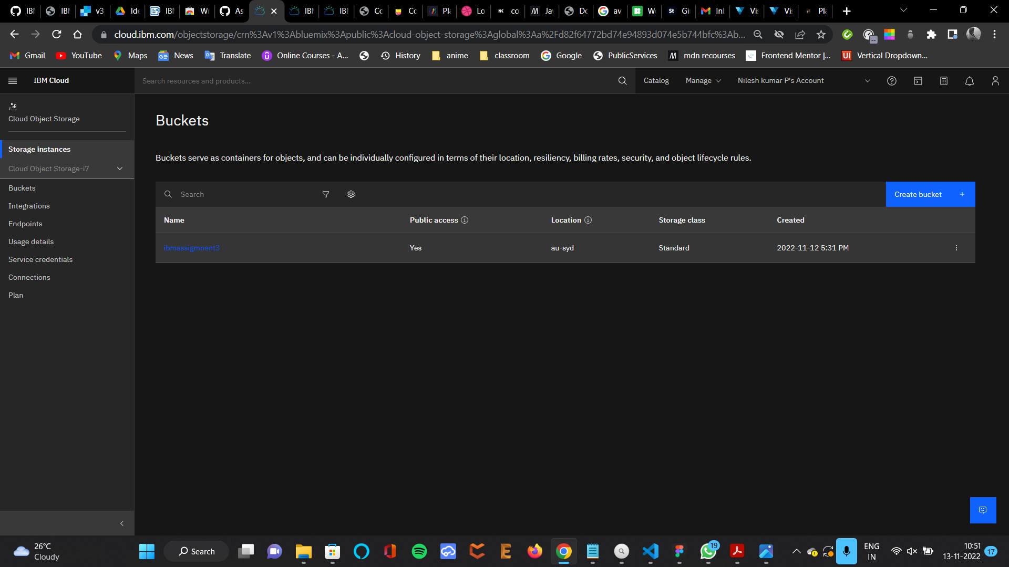

2.Upload an 5 images to IBM object storage and make it public. write html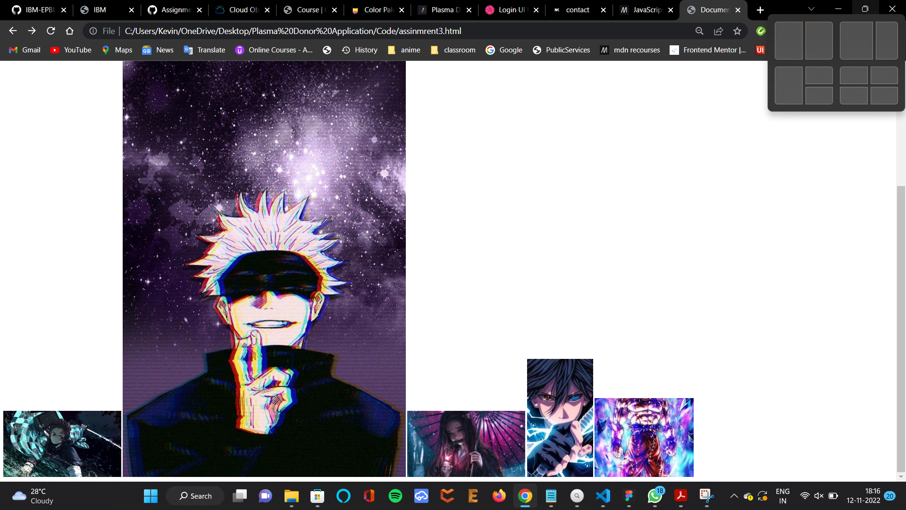

1. <img
2. src="https://ibmassigmnent3.s3.au-syd.cloud-object-storage.appdomain.cloud/demon%20slayer.jpeg"
3. alt="demonslayer"
4. <img
5. src="https://ibmassigmnent3.s3.au-syd.cloud-object-storage.appdomain.cloud/gojo.jpg"
6. alt="gojo"
7. <img
8. src="https://ibmassigmnent3.s3.au-syd.cloud-object-storage.appdomain.cloud/nezuko.jpeg"
9. alt="nezuko"
10. <img
11. src="https://ibmassigmnent3.s3.au-syd.cloud-object-storage.appdomain.cloud/sasuke.jpeg"
12. alt="sasuke"
13. <img
14. src="https://ibmassigmnent3.s3.au-syd.cloud-object-storage.appdomain.cloud/goku.jpeg"
15. alt="goku"

3.Upload a css page to the object storage and use the same page in your HTML code.

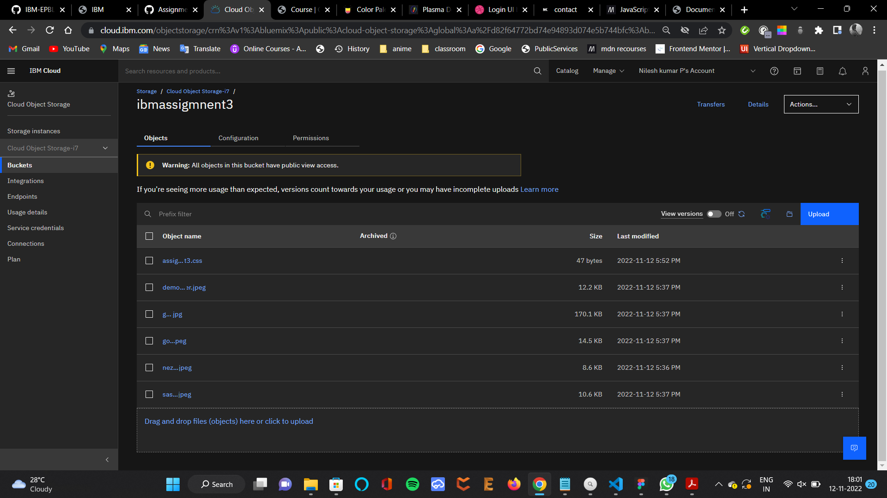

1. <link
2. rel="stylesheet"
3. href="https://ibmassigmnent3.s3.au-syd.cloud-object-storage.appdomain.cloud/assignment3.css"
4. <img
5. src="https://ibmassigmnent3.s3.au-syd.cloud-object-storage.appdomain.cloud/demon%20slayer.jpeg"
6. alt="demonslayer"
7. <img
8. src="https://ibmassigmnent3.s3.au-syd.cloud-object-storage.appdomain.cloud/gojo.jpg"
9. alt="gojo"
10. <img
11. src="https://ibmassigmnent3.s3.au-syd.cloud-object-storage.appdomain.cloud/nezuko.jpeg"
12. alt="nezuko"
13. <img
14. src="https://ibmassigmnent3.s3.au-syd.cloud-object-storage.appdomain.cloud/sasuke.jpeg"
15. alt="sasuke"
16. <img
17. src="https://ibmassigmnent3.s3.au-syd.cloud-object-storage.appdomain.cloud/goku.jpeg"
18. alt="goku"

4.Design a chatbot using IBM Watson assistant for hospital. Ex: User comes with query to know the branches for that hospital in your city. Submit the web URL of that chat bot as a assignment.

5.Create Watson assistant service with 10 steps and use 3 conditions in it. Load that script in HTML page.

4 th and 5 th answer are answered together.

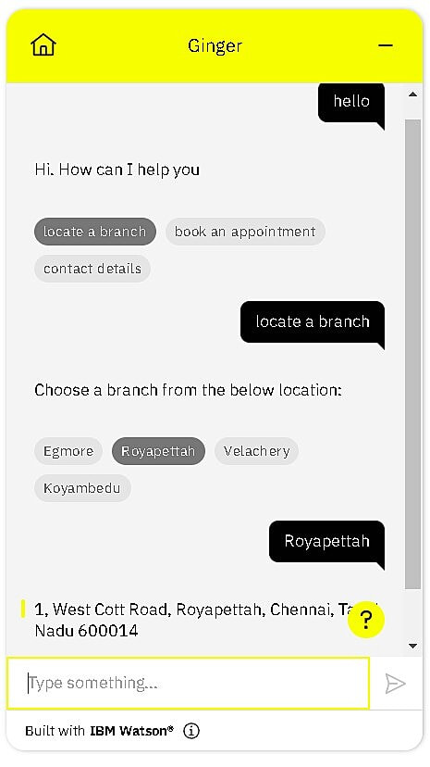

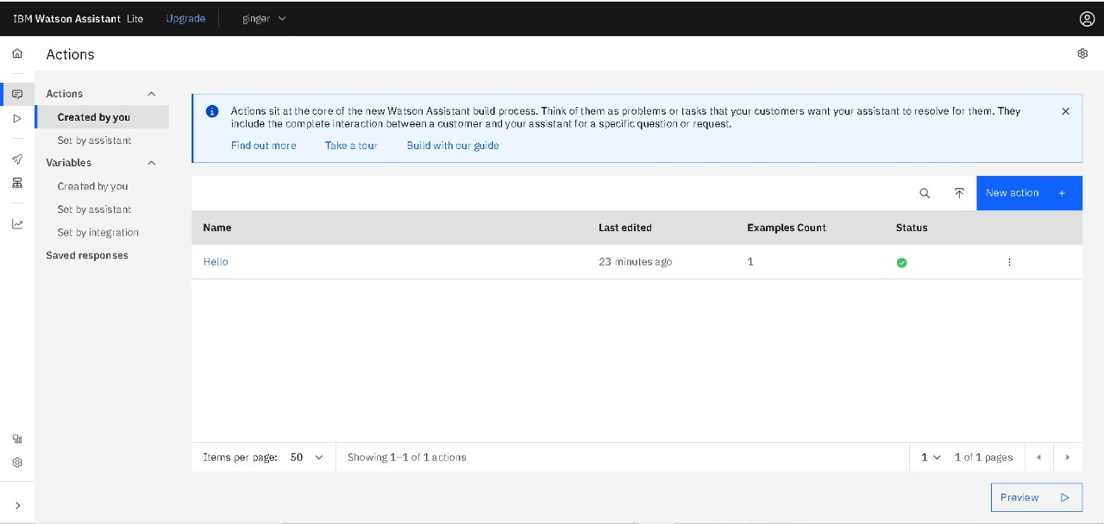

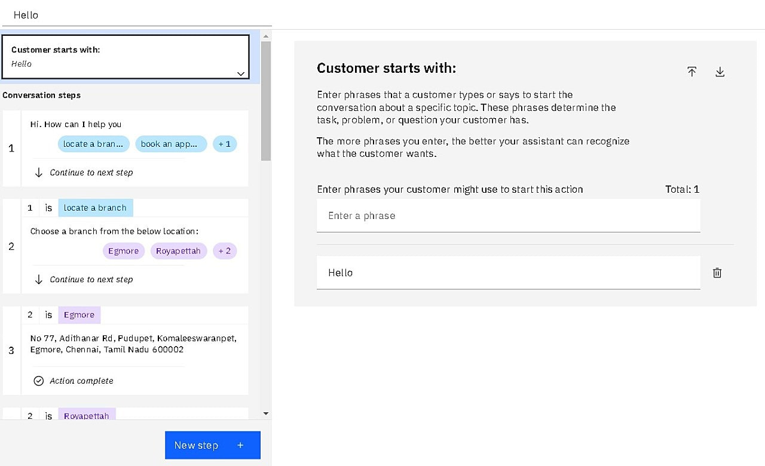

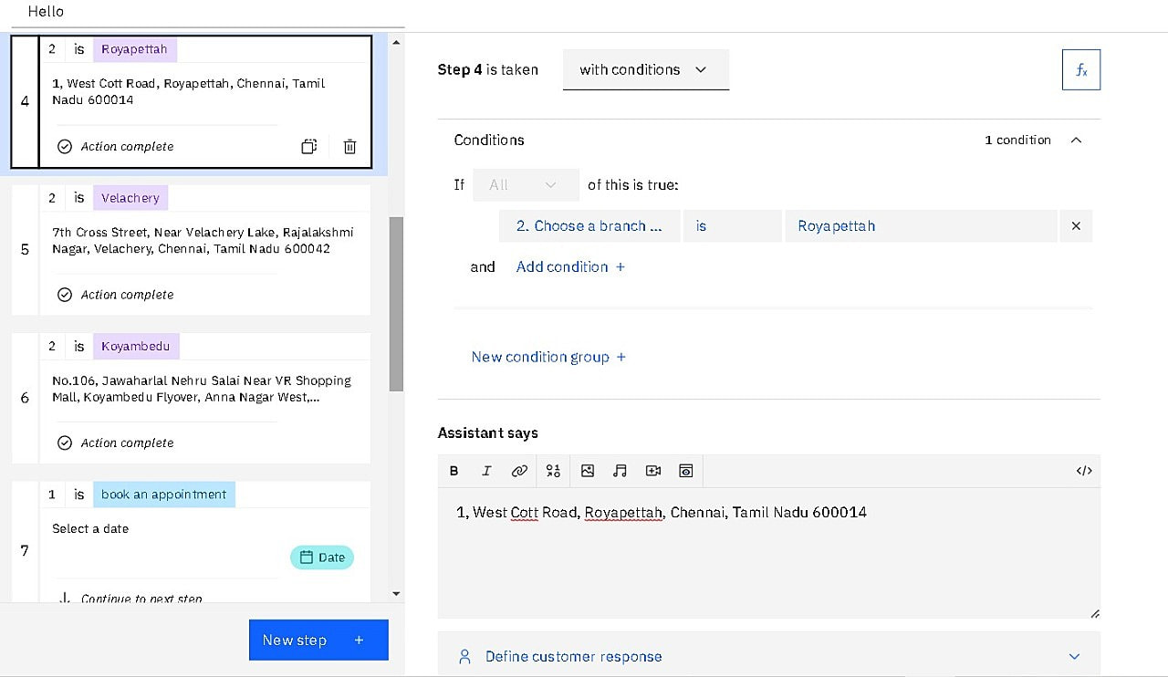

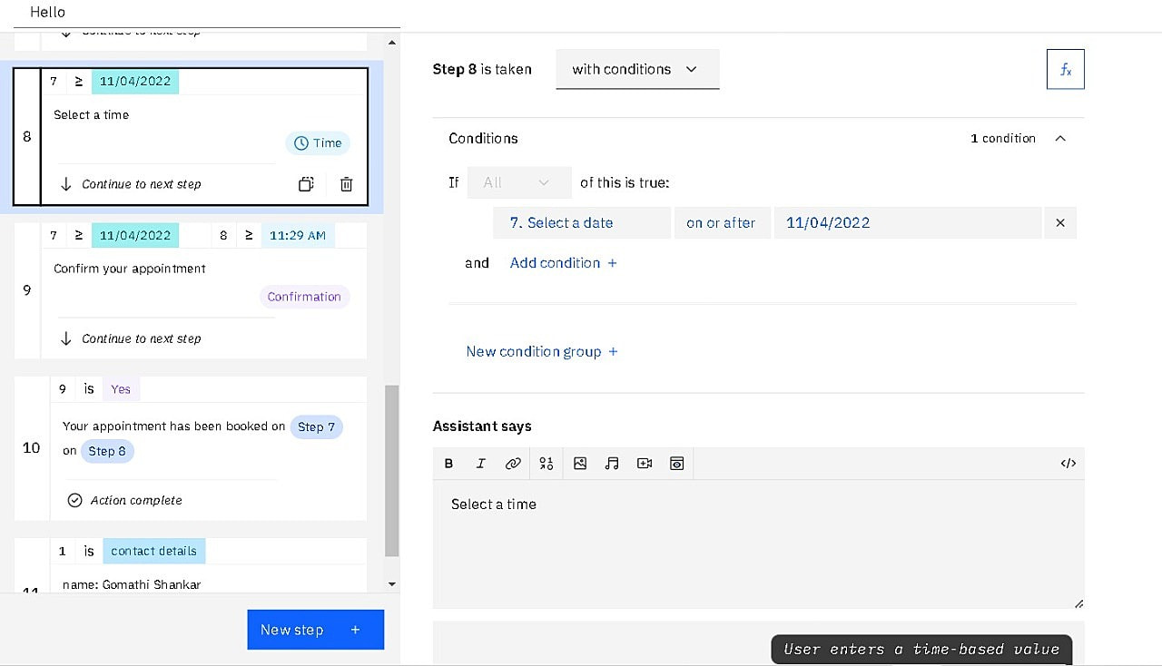

1. sbioloadproject('insulindemo', 'm1')
2. warnSettings = warning('off', 'SimBiology:DimAnalysisNotDone_MatlabFcn_Dimensionless');
3. mealDose = sbioselect(m1, 'Name', 'Single Meal');
4. get(mealDose)
5. configset = getconfigset(m1,'active');
6. configset.StopTime = 7;
7. configset.TimeUnits
8. normalMealSim = sbiosimulate(m1, configset, [], mealDose);
9. diabeticVar = sbioselect(m1, 'Name', 'Type 2 diabetic')
10. diabeticMealSim = sbiosimulate(m1, configset, diabeticVar, mealDose);
11. outputNames = {'Plasma Glu Conc', 'Plasma Ins Conc', 'Glu Prod', ...
12. 'Glu Appear Rate', 'Glu Util', 'Ins Secr'};
13. figure;
14. for i = 1:numel(outputNames)
15. subplot(2, 3, i);
16. [tNormal, yNormal ] = normalMealSim.selectbyname(outputNames{i});
17. [tDiabetic, yDiabetic] = diabeticMealSim.selectbyname(outputNames{i});
18. plot( tNormal , yNormal , '-' , ...
19. tDiabetic , yDiabetic , '--' );
20. % Annotate figures
21. outputParam = sbioselect(m1, 'Name', outputNames{i});
22. title(outputNames{i});
23. xlabel('time (hour)');
24. if strcmp(outputParam.Type, 'parameter')
25. ylabel(outputParam.ValueUnits);
26. else
27. ylabel(outputParam.InitialAmountUnits);
28. end
29. xlim([0 7]);
30. % Add legend
31. if i == 3
32. legend({'Normal', 'Diabetic'}, 'Location', 'Best');
33. end
34. end
35. configset.StopTime = 24;
36. dayDose = sbioselect(m1, 'Name', 'Daily Life');
37. normalDaySim = sbiosimulate(m1, configset, [], dayDose);
38. impairVars{1} = sbioselect(m1, 'Name', 'Low insulin sensitivity' ) ;
39. impairVars{2} = [impairVars{1}, ...
40. sbioselect(m1, 'Name', 'High beta cell responsivity')];
41. impairVars{3} = sbioselect(m1, 'Name', 'Low beta cell responsivity' ) ;
42. impairVars{4} = [impairVars{3}, ...
43. sbioselect(m1, 'Name', 'High insulin sensitivity' )];
44. for i = 1:4
45. impairSims(i) = sbiosimulate(m1, configset, impairVars{i}, dayDose);
46. end
47. figure;
48. outputNames = {'Plasma Glu Conc', 'Plasma Ins Conc'};
49. legendLabels = {{'Normal'}, ...
50. {'-Ins =\beta', '-Ins +\beta'}, ...
51. {'=Ins -\beta', '+Ins -\beta'}};
52. yLimits = [80 240; 0 500];
53. for i = 1:numel(outputNames)
54. [tNormal, yNormal] = selectbyname(normalDaySim , outputNames{i} );
55. [tImpair, yImpair] = selectbyname(impairSims , outputNames{i} );
56. % Plot Normal
57. subplot(2, 3, 3*i-2 );
58. plot(tNormal, yNormal, 'b-');
59. xlim([0 24]);
60. ylim(yLimits(i,:));
61. xlabel('time (hour)');
62. legend(legendLabels{1}, 'Location', 'NorthWest');
63. % Plot Low Insulin
64. subplot(2, 3, 3*i-1 );
65. plot(tImpair{1}, yImpair{1}, 'g--', tImpair{2}, yImpair{2}, 'r:');
66. xlim([0 24]);
67. ylim(yLimits(i,:));
68. xlabel('time (hour)');
69. legend(legendLabels{2}, 'Location', 'NorthWest');
70. title(outputNames{i});
71. % Plot Low Beta
72. subplot(2, 3, 3*i );
73. plot(tImpair{3}, yImpair{3}, 'c-.', tImpair{4}, yImpair{4}, 'm-');
74. xlim([0 24]);
75. ylim(yLimits(i,:));
76. xlabel('time (hour)');
77. legend(legendLabels{3}, 'Location', 'NorthWest');
78. end