**SMART WASTE MANAGEMENT SYSTEM**

**TEAM ID:PNT2022TMID50597**

**STEP 1:**

**PROBLEM SOLVING CARDS:**

**-Basic questions**

1)How will be collecting and handling?

2) What is the processing and resource recovery?

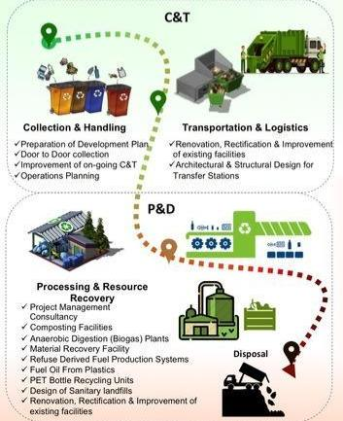

**STEP 2:**

**FRAMING STATEMENTS**

**Smart waste management system framing**

The Waste Framework Directive sets the basic concepts and definition related to waste management, including definitions of waste, recycling and recovery.

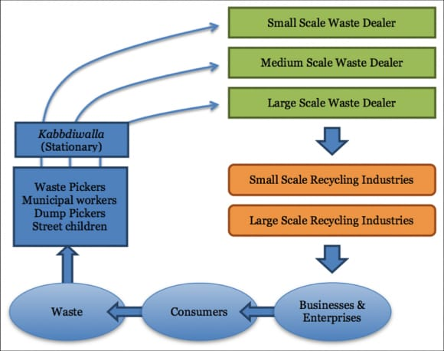

Sustainable waste management means reducing and avoiding the amount of single-use plastic products along with increasing the amount recycled at the same time, which currently stands at just 8.5%.Waste management is intended to reduce adverse effects of waste on human health, the environment, planetary resources and aesthetics. The aim of waste management is to reduce the dangerous effects of such waste on the environment and human health. Waste management involves the processes of waste collection, transportation, processing, as well as waste recycling or disposal. Sustainable waste management systems include advanced management strategies to minimize environmental challenges and protect resources.

STEP 3:

**IDEAS**

**Problem solution**

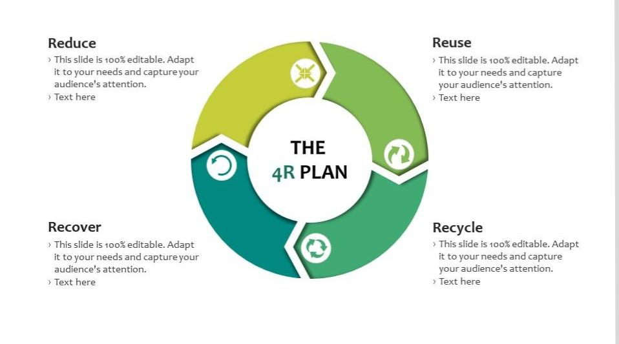

* By minimizing the use of disposable items and promoting the use of recycled articles.
* Separating biodegradable and non-biodegradable waste before dumping them.
* Recycling the non-biodegradable waste material.