**CIRCUIT DIAGRAM :**

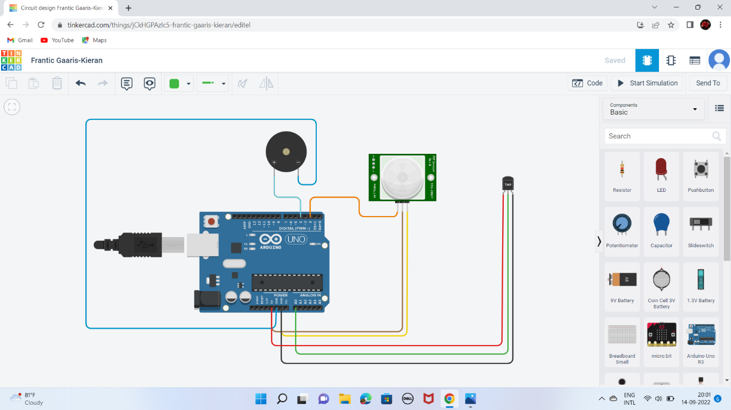

**ARDUINO CODE :**

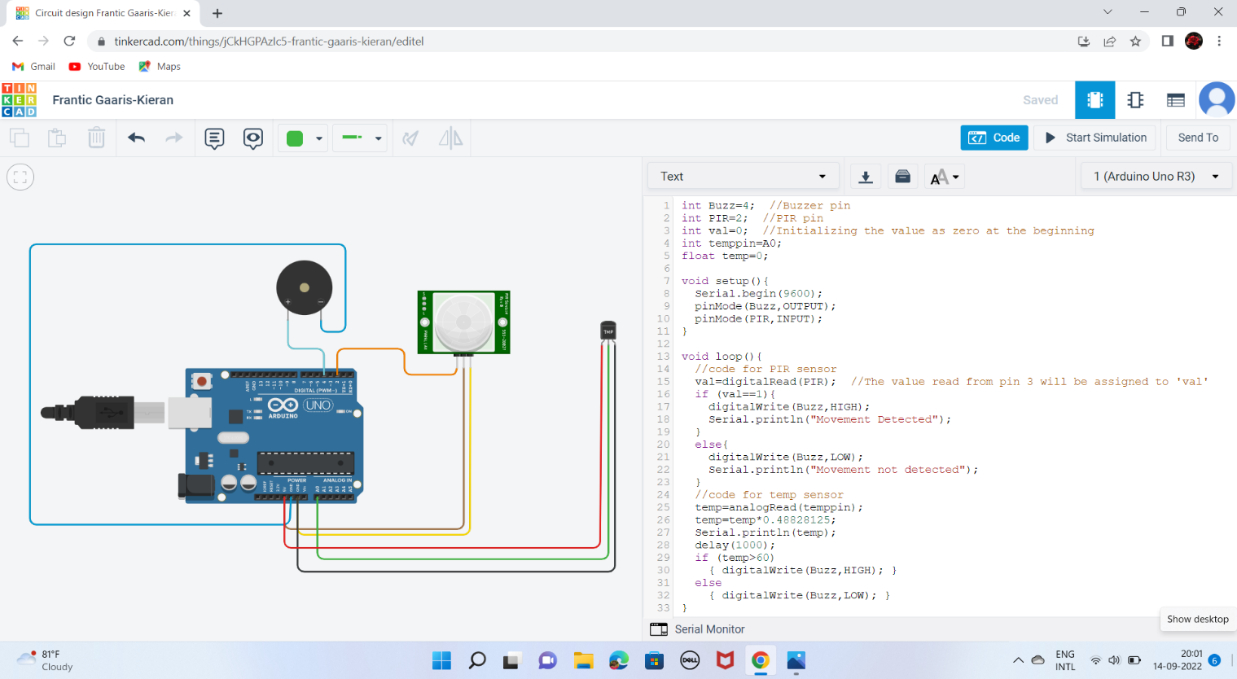

**OUTPUT :**

**No Movement and Temperature<60 C :**

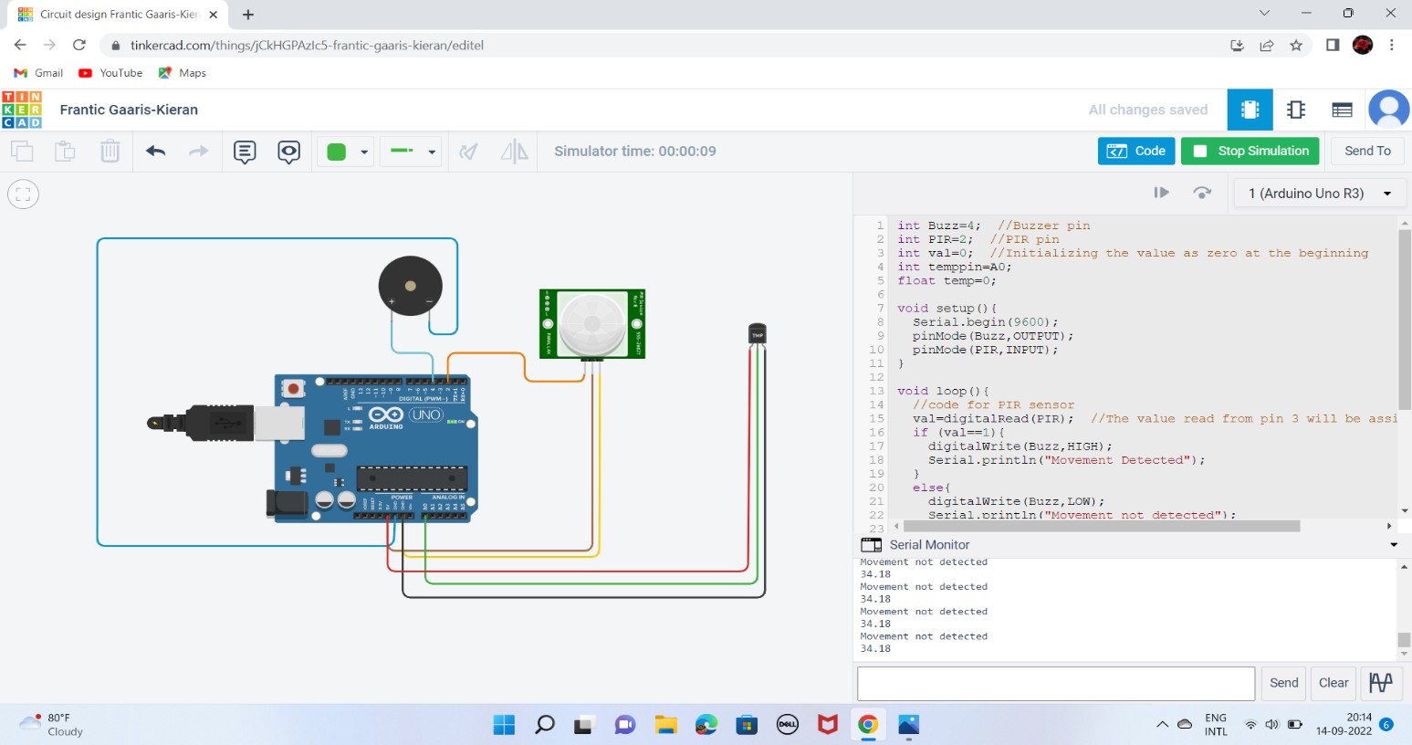

**Movement Detected in PIR sensor :**

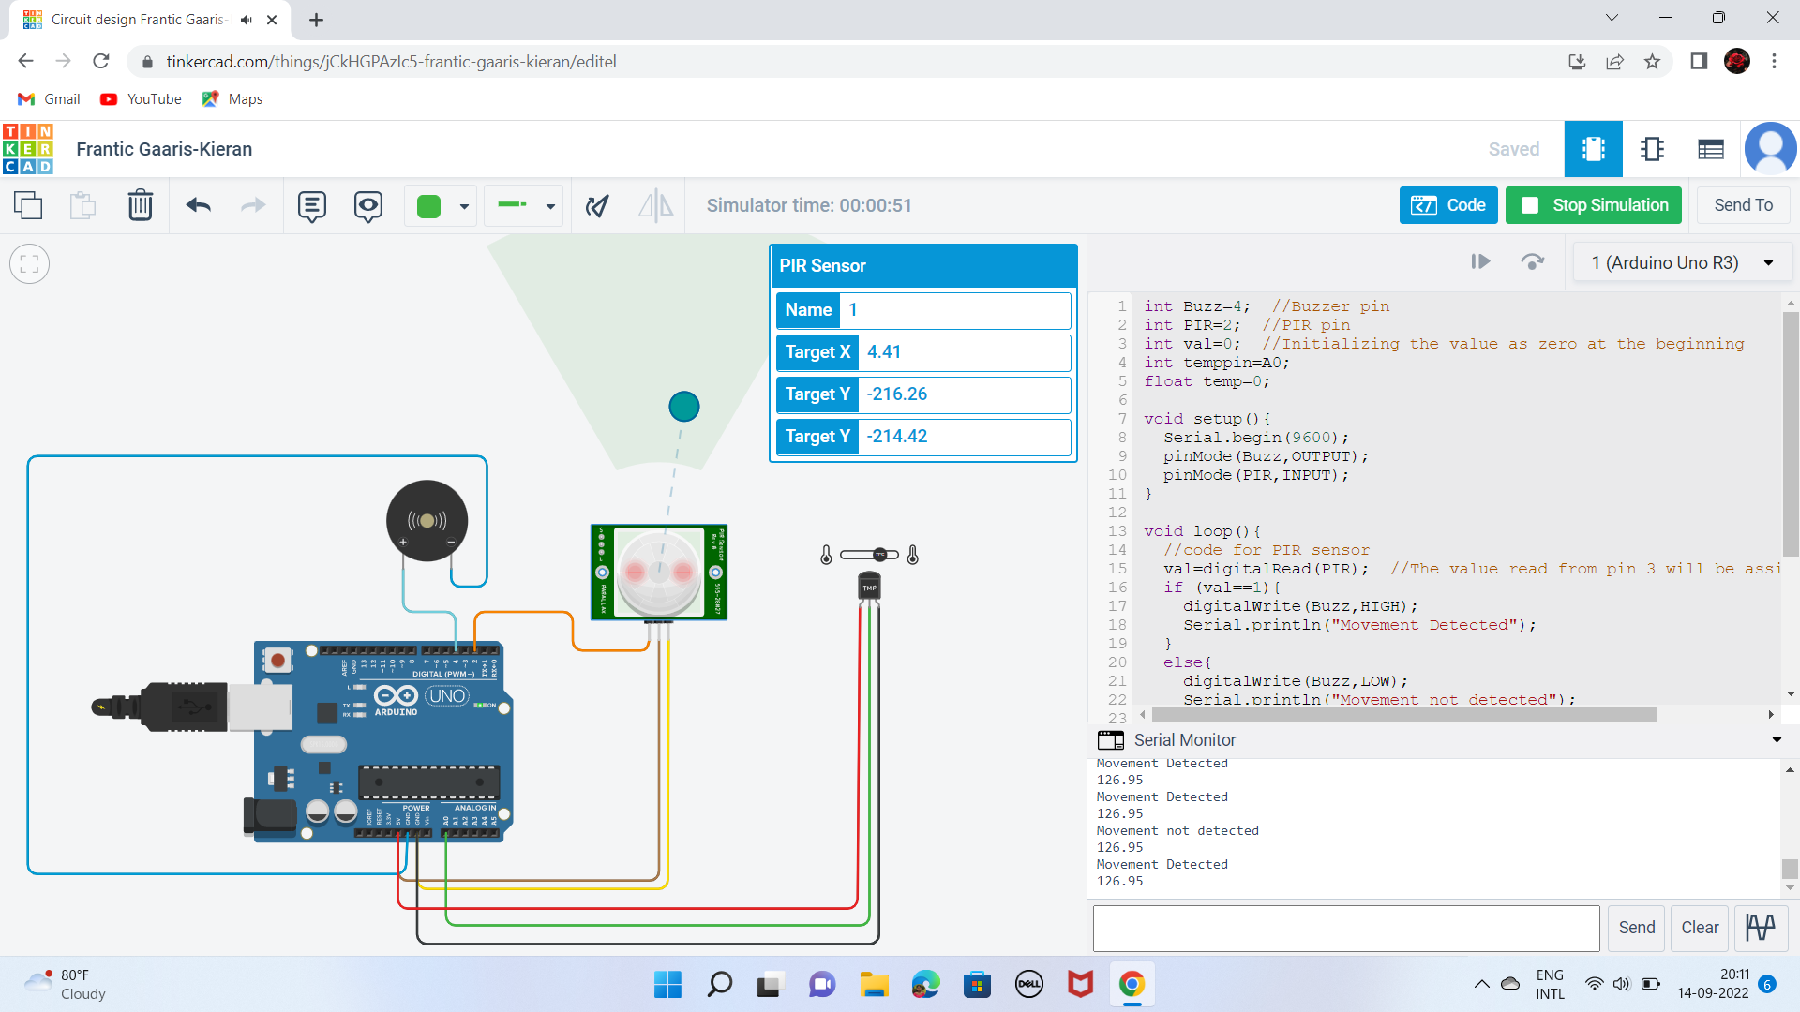

**Temperature>60 C in Temperature Sensor :**

