**Assignment -1**

Html form `

|  |  |
| --- | --- |
| Assignment Date | 19 September 2022 |
| Student Name | Mr M Esakkiraja @ Vishal |
| Student Roll Number | 952819106007 |
| Maximum Marks | 2 Marks |

**Question-1:**

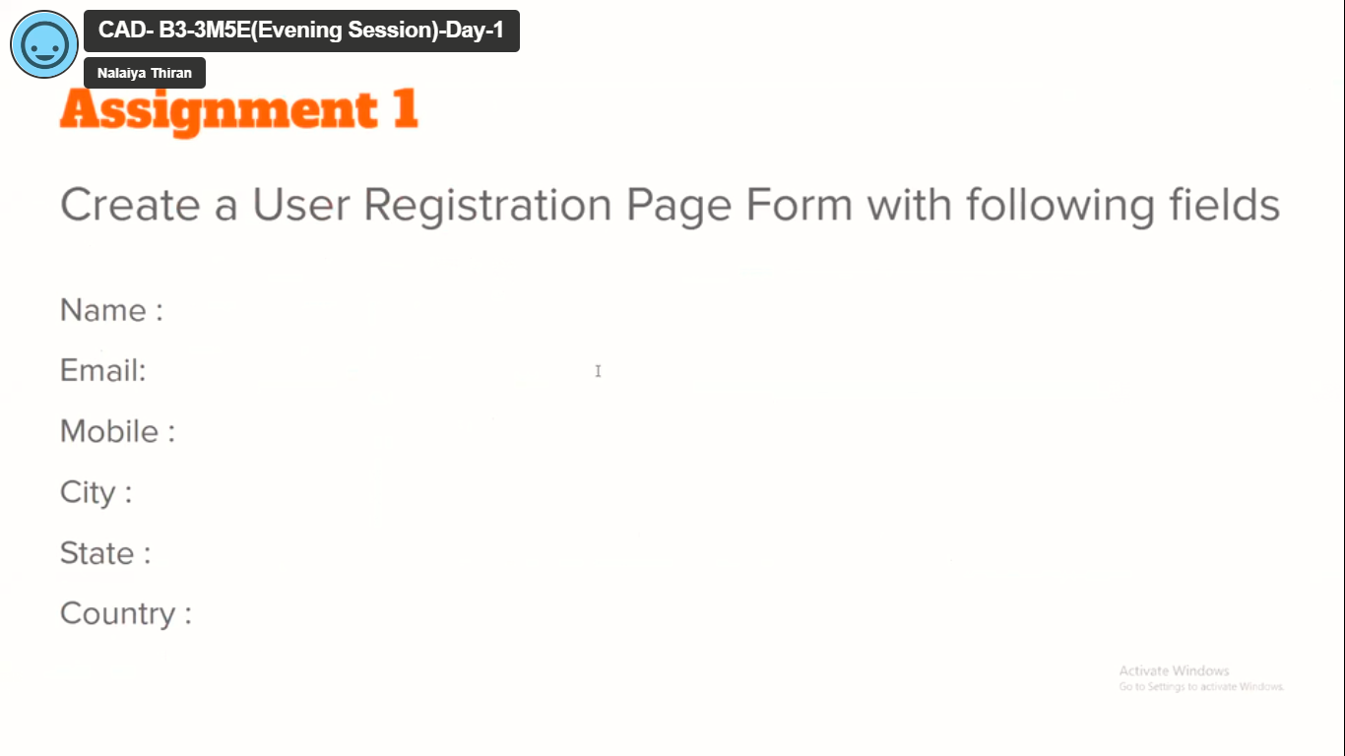

**Solution:**

<!DOCTYPE html>

<html>

    <head>

        <title> assignment_1 for nalliyathiran</title>

    </head>

    <body>

        <form action="/sign up" method="POST">

            <label for= "fname">name</label><br>

             <input type="text" id="fname" name="fname" value="Esakkiraju@vishal"><br>

             <label for="email">email id</label><br>

             <input type-="email" id="email" name="email" value="Vishal2235@gmail.com" size="28"><br>

             <label for= "mobile"> mobile number</label><br>

             <input type="number" id="number" name="number" value="123456789"size="10"><br>

             <label for= "city">city</label><br>

             <input type="text" id="city" name="city" value="Nagalkulam"><br>

             <label for= "state">state</label><br>

             <input type="text" id="state" name="state" value="Tamil nadu"><br>

             <label for= "fname">country</label><br>

             <input type="text" id="country" name="country" value="india"><br>

             <br>

             <input type="submit" value="submit" style="color:black ;">

        </form>

    </body>

</html>

**Output:**

