**ASSIGNMENT 1**

**SMART HOME AUTOMATION**

|  |  |
| --- | --- |
| **Assignment Date** | 22 September 2022 |
| **Student Name** | SelvaPriya.M |
| **Student Roll Number** | 950619106025 |

**Question1:**

Build a smart home in tinkercad

Use atleast 2 Sensors, Led and Buzzer in a circuit. Simulate in a single code.

**Link:**

<https://www.tinkercad.com/things/aIyViPOsxTM-exquisite-juttuli/editel?sharecode=4qX_RpQyIZsgTMvT5jAAjZW1rZg3ghf1jUP2AkVnvbs>

**Program Code:**

float x,y;

void setup

{

pinMode (8,INPUT);

pinMode(5,OUTPUT);

pinMode(A5,INPUT);

Serial.begin(9600);

}

void loop()

{

X=digitalRead(8);

Y=analogRead(A5);

Serial.println(x);

Serial.println(y);

if((x>0)&&(y<550))

{

digitalWrite(5,HIGH);

delay(5000);

}

else

{

digitalWrite(5,0);

}}

**Circuit Design:**

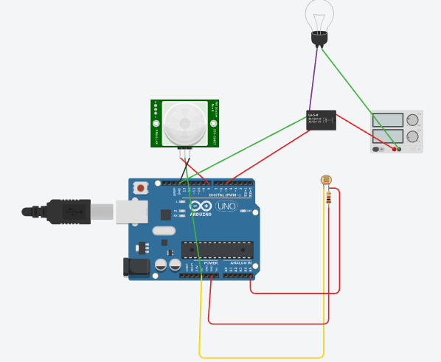

**Output:**

