**Project Design Phase-II**

**Data Flow Diagram & User Stories**

**Data Flow Diagrams:**

A two-dimensional diagram explains how data is processed and transferred in a system. The graphical depiction identifies each source of data and how it interacts with other data sources to reach a common output. Individuals seeking to draft a data flow diagram must identify external inputs and outputs, determine how the inputs and outputs relate to each other, and explain with graphics how these connections relate and what they result in. This type of diagram helps business development and design teams visualize how data is processed and identify or improve certain aspects.

**LEVEL 0:**

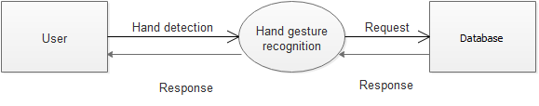

**Level 1:**

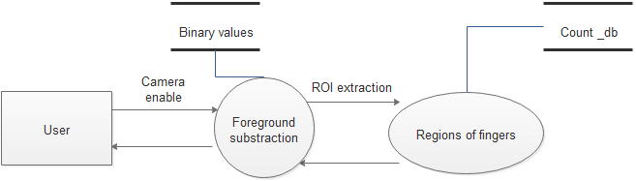

**Level 2:**

