**ASSIGNMENT-4**

**DISTANCE DETECTION USING ULTRASONIC SENSOR**

Question:

Write code and connections in wokwi for ultrasonic sensor. Whenever distance is less than 100 cms send "alert" to ibm cloud and display in device recent events.

Code:

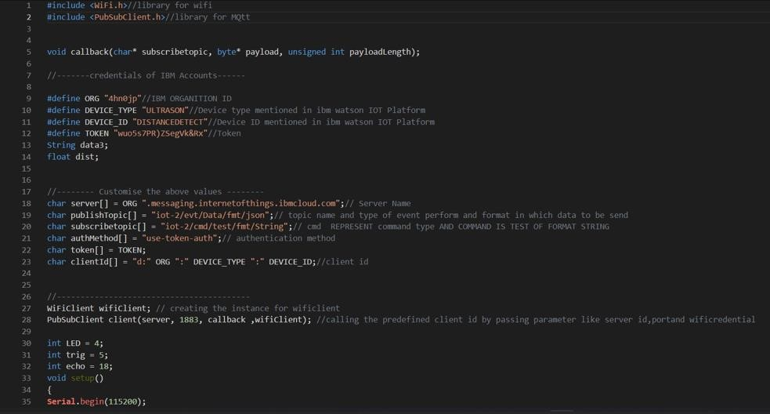

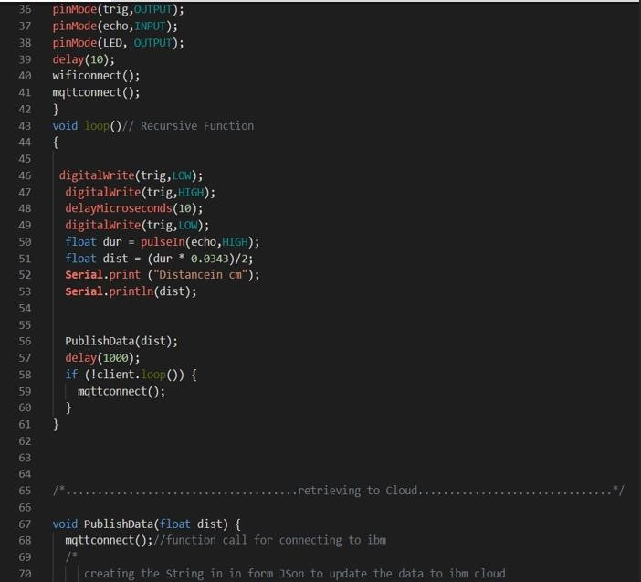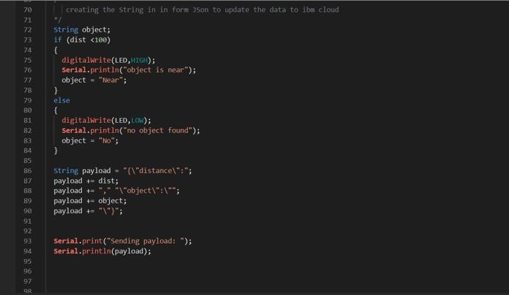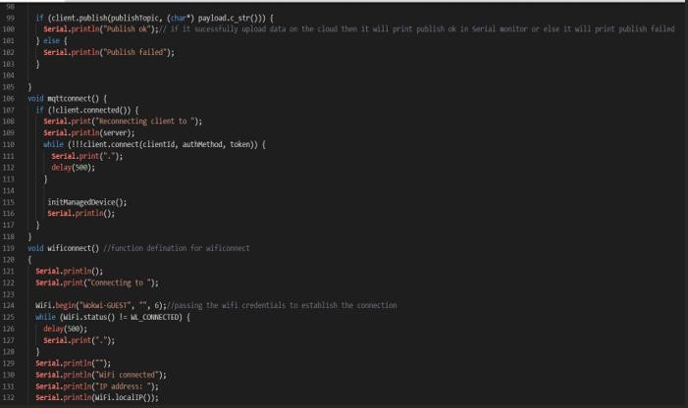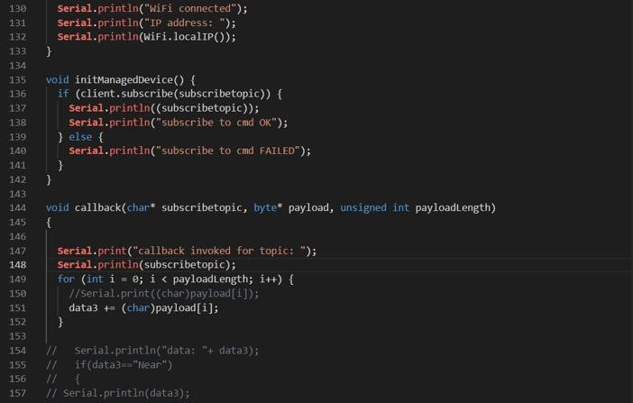

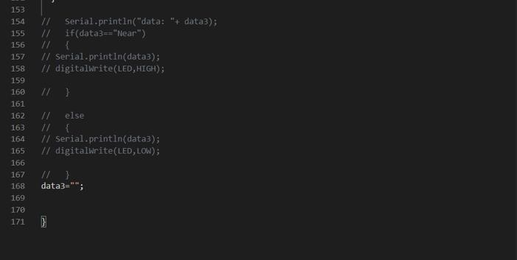

Output:

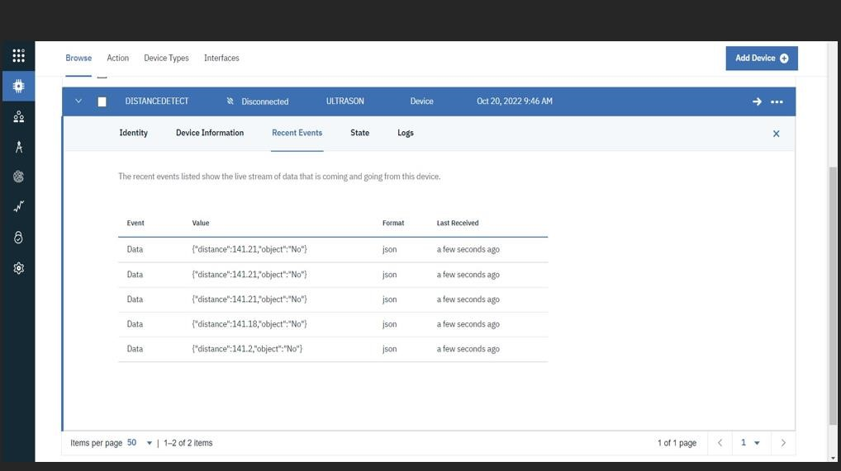

When object is near to the ultrasonic sensor

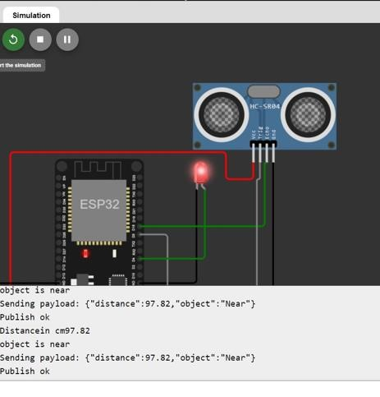

Data sent to the IBM Cloud device when the object is near

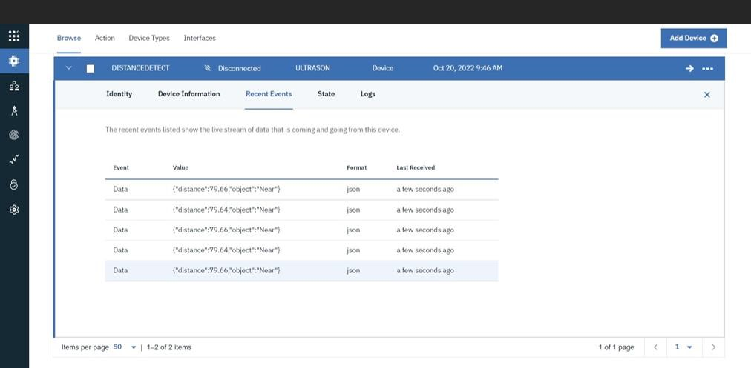

By, C.M.Benoj