ASSIGNMENT -2

Build a python code, Assume u get temperature and humidity values (generated with random function to a variable) and write a condition to continuously detect alarm in case of high temperature.

**CODE**:

import random  
while(True):  
  temp=random.randint(10,99)  
  humid=random.randint(10,99)  
  print("current temperature:",temp)  
  print("current humidity:",humid,"%")  
  temp_ref=37  
  humid_ref=35  
  if temp>temp_ref and humid<humid_ref:  
     print("Sound alarm")  
  else:  
     print("Sound off")  
  break

**output:**

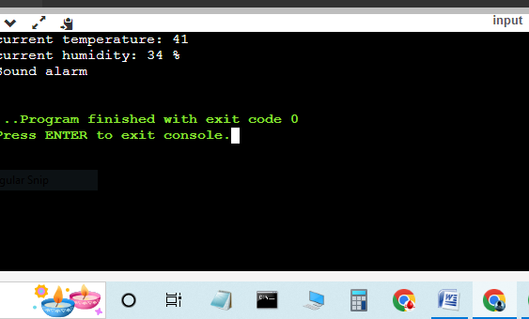

By

M.Maria leo mesha