INSTALLATION OF PYTHON 3.9.8

|  |  |
| --- | --- |
| DATE | 26 OCT 2022 |
| TEAM ID | PNT2022TMID44629 |
| PROJECT NAME | GAS LEAKAGE MONITORING AND ALERTING SYSTEM |

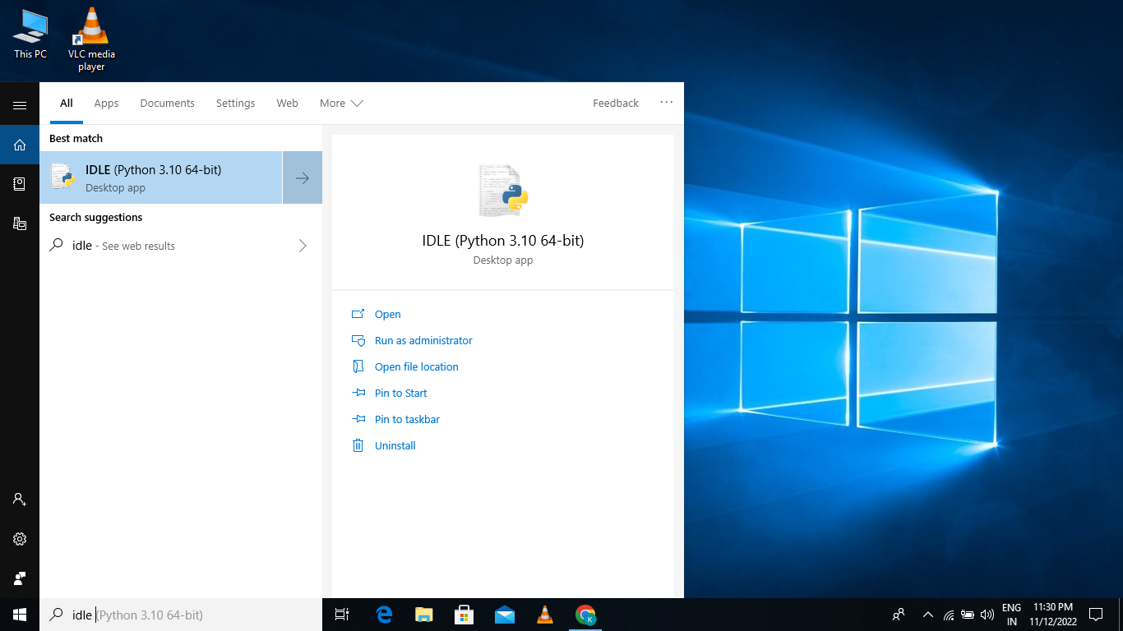

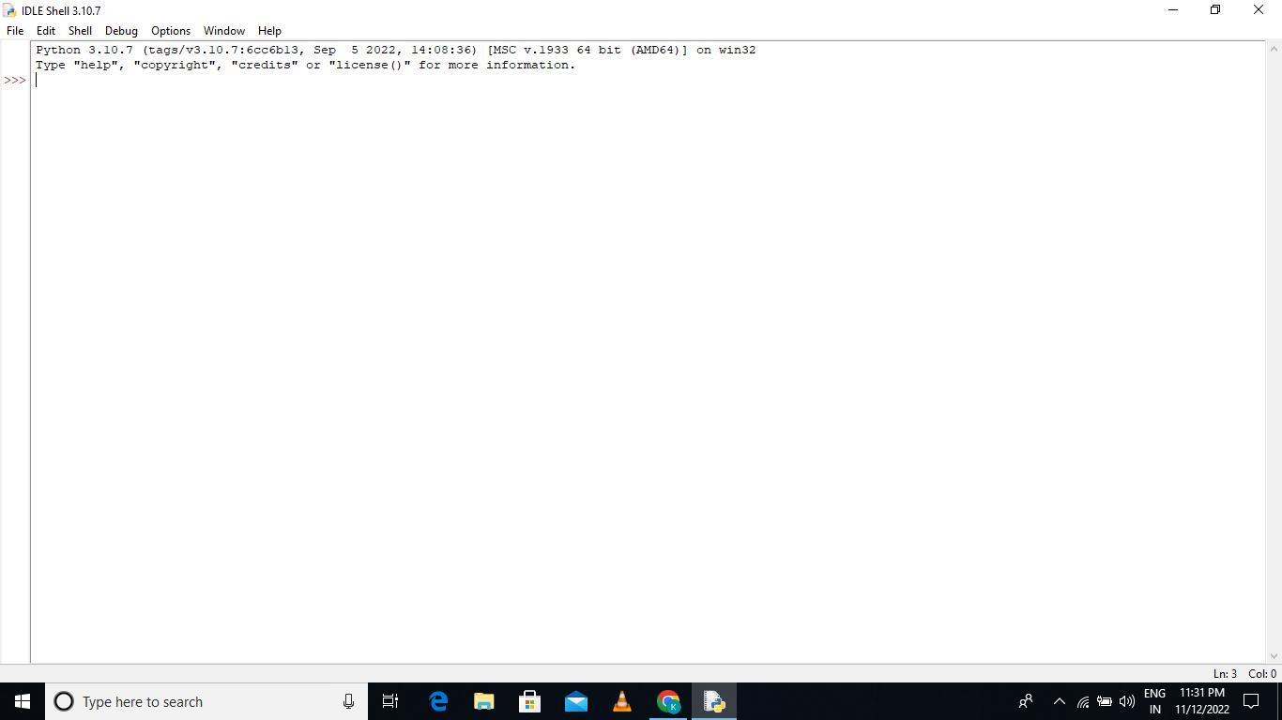

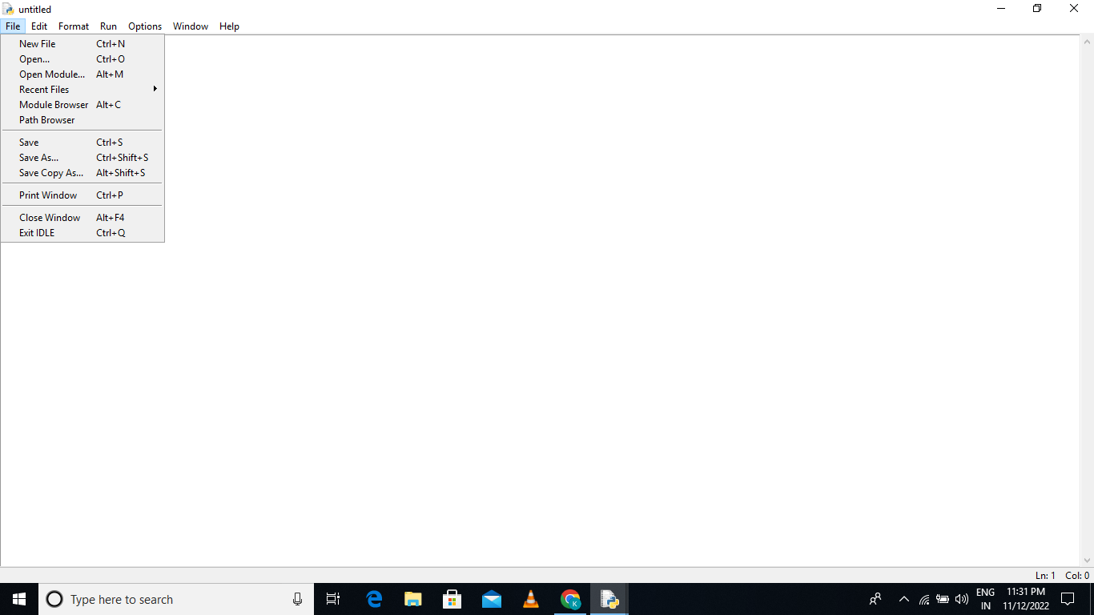

PYTHON 3.9.8 IS INSTALLED SUCCESSFULLY