|  |  |
| --- | --- |
| Date | 12-11-2022 |
| Team ID | PNT2022TMID44624 |
| Project Name | Signs with Smart Connectivity for Better Road Safety |
| Maximum marks | 2 Marks |

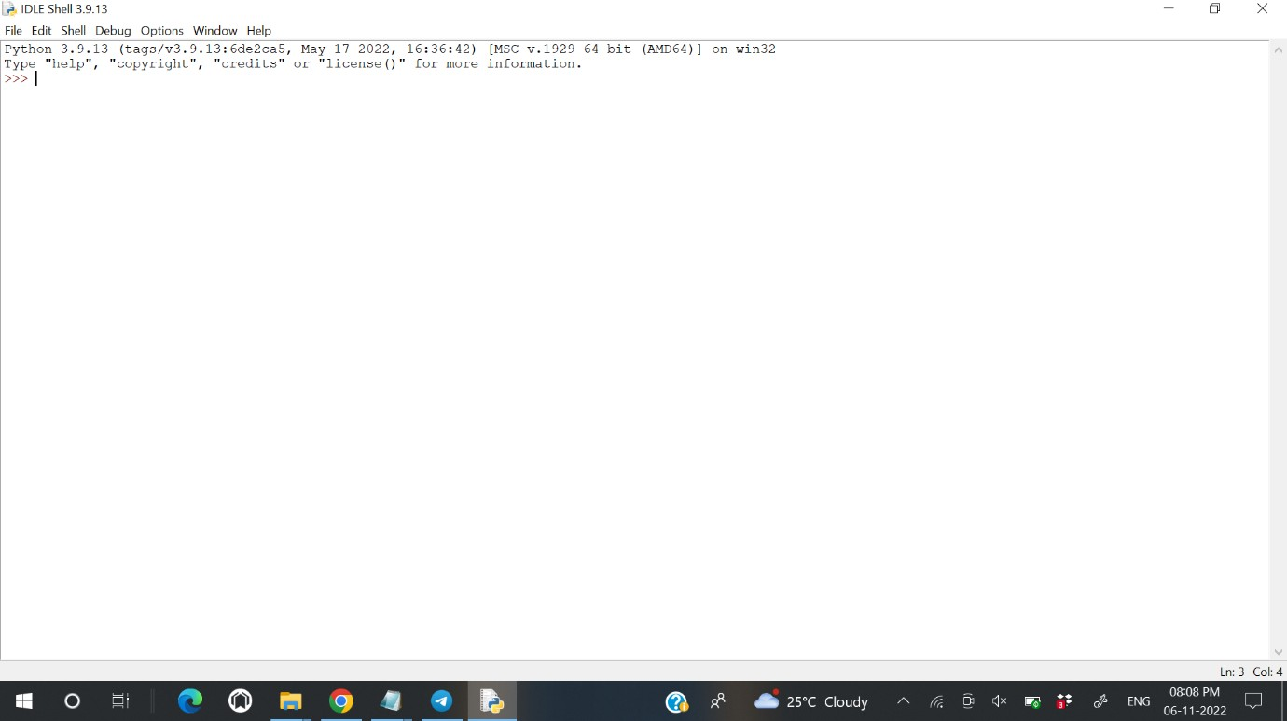

Step 2: Install wiotp-sdk

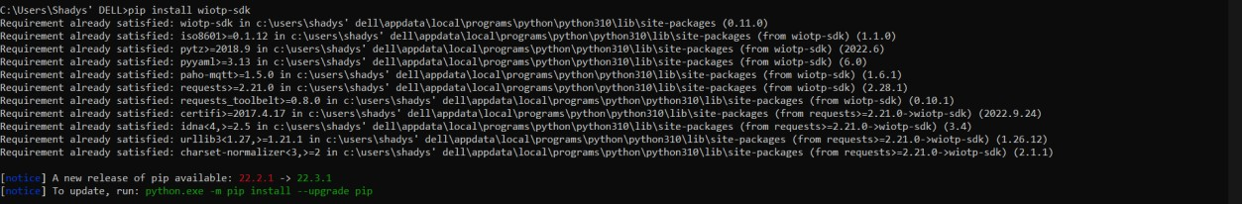

Step 3: Install ibm cloudant

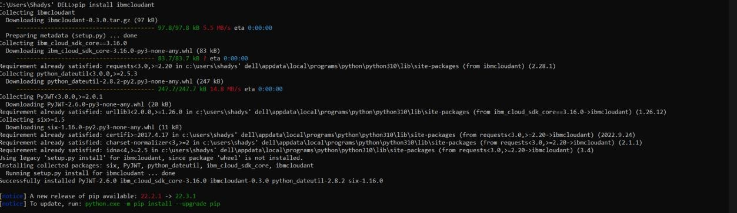

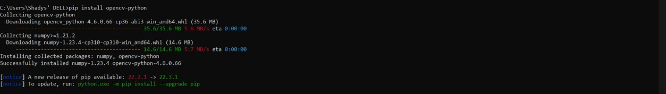

Step 5: Install pyzbar

