# Assignment -3

Python Programming

# Question-1:

Create a Bucket in IBM object storage.

# Solution-1:

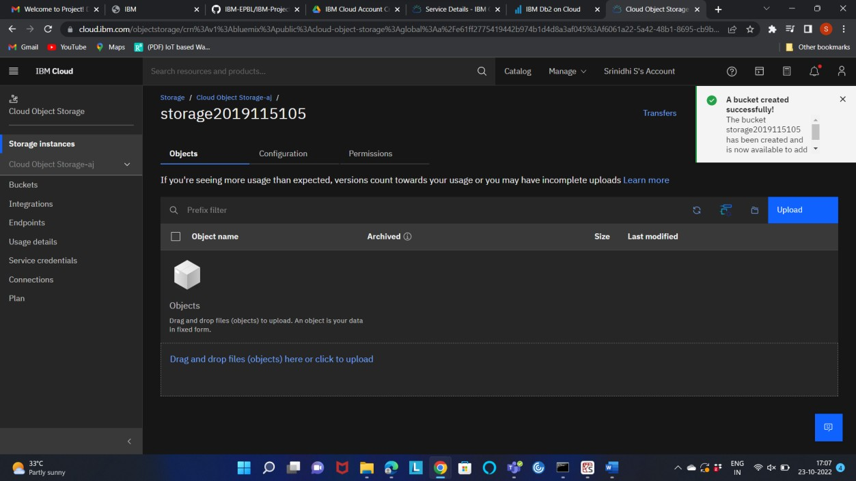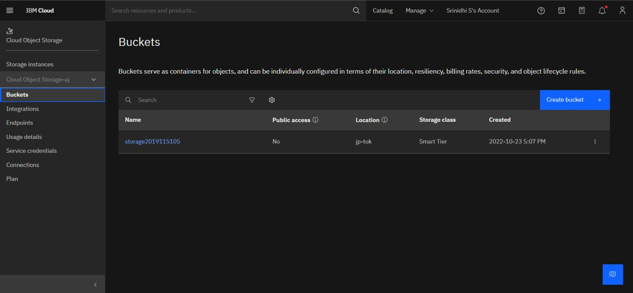

**Question-2:**

Upload 5 images to ibm object storage and make it public. Write html code to displaying all 5 images.

# Solution-2:

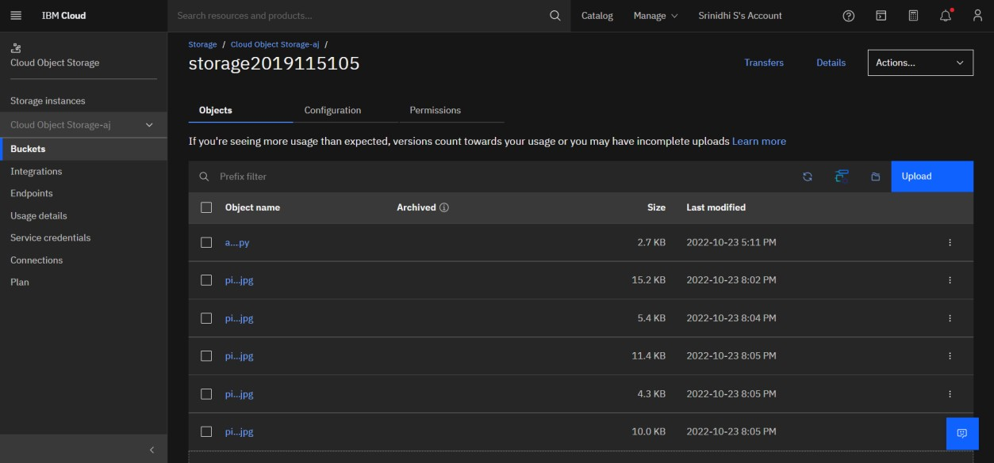

Image 1: <https://storage2019115105.s3.jp-tok.cloud-object-storage.appdomain.cloud/pic1.jpg>

Image 2: [https://storage2019115105.s3.jp-tok.cloud-object-storage.appdomain.cloud/pic2.jpg](https://storage2019115105.s3.jp-tok.cloud-object-storage.appdomain.cloud/pic2.jpg%20Image%203)

[Image 3](https://storage2019115105.s3.jp-tok.cloud-object-storage.appdomain.cloud/pic2.jpg%20Image%203): <https://storage2019115105.s3.jp-tok.cloud-object-storage.appdomain.cloud/pic3.jpg>

Image 4: <https://storage2019115105.s3.jp-tok.cloud-object-storage.appdomain.cloud/pic4.jpg>

Image 5: <https://storage2019115105.s3.jp-tok.cloud-object-storage.appdomain.cloud/pic5.jpg>

<!DOCTYPE HTML>

<html>

<head>

<title>User application</title>

<link rel="stylesheet" href="https://first2019115055.s3.us-south.cloud- objectstorage.appdomain.cloud/style.css">

<meta charset="utf-8">

<meta name="viewport" content="width=device-width, initial-scale=1, shrink-to-fit=no">

</head>

<body>

<div class = "msg">

<h1><b>Welcome! Images pulled from cloud object storage</b></h1>

</div>

<div><img src="https://storage2019115105.s3.jp-tok.cloud-object- storage.appdomain.cloud/pic1.jpg" alt="Trulli" width="500" height="333">

<img src="https://storage2019115105.s3.jp-tok.cloud-object-storage.appdomain.cloud/pic2.jpg" alt="Trulli" width="500" height="333">

<img src="https://storage2019115105.s3.jp-tok.cloud-object-storage.appdomain.cloud/pic3.jpg" alt="Trulli" width="500" height="333"></div>

<div><img src="https://storage2019115105.s3.jp-tok.cloud-object- storage.appdomain.cloud/pic4.jpg" alt="Trulli" width="500" height="333">

<img src="https://storage2019115105.s3.jp-tok.cloud-object-storage.appdomain.cloud/pic5.jpg" alt="Trulli" width="500" height="333"></div>

</body>

</HTML>

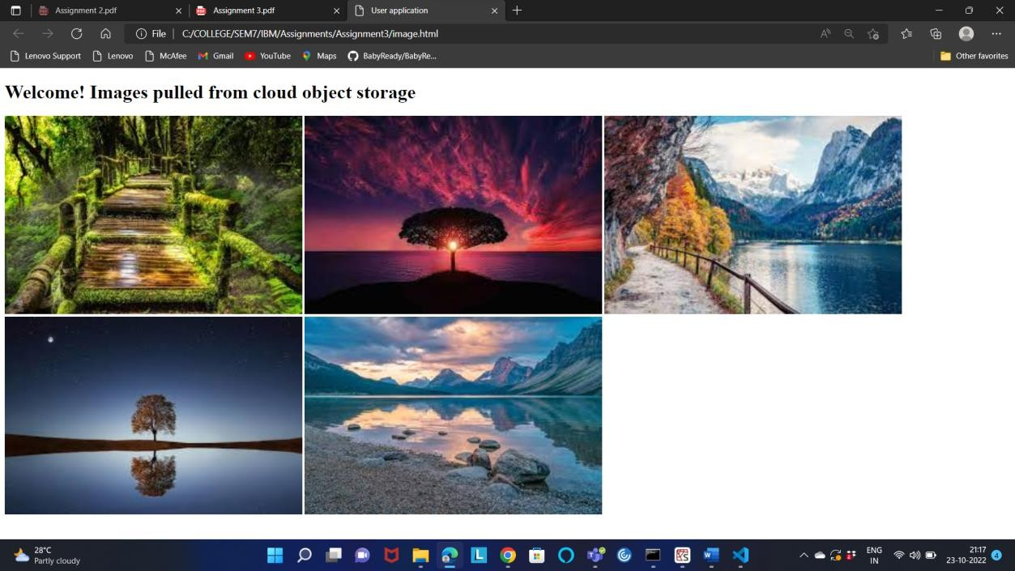

# Question-3:

Upload a css page to the object storage and use the same page in your HTML code

# Solution-3:

CSS Link**:** <https://storage2019115105.s3.jp-tok.cloud-object-storage.appdomain.cloud/style.css>

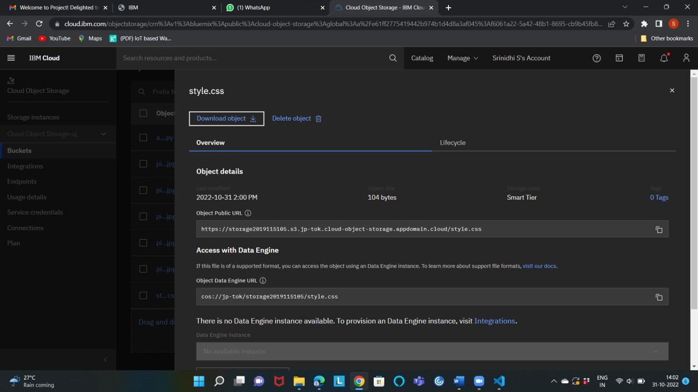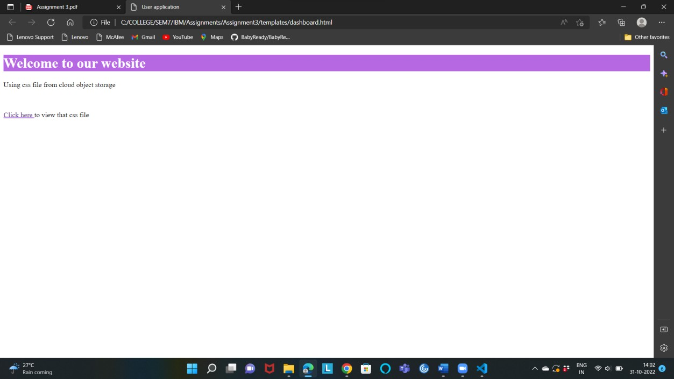

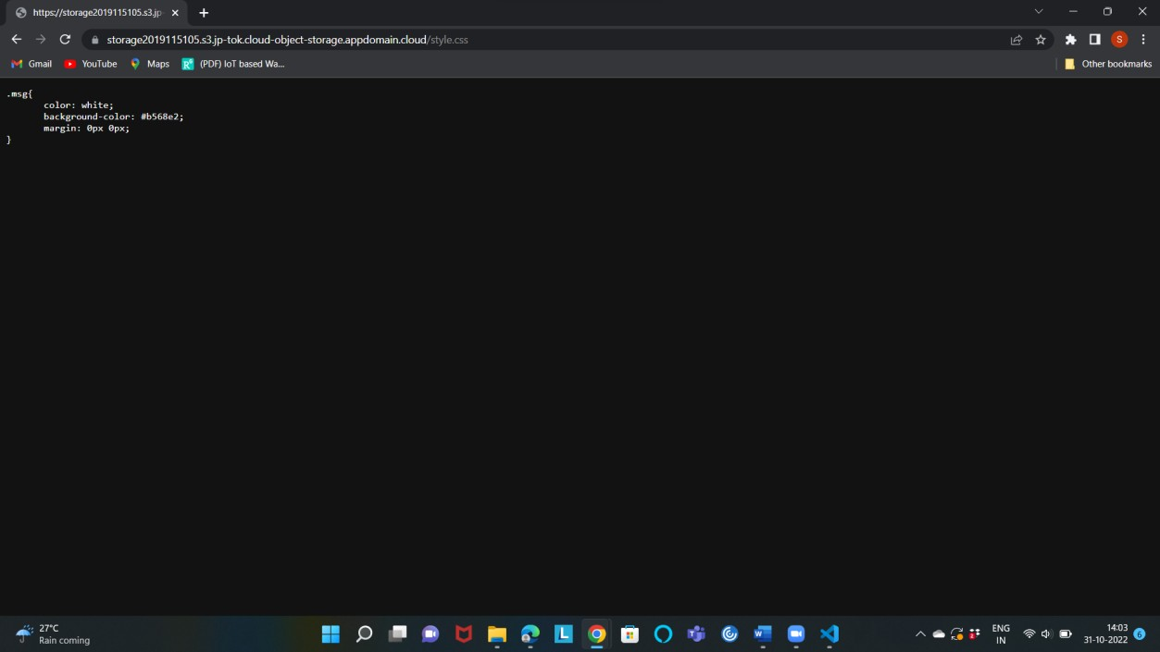

# Question-4:

Design a chatbot using IBM Watson assistant for hospital. Ex: User comes with query to know the branches for that hospital in your city. Submit the web URL of that chat bot as an assignment.

# Solution-4:

Link - [https://web-](https://web-chat.global.assistant.watson.appdomain.cloud/preview.html?backgroundImageURL=https%3A%2F%2Fus-south.assistant.watson.cloud.ibm.com%2Fpublic%2Fimages%2Fupx-18a683ad-b6bc-4d73-927f-3a1cd8329ac1%3A%3A2c9b4a8c-e008-4eee-960d-5b1ca9df6e7f&integrationID=ca46aa85-bdf9-4762-adb4-e35a709c20fa&region=us-south&serviceInstanceID=18a683ad-b6bc-4d73-927f-3a1cd8329ac1) [chat.global.assistant.watson.appdomain.cloud/preview.html?backgroundImageURL=https%3A%2F%](https://web-chat.global.assistant.watson.appdomain.cloud/preview.html?backgroundImageURL=https%3A%2F%2Fus-south.assistant.watson.cloud.ibm.com%2Fpublic%2Fimages%2Fupx-18a683ad-b6bc-4d73-927f-3a1cd8329ac1%3A%3A2c9b4a8c-e008-4eee-960d-5b1ca9df6e7f&integrationID=ca46aa85-bdf9-4762-adb4-e35a709c20fa&region=us-south&serviceInstanceID=18a683ad-b6bc-4d73-927f-3a1cd8329ac1) [2Fus-south.assistant.watson.cloud.ibm.com%2Fpublic%2Fimages%2Fupx-18a683ad-b6bc-4d73-](https://web-chat.global.assistant.watson.appdomain.cloud/preview.html?backgroundImageURL=https%3A%2F%2Fus-south.assistant.watson.cloud.ibm.com%2Fpublic%2Fimages%2Fupx-18a683ad-b6bc-4d73-927f-3a1cd8329ac1%3A%3A2c9b4a8c-e008-4eee-960d-5b1ca9df6e7f&integrationID=ca46aa85-bdf9-4762-adb4-e35a709c20fa&region=us-south&serviceInstanceID=18a683ad-b6bc-4d73-927f-3a1cd8329ac1) [927f-3a1cd8329ac1%3A%3A2c9b4a8c-e008-4eee-960d-5b1ca9df6e7f&integrationID=ca46aa85-](https://web-chat.global.assistant.watson.appdomain.cloud/preview.html?backgroundImageURL=https%3A%2F%2Fus-south.assistant.watson.cloud.ibm.com%2Fpublic%2Fimages%2Fupx-18a683ad-b6bc-4d73-927f-3a1cd8329ac1%3A%3A2c9b4a8c-e008-4eee-960d-5b1ca9df6e7f&integrationID=ca46aa85-bdf9-4762-adb4-e35a709c20fa&region=us-south&serviceInstanceID=18a683ad-b6bc-4d73-927f-3a1cd8329ac1) [bdf9-4762-adb4-e35a709c20fa&region=us-south&serviceInstanceID=18a683ad-b6bc-4d73-927f-](https://web-chat.global.assistant.watson.appdomain.cloud/preview.html?backgroundImageURL=https%3A%2F%2Fus-south.assistant.watson.cloud.ibm.com%2Fpublic%2Fimages%2Fupx-18a683ad-b6bc-4d73-927f-3a1cd8329ac1%3A%3A2c9b4a8c-e008-4eee-960d-5b1ca9df6e7f&integrationID=ca46aa85-bdf9-4762-adb4-e35a709c20fa&region=us-south&serviceInstanceID=18a683ad-b6bc-4d73-927f-3a1cd8329ac1) [3a1cd8329ac1](https://web-chat.global.assistant.watson.appdomain.cloud/preview.html?backgroundImageURL=https%3A%2F%2Fus-south.assistant.watson.cloud.ibm.com%2Fpublic%2Fimages%2Fupx-18a683ad-b6bc-4d73-927f-3a1cd8329ac1%3A%3A2c9b4a8c-e008-4eee-960d-5b1ca9df6e7f&integrationID=ca46aa85-bdf9-4762-adb4-e35a709c20fa&region=us-south&serviceInstanceID=18a683ad-b6bc-4d73-927f-3a1cd8329ac1)

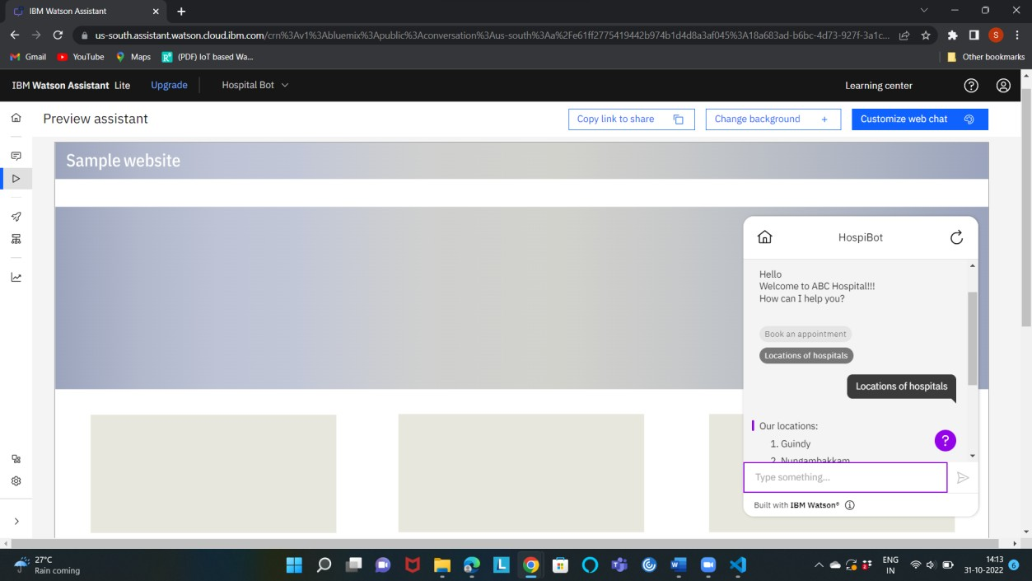

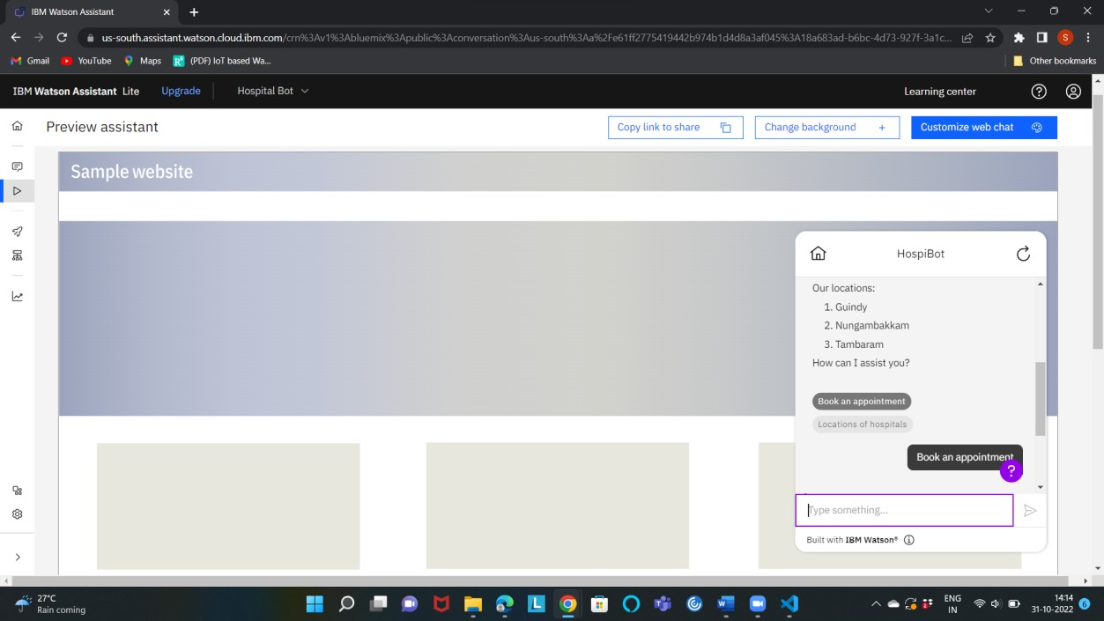

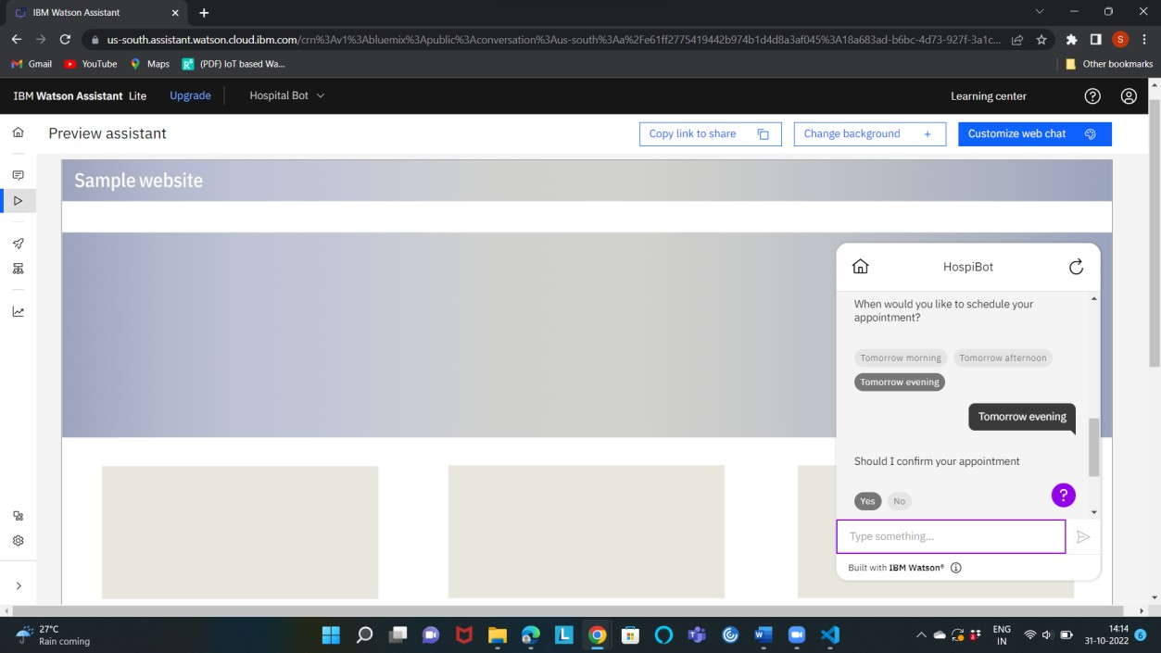

# Question-5:

Create Watson assistant service with 10 steps and use 3 conditions in it. Load that script in HTML page.

# Solution-5:

<!DOCTYPE HTML>

<html>

<head>

<title>User application</title>

<meta charset="utf-8">

<meta name="viewport" content="width=device-width, initial-scale=1, shrink-to-fit=no">

<style>

.msg{

color: white;

background-color: #53861d; margin: 0px 0px;

}

body{

background-image : url('img.jpg');

}

</style>

</head>

<body>

<div class = "msg">

<h1><b>Welcome to ABC Hospital</b></h1>

</div>

<script> window.watsonAssistantChatOptions = {

integrationID: "ca46aa85-bdf9-4762-adb4-e35a709c20fa", // The ID of this integration. region: "us-south", // The region your integration is hosted in.

serviceInstanceID: "18a683ad-b6bc-4d73-927f-3a1cd8329ac1", // The ID of your service instance.

onLoad: function(instance) { instance.render(); }

};

setTimeout(function(){

const t=document.createElement('script');

t.src="https://web-chat.global.assistant.watson.appdomain.cloud/versions/" + (window.watsonAssistantChatOptions.clientVersion || 'latest') + "/WatsonAssistantChatEntry.js";

document.head.appendChild(t);

});

</script>

</body>

</HTML>

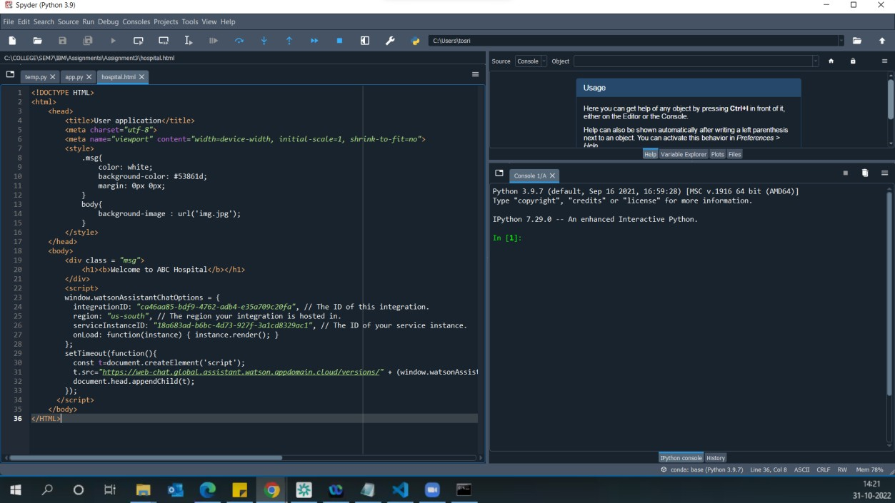

Output:

