FERTILIZER RECOMMENDATION SYSTEM FOR DISEASE PREDICTION

Team Leader: Vidhya.V

Team Members:Sneha.V,Aarthi.R,Dharni.S,Keerthana.R

PREREQUISITES:

Anaconda Navigator:

Anaconda Python:

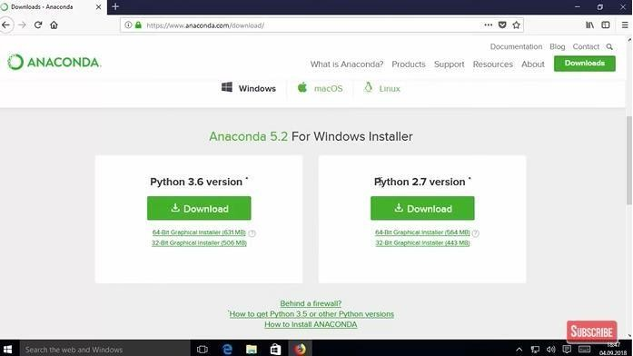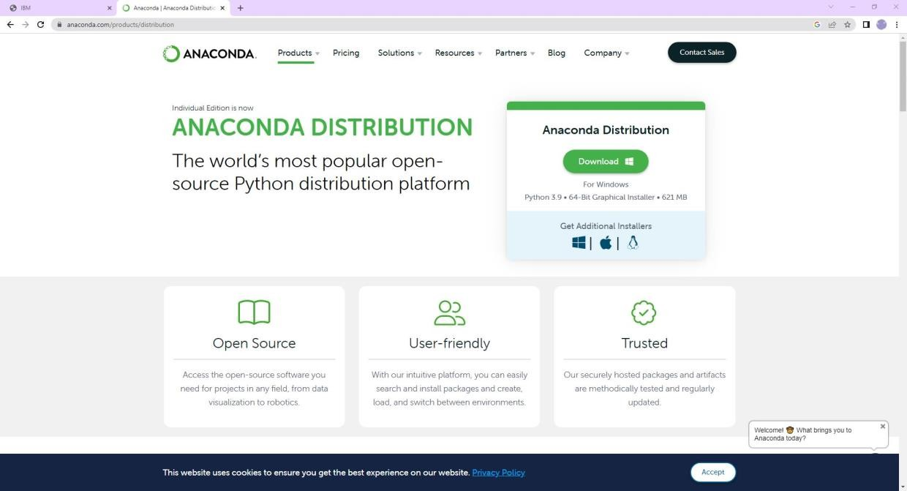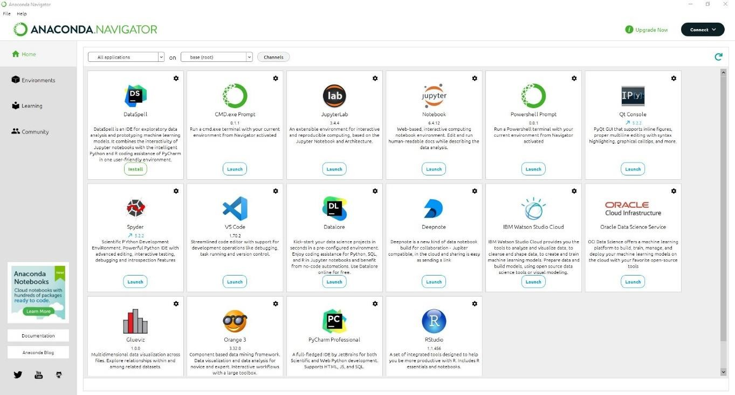

JUPYTER:

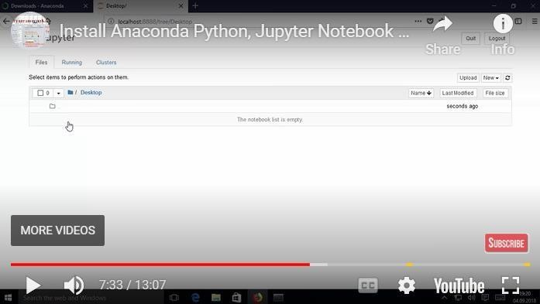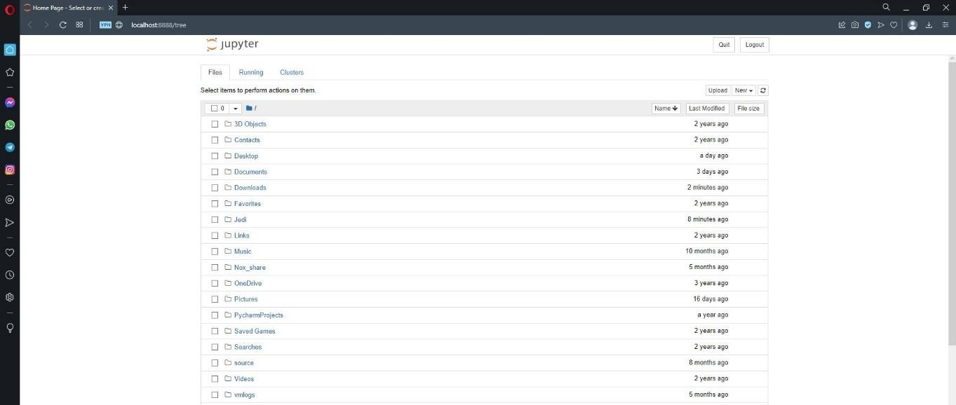

Spyder:

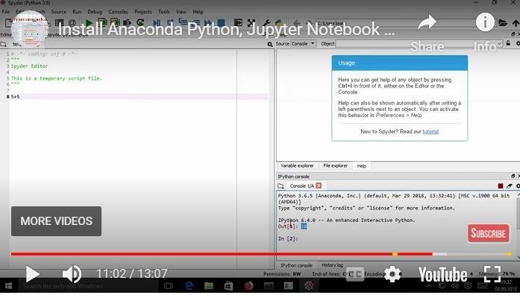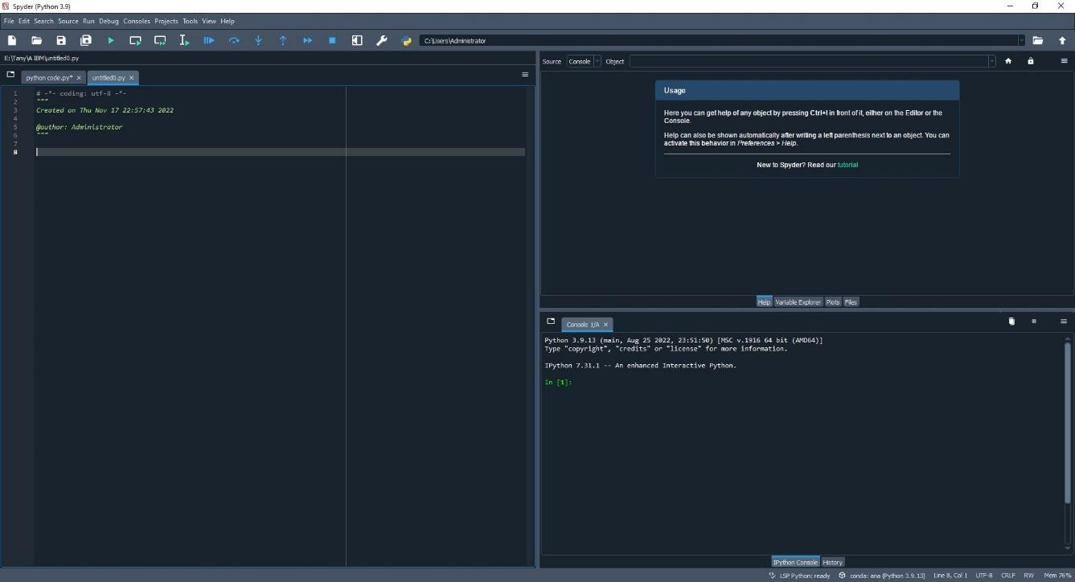

Python Packages Installations For Machine Learning And Deep Learning:

