Regulation : 2013 year/Semester : IV/7

Course code/Title:CS6003/Adhoc and Sensor Networks

Assignment no: 3 Date:

Topic | Questions | Relevance to CO
Localization techniques | Classify the various localization algorithms in WSN. | CO5
QoS related performance measurements | Discuss the summary of WSN strategies that produce improvement in QoS metrics | CO6

- Classify the various localization algorithms in WSN.
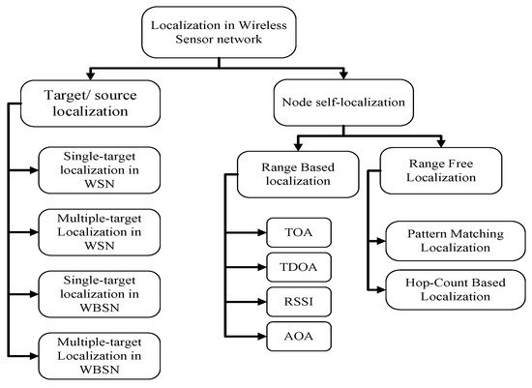

- Discuss the summary of WSN strategies that produce improvement in QoS metrics
