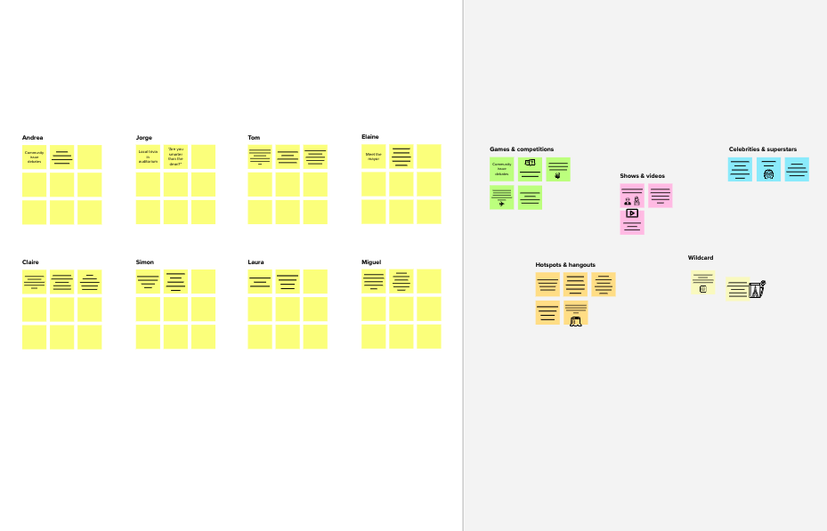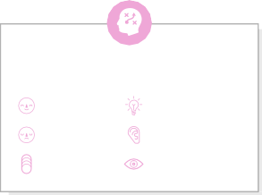

**Smart Waste Management for metropolitan cities: IOT**

**TIP**

You can select a sticky note and hit the pencil [switch to sketch] icon to start drawing!

## Before you collaborate

#### A little bit of preparation goes a long way with this session. Here’s what you need to do to get going.

##### 10 minutes

**TEAM ID:PNT2022TMID19657**

**1**

## Define your problem statement

#### What problem are you trying to solve? Frame your problem as a How Might We statement. This will be the focus of your brainstorm.

##### 5 minutes

**TEAM ID:PNT2022TMID19657**

## PROBLEM

Today big cities around the world are facing a common problem, managing the city waste effectively without making city unclean. Today’s waste management systems involve a large number of employees being appointed to attend a certain number of dumpsters. This leads to a very inefficient and unclean system in which some dumpsters are overflowing. Here a smart waste management system is introduced in which each dumpster is embedded in a monitoring system that will notify if the dumpster is full.

This system provides an effective solution to the waste management problem.

**2**

## Brainstorm

#### Write down any ideas that come to mind that address your problem statement.

##### 10 minutes

**3**

## Group ideas

#### Take turns sharing your ideas while clustering similar or related notes as you go. Once all sticky notes have been grouped, give each cluster a sentence-like label. If a cluster is bigger than six sticky notes, try and see if you and break it up into smaller sub-groups.

##### 20 minutes

**4**

## Prioritize

#### Your team should all be on the same page about what's important moving forward. Place your ideas on this grid to determine which ideas are important and which are feasible.

**20 minutes**

## After you collaborate

You can export the mural as an image or pdf to share with members of your company who might find it helpful.

**Quick add-ons**

Enable GPS function to locate bins easier

The bins GPS location is sent to the municipality if threshold is reached

**Team Leader: Thasneem.**

**Team Members: Parthasarathy**

**Siva Ganesh**

**Surya Vishwa**

**Thanya**

###### Team gathering

Define who should participate in the session and send an invite. Share relevant information or pre-work ahead.

###### Set the goal

Think about the problem you'll be focusing on solving in the brainstorming session.

###### Learn how to use the facilitation tools

Use the Facilitation Superpowers to run a happy and

Partha sarathy

# 

The sensor values are collected

The collected data is stored and maintained in a cloud platform

Siva Ganesh

# 

Amount of garbage collected in bins is monitored using sensor

Analyse the sensor data to indicate the municipality

The proposed system would be able to automate the solid waste monitoring process and management of the overall collection process using IOT (Internet of Things).

The data is stored into cloud and analyzed

Data analytics can help assess trends to better plan

**TIP**

Add customizable tags to sticky notes to make it easier to find, browse, organize, and categorize important ideas as themes within your mural.

###### Share the mural

**Share a view link** to the mural with stakeholders to keep them in the loop about the outcomes of the session.

###### Export the mural

Export a copy of the mural as a PNG or PDF to attach to emails, include in slides, or save in your drive.

The optimal path to reach the bins is determined

**10 minutes** to prepare

**1 hour** to collaborate

**2-8 people** recommended

productive session.

[**Open article**](https://support.mural.co/en/articles/2113740-facilitation-superpowers)

Data analytics can

help in improving the efficiency

Sensors are fixed in the garbage bins to detect the level of garbage

**Key rules of brainstorming**

To run an smooth and productive session

Surya Vishwa

Once the threshold limit is reached, GPS location is sent

Level of garbage is monitored whether it reached threshold or not

Thanya

Thasneem

### Keep moving forward

The optimal path to reach the bins location is analyzed

###### Strategy blueprint

Define the components of a new idea or strategy.

###### [Open the template](https://app.mural.co/template/e95f612a-f72a-4772-bc48-545aaa04e0c9/984865a6-0a96-4472-a48d-47639307b3ca)

**Customer experience journey map**

Stay in topic. Defer judgment.

Store the data in the cloud and analyze them

Encourage wild ideas. Listen to others.

### Importance

The optimal path to reach the bins is determined

Enable GPS function to locate bins easier

An Ultrasonic sensor always senses

the garbage level and checks whether the threshold value is reached or not

If each of these

Understand customer needs, motivations, and obstacles for an experience.

###### [Open the template](https://app.mural.co/template/b7114010-3a67-4d63-a51d-6f2cedc9633f/c1b465ab-57af-4624-8faf-ebb312edc0eb)

Go for volume. If possible, be visual.

tasks could get

done without any difficulty or cost, which would have the most positive impact?

Reduction of pollution

Clean Environment

Less labour intensive

###### Strengths, weaknesses, opportunities & threats

Identify strengths, weaknesses, opportunities, and threats (SWOT) to develop a plan.

|  |  |
| --- | --- |
|  |  |
|  |  |

###### [Open the template](https://app.mural.co/template/6a062671-89ee-4b76-9409-2603d8b098be/ca270343-1d54-4952-9d8c-fbc303ffd0f2)

Nearby truck drivers are intimated to collect the garbage

**TIP**

Participants can use their cursors to point at where sticky notes should go on the grid. The facilitator can confirm the spot by using the laser pointer holding the **H key** on the keyboard.

###### [Share template feedback](https://muralco.typeform.com/to/CiqaHVat?typeform-source=app.mural.co)

[**Share template feedback**](https://muralco.typeform.com/to/CiqaHVat?typeform-source=app.mural.co)

### Feasibility

Regardless of their importance, which tasks are more feasible than others? (Cost, time, effort, complexity, etc.)

**Varsha**

**Template**

**Need some inspiration?**

See a finished version of this template to kickstart your work.

[**Open example**](https://app.mural.co/template/e5a93b7b-49f2-48c9-afd7-a635d860eba6/93f1b98d-b2d2-4695-8e85-7e9c0d2fd9b9)