



* **Profit by State**
* **Profit compared to R&D Spend by Administration colored by State**
* **Marketing Spend for R&D Spend**
* **Administration by Marketing Spend colored by State**
* **Marketing Spend hierarchy colored by State and sized by Profit**
* **R&D Spend and Administration with State and State for Profit**

Explore data relationships

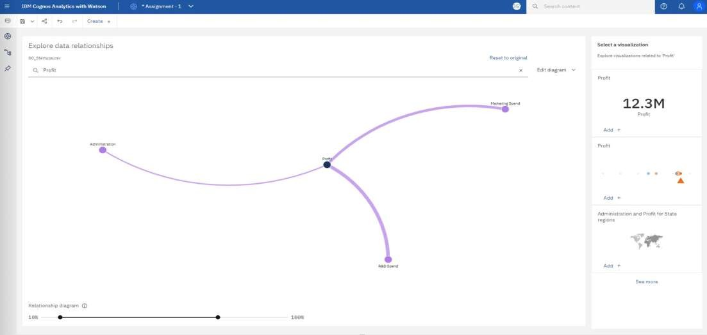

# Profit by State

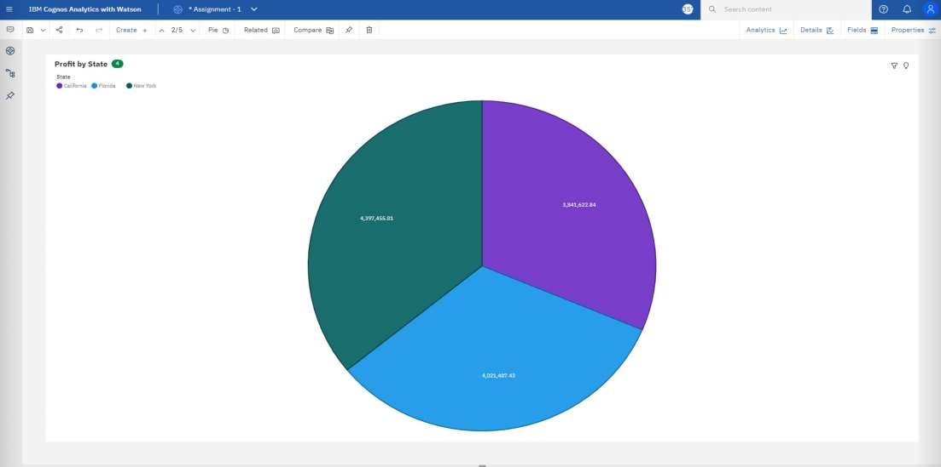

**Profit compared to R&D Spend by Admin colored by State**

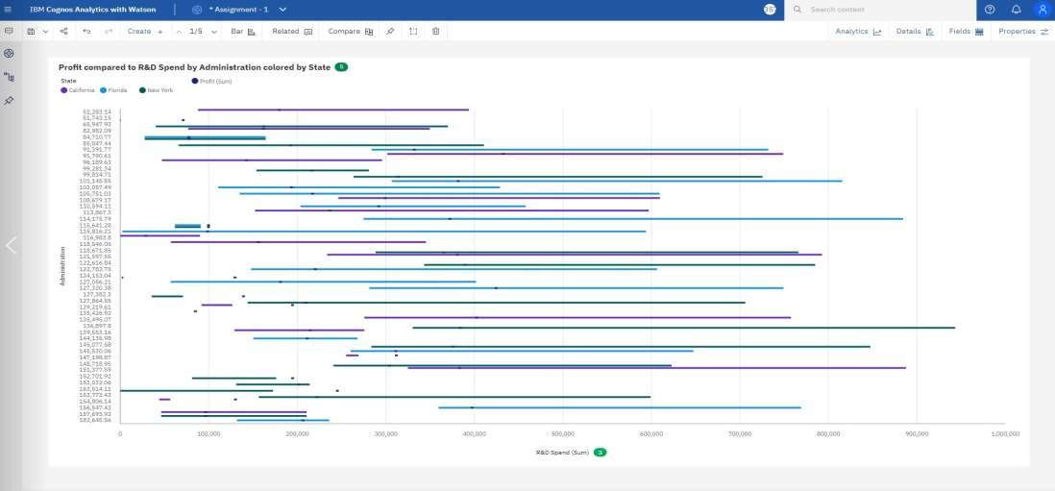

**Marketing Spend for R&D Spend**

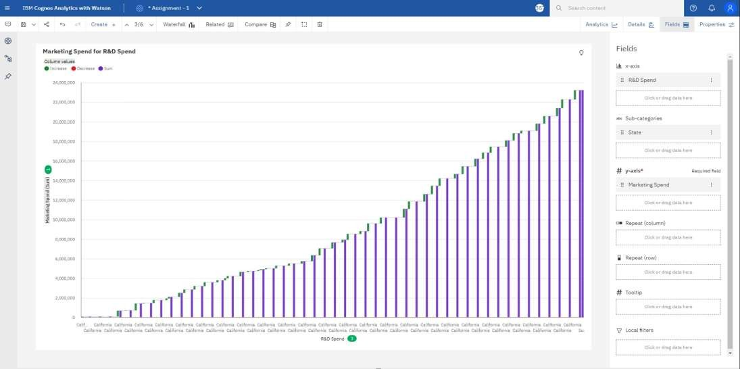

**Administration by Marketing Spend colored by State**

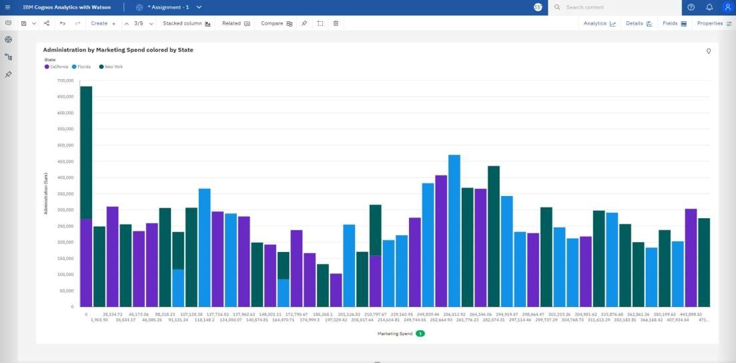

**Marketing Spend hierarchy colored by State and sized by Profit**

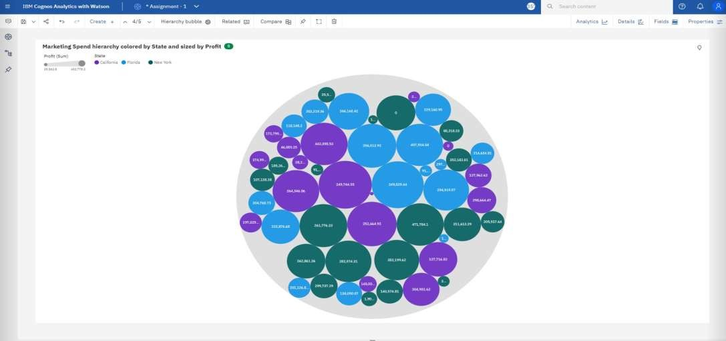

**R&D Spend and Administration with State and State**

**for Profit**

