ASSIGNMENT - 4

DISTANCE DETECTION USING ULTRASONIC SENSOR

|  |  |
| --- | --- |
| **Date** | 10 NOVEMBER 2022 |
| **Team ID** | **PNT2022TMID47589** |
| **Name** | N.Swetha |
| **Register Number** | 911019104028 |
| **Maximum Marks** | 2 Marks |

**CODE:**

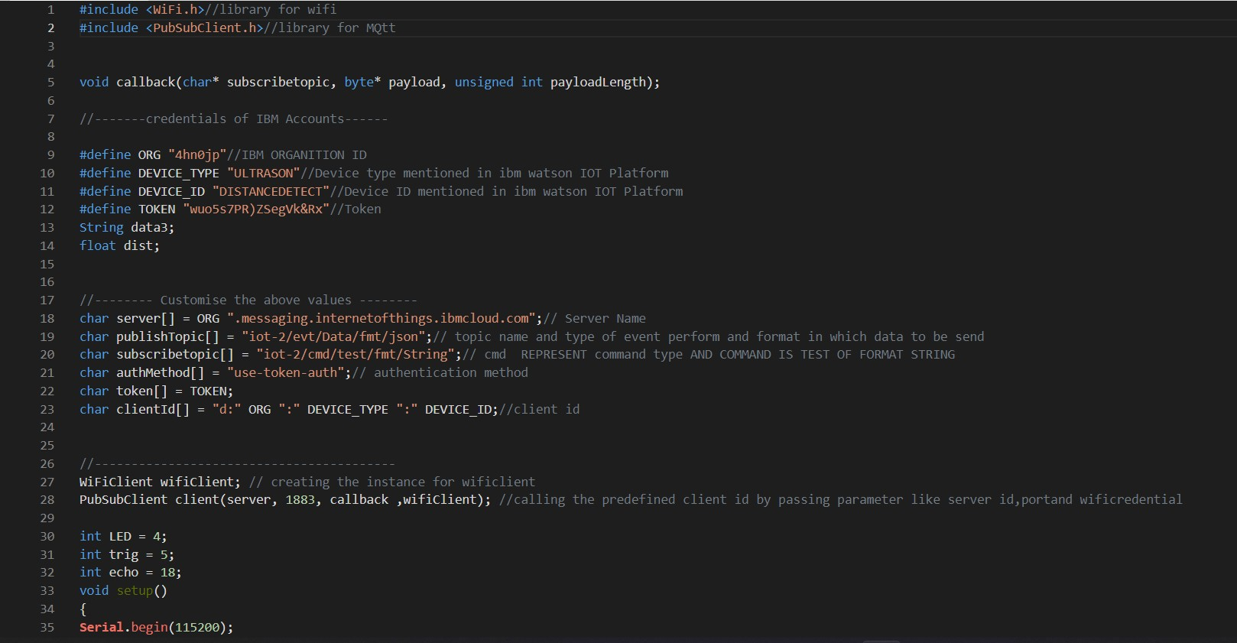

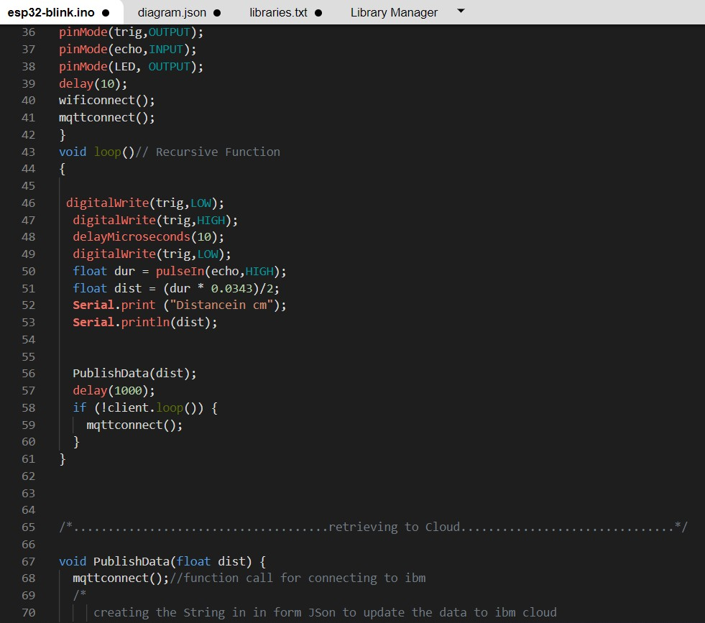

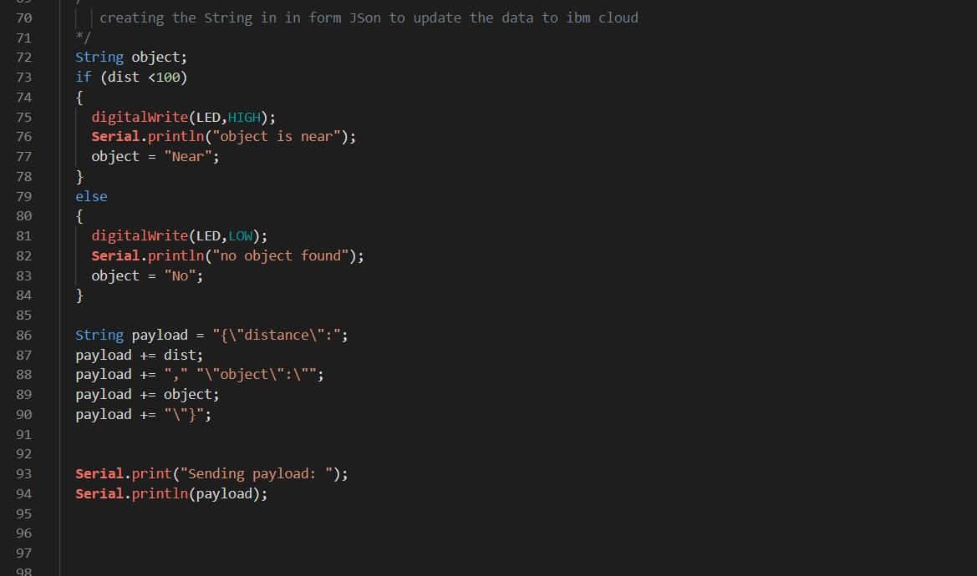

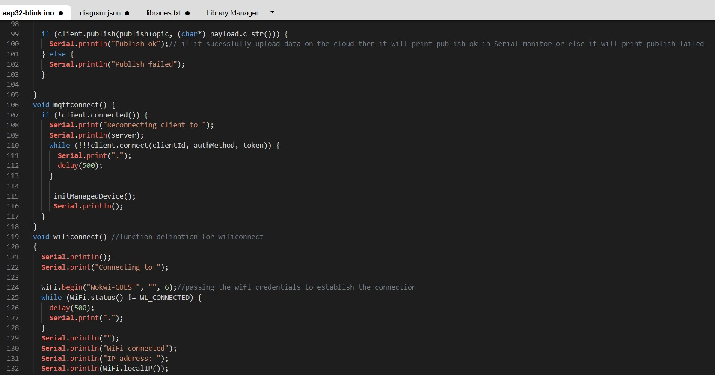

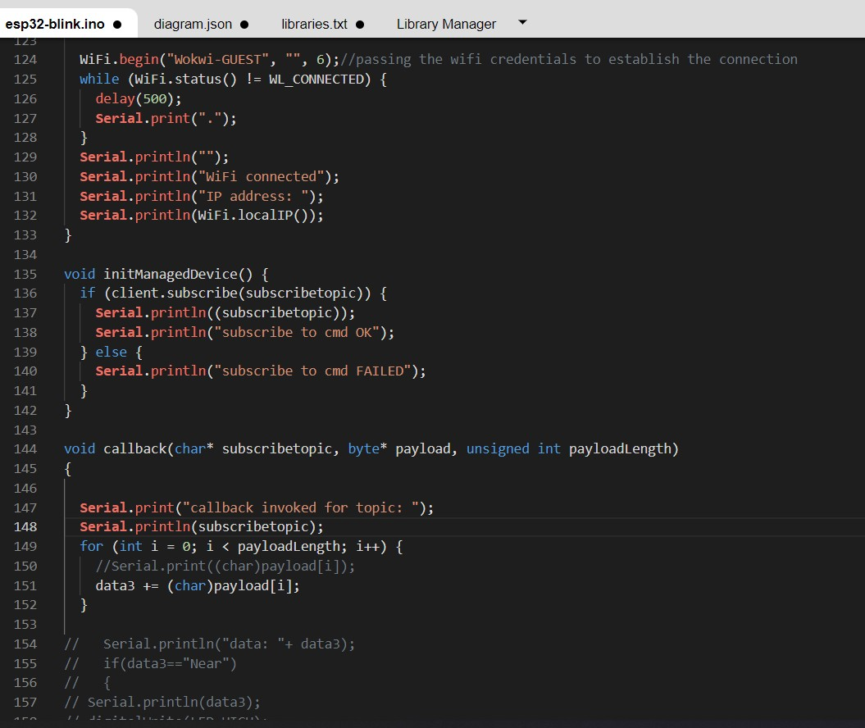

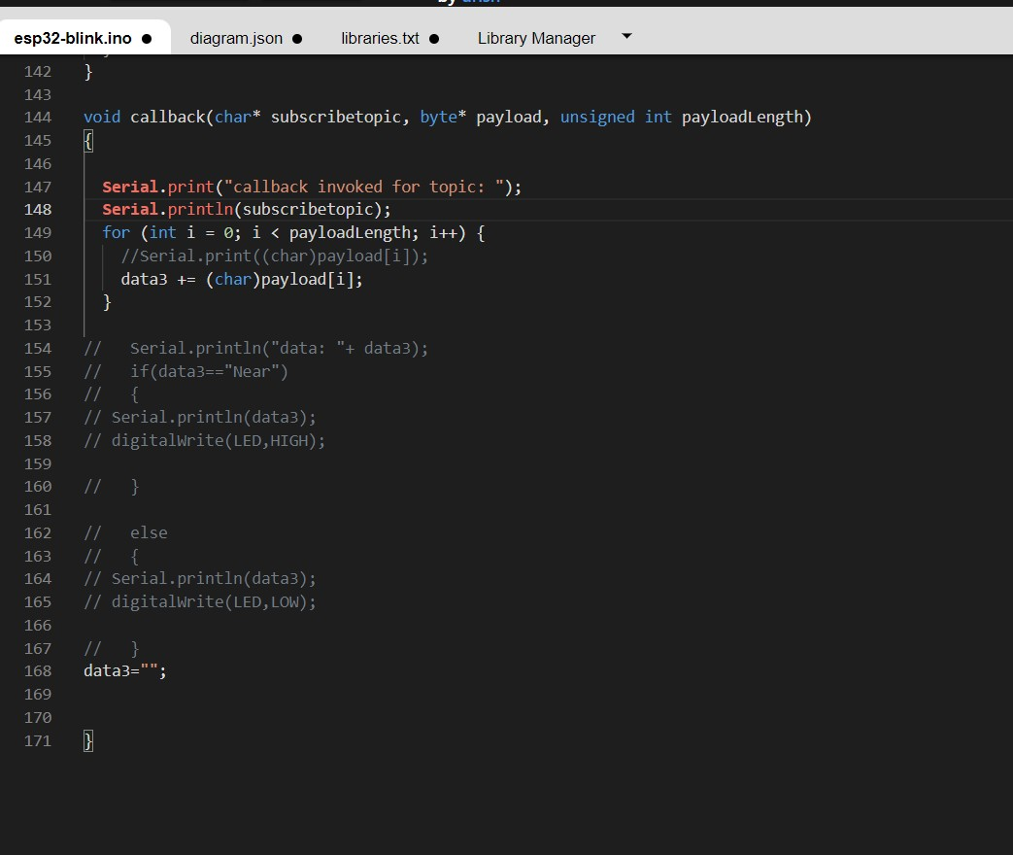

**OUTPUT:**

