IoT Based Safety Gadget for Child Safety Monitoring and Notification

ASSIGNMENT 1
SMART HOME IN TINKERCAD USING 2+ SENSORS
- Circuit Diagram
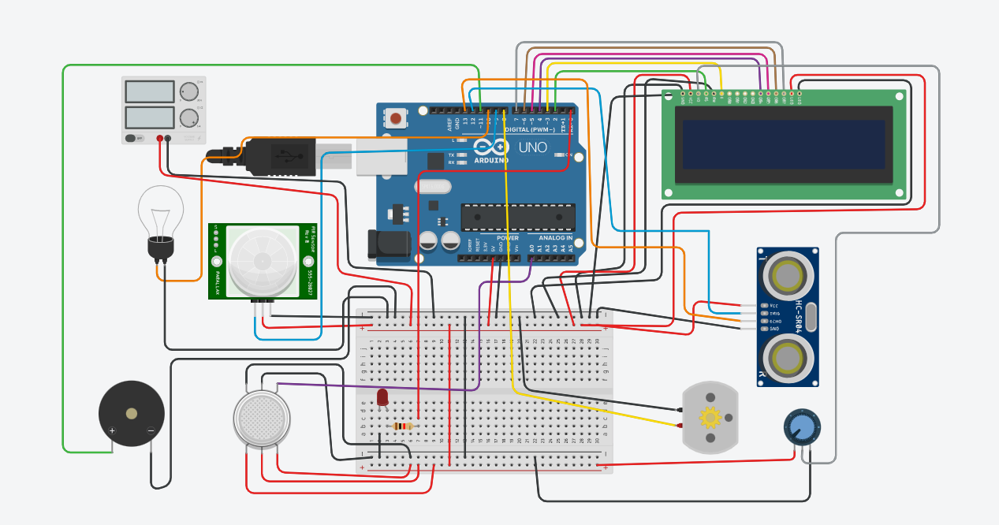

- Components Required:
Name | Quantity | Component
U1 | 1 | Arduino Uno R3
DIST1 | 1 | Ultrasonic Distance Sensor
M1 | 1 | DC Motor
U2 | 1 | LCD 16 x 2
P1 | 1 | 21 , 5 Power Supply
PIR1 | 1 | 20.722593638638443 , -237.58262756842853 , -197.9092690878765 , -253.1130883508938 PIR Sensor
L2 | 1 | Light bulb
GAS1 | 1 | Gas Sensor
PIEZO1 | 1 | Piezo
R1 | 1 | 10 kâ„¦ Resistor
Rpot1 | 1 | 250 kâ„¦ Potentiometer
D1 | 1 | Red LED
R2 | 1 | 330 â„¦ Resistor

- Running Simulation in Tinkercad
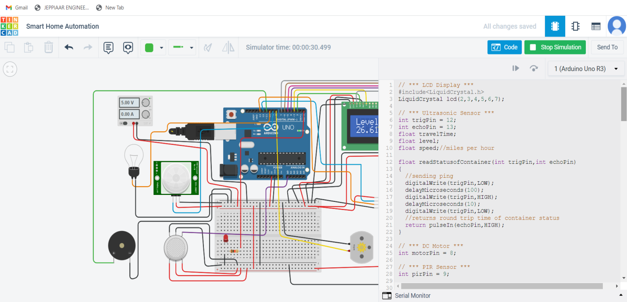
- Code:
// *** LCD Display ***
#include<LiquidCrystal.h>
LiquidCrystal lcd(2,3,4,5,6,7);

// *** Ultrasonic Sensor ***
int trigPin = 12;
int echoPin = 13;
float travelTime;
float level;
float speed;//miles per hour

float readStatusofContainer(int trigPin,int echoPin)
{
//sending ping
digitalWrite(trigPin,LOW);
delayMicroseconds(100);
digitalWrite(trigPin,HIGH);
delayMicroseconds(10);
digitalWrite(trigPin,LOW);
//returns round trip time of container status
return pulseIn(echoPin,HIGH);
}

// *** DC Motor ***
int motorPin = 8;

// *** PIR Sensor ***
int pirPin = 9;

// *** Light ***
int lightPin = 10;

// *** Gas Sensor ***
int gasPin = A0;
int threshold = 400;

// *** Piezo ***
int buzzPin = 11;

// *** LED ***
int ledPin = 0;

void setup()
{
Serial.begin(9600);

// *** LCD Display ***
lcd.begin(16,2);

// *** Ultrasonic Sensor ***
pinMode(trigPin,OUTPUT);
pinMode(echoPin,INPUT);

// *** DC Motor ***
pinMode(motorPin,OUTPUT);

// *** PIR Sensor ***
pinMode(pirPin,INPUT);

// *** Light ***
pinMode(lightPin,OUTPUT);

// *** Gas Sensor ***
pinMode(gasPin,INPUT);

// *** Piezo ***
pinMode(buzzPin, OUTPUT);

// *** LED ***
pinMode(ledPin,OUTPUT);
}

void loop()
{
// *** Trash can monitoring ***
// Trash can height 5 inches
travelTime = readStatusofContainer(trigPin,echoPin);//microseconds
travelTime = travelTime/1000000;//seconds
travelTime = travelTime/3600;//hours
speed = 60.0;//miles per hour(86.4 for 5 inches)
level = speed * travelTime;//miles
level = level/2;//because travelTime is round trip time
level = level * 63360;//inch
if(level <= 4.5)
{
//dispaly status
lcd.clear();
lcd.setCursor(0,0);
lcd.print("Trash Level:");
lcd.setCursor(0,1);
lcd.print(level);
lcd.print(" inches");
delay(100);
}
else
{
//dispaly status
lcd.clear();
lcd.setCursor(0,0);
lcd.print("Trash is full");
lcd.setCursor(0,1);
lcd.print(level);
lcd.print(" inches away");
delay(100);
}

// *** Water level monitoring ***
// Water tank height 20 inches
travelTime = readStatusofContainer(trigPin,echoPin);//microseconds
travelTime = travelTime/1000000;//seconds
travelTime = travelTime/3600;//hours
speed = 240.1;//miles per hour(345.3 for 20 inches)
level = speed * travelTime;//miles
level = level/2;//because travelTime is round trip time
level = level * 63360;//inch
if(level <= 19.0)
{
//dispaly status and Turn on motor
digitalWrite(motorPin,HIGH);
lcd.clear();
lcd.setCursor(0,0);
lcd.print("Level: Motor");
lcd.setCursor(0,1);
lcd.print(level);
lcd.print(" in On");
delay(100);
}
else
{
//dispaly status and Turn off motor
digitalWrite(motorPin,0);
lcd.clear();
lcd.setCursor(0,0);
lcd.print("Level: Motor");
lcd.setCursor(0,1);
lcd.print(level);
lcd.print(" in Off");
delay(100);
}

// *** Motion Detection
if(digitalRead(pirPin)==HIGH)
digitalWrite(lightPin, HIGH);
else
digitalWrite(lightPin, LOW);
delay(100);

// *** Detects flammable gases ***
if(analogRead(gasPin) >= threshold)
{
digitalWrite(ledPin,HIGH);
digitalWrite(buzzPin,HIGH);
}
else
{
digitalWrite(ledPin,LOW);
digitalWrite(buzzPin,LOW);
}
delay(100);
}

- Output:

