**PREREQUISITES**

|  |  |
| --- | --- |
| **DATE** | 29 October 2022 |
| **TEAM ID** | PNT2022TMID24852 |
| **PROJECT NAME** | IoT based Smart Crop Protection System for Agriculture |
| **MAXIMUM MARKS** | 8 Marks |

**Creation of IBM cloud account:**

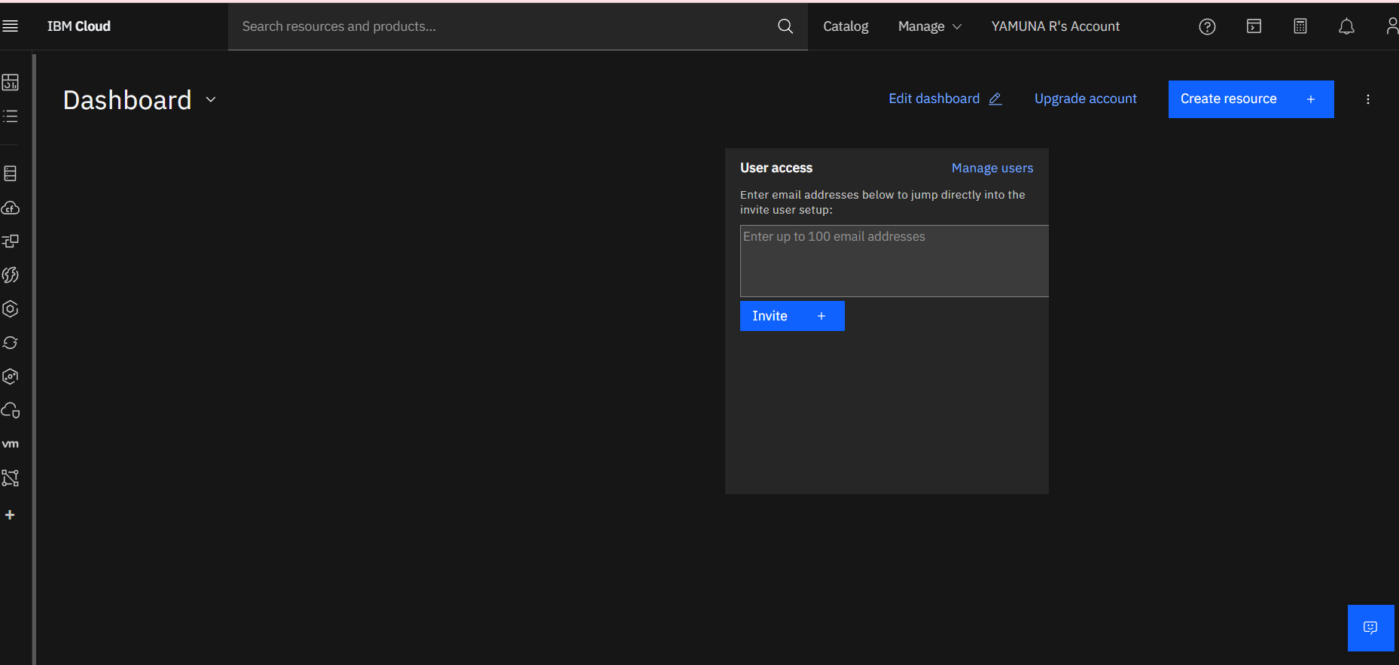

**Python Installation:**

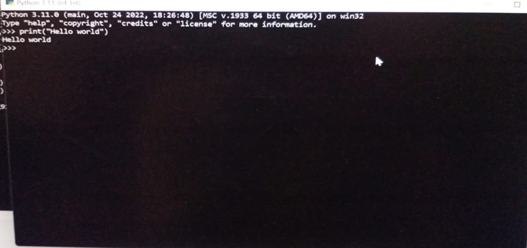

**Creation of account in Clarifai:**

