**Assignment -3**

|  |  |
| --- | --- |
| Assignment Date | 26 October 2022 |
| Student Name | N.S.Sai Prasanthy |
| Student Roll Number | 920819104030 |
| Maximum Marks | 2 Marks |

**Question-1:**

Create a Bucket in IBM object storage

**Solution:**

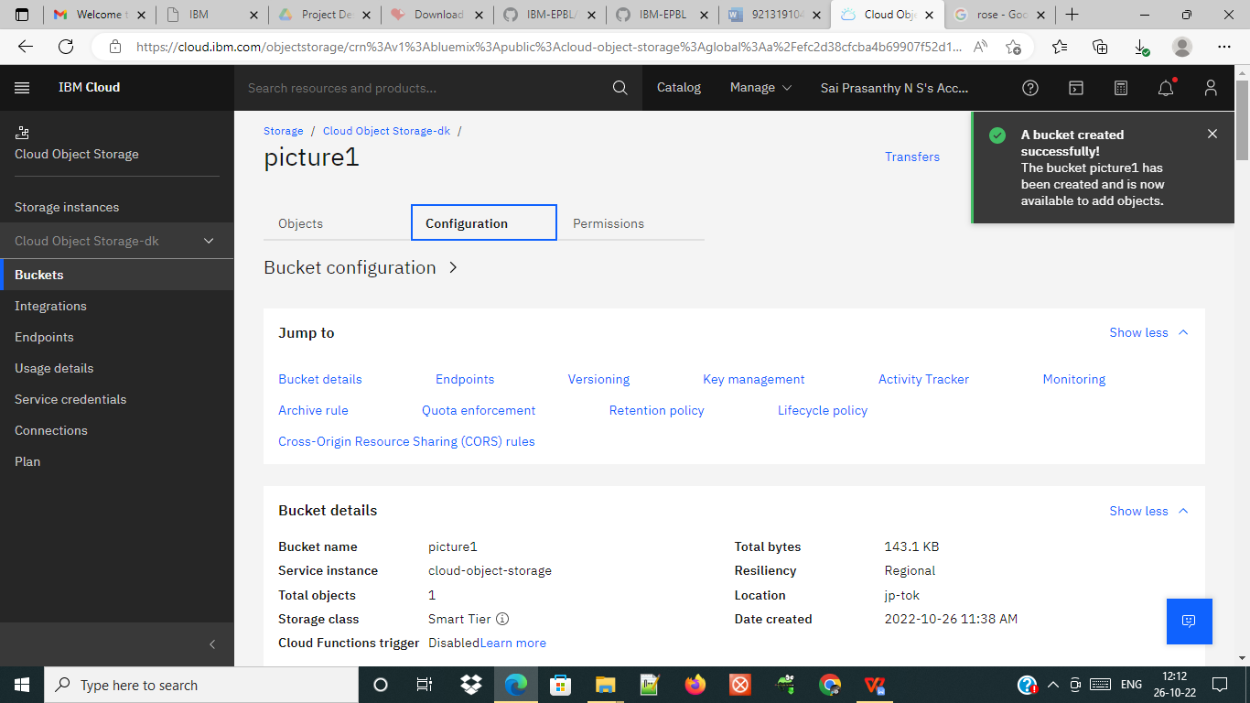

**Question-2:**

**Upload an 5 images to ibm object storage and make it public. Write html code to displaying all the 5 images.**

**Solution:<!DOCTYPE html>**

<html>

<head>

<title>

Images From Cloud Object Storage

</title>

<link rel="stylesheet" href="style.css">

</head>

<body>

<h2>Images In Cloud Object Storage</h2>

<img src="https://cloud-object-storage-sk-cos-standard-0kv.s3.jp-tok.cloud-object-storage.appdomain.cloud/obj%203.jfif"></img>

<img src="https://cloud-object-storage-sk-cos-standard-0kv.s3.jp-tok.cloud-object-storage.appdomain.cloud/obj%203.jfif"></img>

<img src="https://cloud-object-storage-sk-cos-standard-0kv.s3.jp-tok.cloud-object-storage.appdomain.cloud/obj%203.jfif"></img>

<img src="https://cloud-object-storage-sk-cos-standard-0kv.s3.jp-tok.cloud-object-storage.appdomain.cloud/download.jpg"></img>

<img src="https://cloud-object-storage-sk-cos-standard-0kv.s3.jp-tok.cloud-object-storage.appdomain.cloud/images.jpg"></img>

</body>

</html>

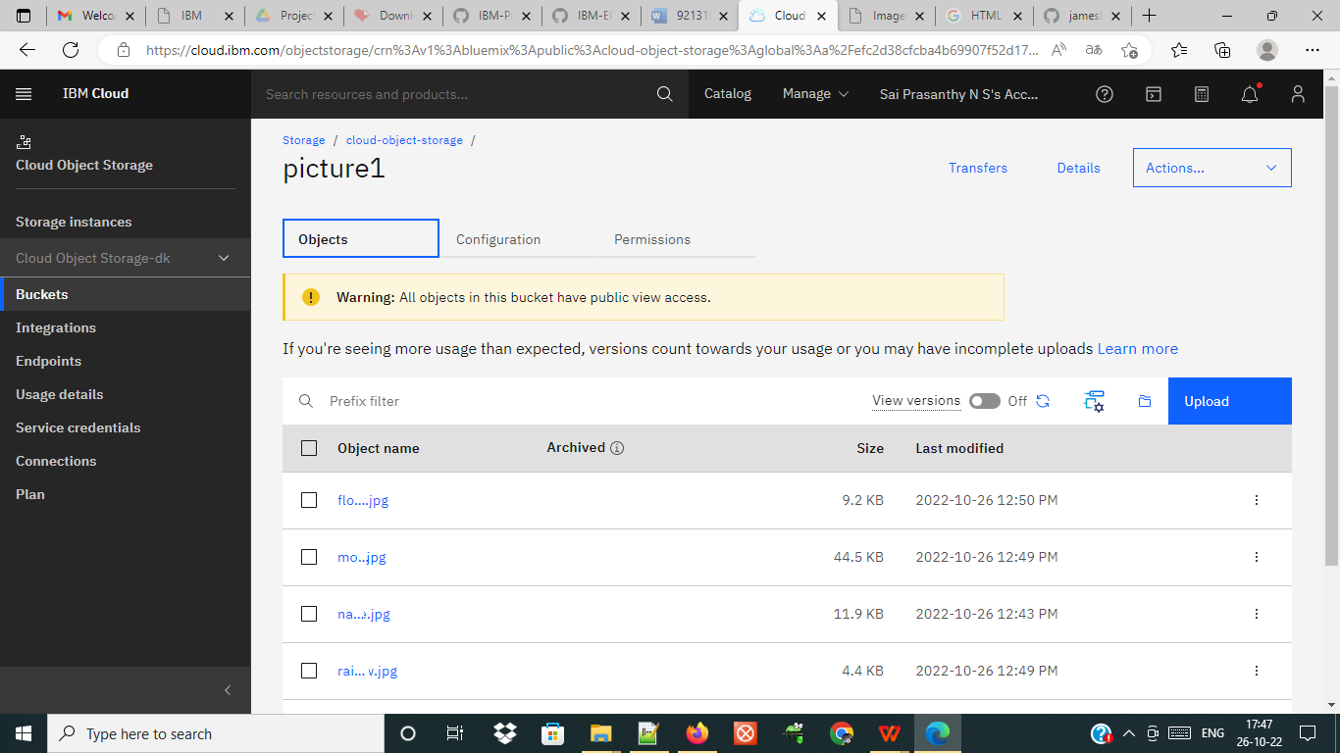

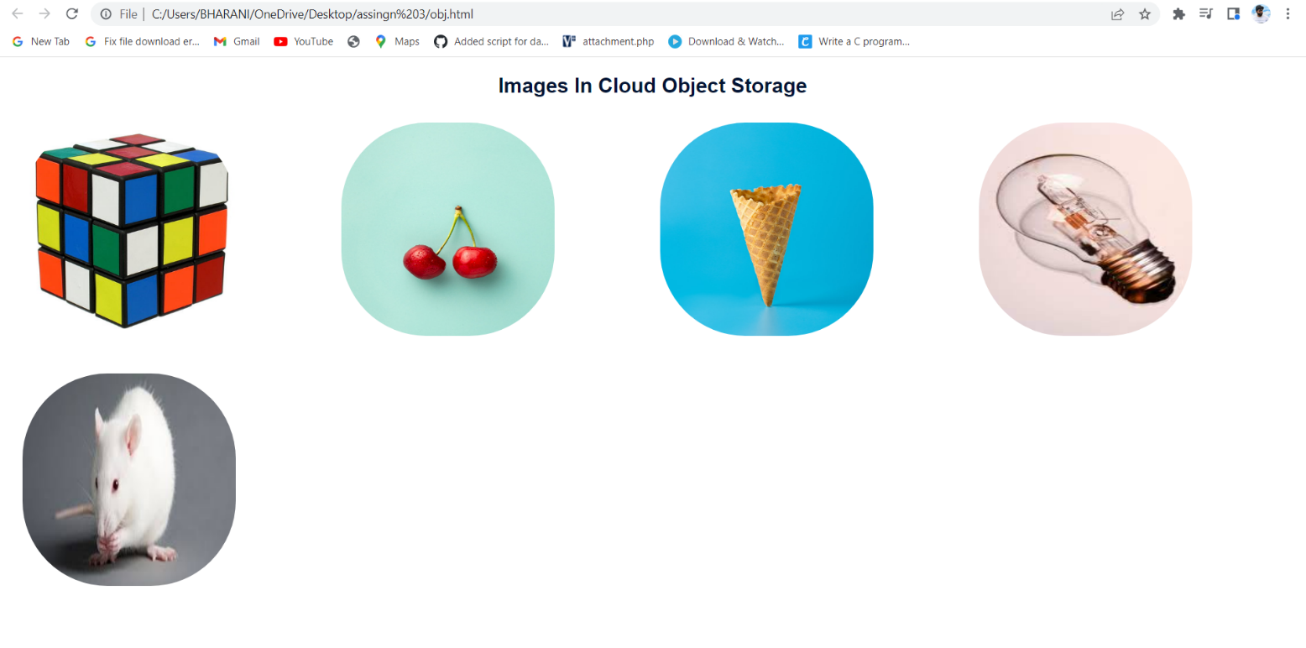

**Question-3:**

Upload a css page to the object storage and use the same page in your html code. Solution:

New.css uploaded to the object storage and used the same page in html code



Css page used in HTML page:



**Question-4:**

Design a Chabot using IBM Watson assistant for hospital.

Solution:

<https://web-chat.global.assistant.watson.appdomain.cloud/preview.html?backgroundImageURL=https%3A%2F%2Fau-syd.assistant.watson.cloud.ibm.com%2Fpublic%2Fimages%2Fupx-25e59597-0ccb-4797-bf68-f8930639df91%3A%3Afa5c06a0-21b6-44e8-8a57-e4239526f968&integrationID=ed3db3d7-2fb3-4898-a2b3-f079db727e0a&region=au-syd&serviceInstanceID=25e59597-0ccb-4797-bf68-f8930639df91>

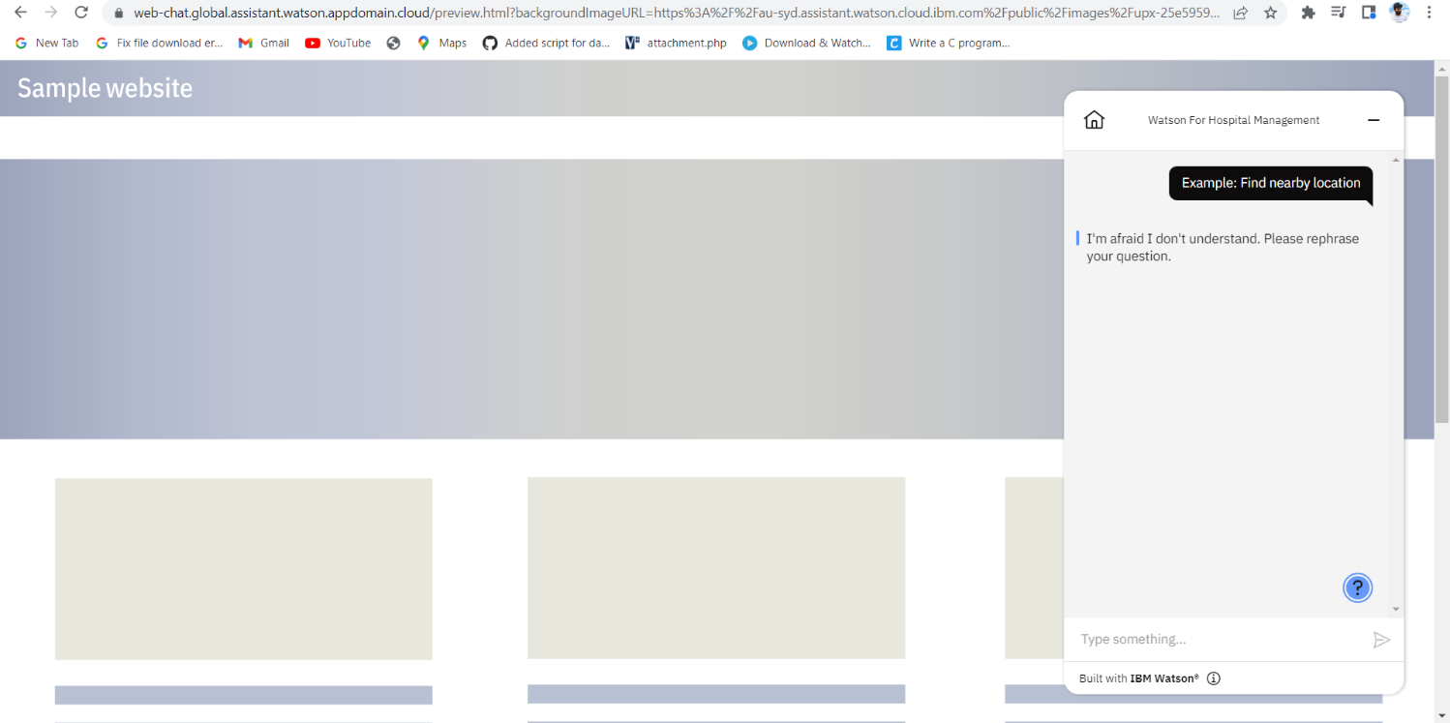

**Question-5:**

Create Watson assistant service with 10 steps and use 3 conditions in it. Load that script in html page Solution:

|  |
| --- |
| <!DOCTYPE html>  <html>  <head>  <title>  IBM Watson ChatBot  </title>  <link rel="stylesheet" href="style.css”;  <script>  window.watsonAssistantChatOptions = {  integrationID: "ed3db3d7-2fb3-4898-a2b3-f079db727e0a", // The ID of this integration.  region: "au-syd", // The region your integration is hosted in.  serviceInstanceID: "25e59597-0ccb-4797-bf68-f8930639df91", // The ID of your service instance.  onLoad: function(instance) { instance.render(); }  };  setTimeout(function(){  const t=document.createElement('script');  t.src="https://web-chat.global.assistant.watson.appdomain.cloud/versions/" + (window.watsonAssistantChatOptions.clientVersion || 'latest') + "/WatsonAssistantChatEntry.js";  document.head.appendChild(t);  });  </script>    </head>  <body>  <h1>ChatBot Page </h1>  </body>  </html> |

Output:

