Personal Assistance for Seniors Who Are Self-Reliant

Assignment

Topic : PYTHON CODE TO GET TEMPERATURE AND HUMIDITY VALUE

Name: Christiya.l

Code:

import random while(True):

temp-random.randint(1 0,99) humidity-random.randint(10,99) print("current temperature: ",temp) print("current humidity:",humidity,"%") temp_ref=45 humidity_ref=50 if temp > temp_ref and humidity < humidity_ref: print("Alarm on") else:

print("Alarm off") break

OUTPUT :

# ALARM ON

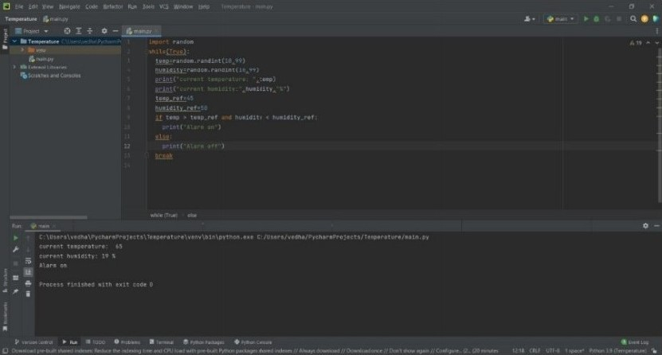

# ALARM OFF

