Project Design Phase-II

Data Flow Diagram & User Stories

|  |  |
| --- | --- |
| Date | 14 October 2022 |
| Team ID | PNT2022TMID14066 |
| Project Name | Project -Signs with Smart Connectivity for Better Road Safety |
| Maximum Marks | 4 Marks |

# Data Flow Diagrams:

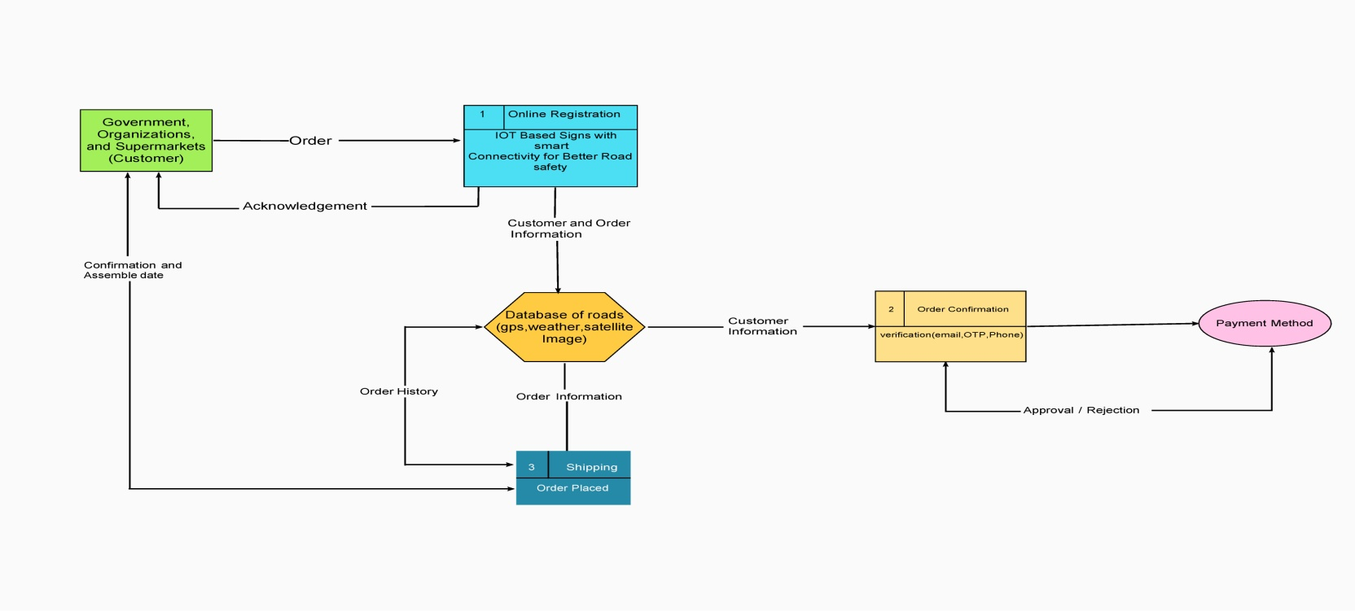

**User Stories**

Use the below template to list all the user stories for the product.

|  |  |  |  |  |  |  |
| --- | --- | --- | --- | --- | --- | --- |
| **User Type** | **Functional**  **Requirement (Epic)** | **User Story Number** | **User Story / Task** | **Acceptance criteria** | **Priority** | **Release** |
| Customer (Mobile user) | Registration | USN-1 | As a user, I can register for the application by entering my email, password, and confirming my password. | I can access my account / dashboard | High | Sprint-1 |
|  |  | USN-2 | As a user, I will receive confirmation email once I have registered for the application | I can receive confirmation email & click confirm | High | Sprint-1 |
|  |  | USN-3 | As a user, I can register for the application through Facebook | I can register & access the dashboard with Face book Login | Low | Sprint-2 |
|  |  | USN-4 | As a user, I can register for the application through Gmail |  | Medium | Sprint-1 |
|  | Login | USN-5 | As a user, I can log into the application by entering email & password |  | High | Sprint-1 |
|  | Dashboard |  |  |  |  |  |
| Customer (Web user) |  |  |  |  |  |  |
| Customer Care Executive |  |  |  |  |  |  |
| Administrator |  |  |  |  |  |  |