Brainstorm

& idea prioritization

Cost reduction

Confidential

Easy Report Genreation

**1**

# Problem Statement

## To develop a machine learning model for Liver disease prediction in early stage

**2**

# Liver disease prediction using machine learning

## To analyze the patients data and to select a machine learning model which gives high accuracy for predicting the liver disease of the patients in the early stage

**4**

# Prioritize

## Prioritization of features and attributes

Use this template in your own brainstorming sessions so your team can unleash their imagination and start shaping concepts even if you're not sitting in the same room.

**10 minutes** to prepare

**1 hour** to collaborate

**2-8 people** recommended

**PROBLEM**

**To choose a classification algorithm which best fits for the given problem statement and able to map output with low cost of learning and with high accuracy**

# Lavanya S

High Accuracy

Security

User Friendly

SMS/email Support

# Preethi U

**Dharun kanna N**

**Thowfeekahamadu M**

**Bhuvanasri J**

Enhanced UI

Reliablity

Early Diagonisis

Trustable

# Abinaya M

**Divya D**

**Bhuvaneshwari T**

**Importance**

Availablity

Forwarding result to nearest Hospital

If each of these tasks could get done without any difficulty or cost, which would have the most positive impact?

Enhanced UI

Cost reduction

SMS/email Support

Early Diagonisis

High Accuracy

Survival Rate Increases

Connection with Health Care Centers

Reliablity

Integrity

Easy access

Adoptability

Early stage Prediction

Instant Accurate results

Rapid Prediction

24/7

Helpline Support

Survival Rate Increases

Easy Report Genreation

Risk Free

Connection with Health Care Centers

24/7

Helpline Support

Less complex

Confidential

Less complex

[**Share template feedback**](https://muralco.typeform.com/to/CiqaHVat?typeform-source=app.mural.co)

**Feasibility**

Regardless of their importance, which tasks are more feasible than others? (Cost, time, effort, complexity, etc.)

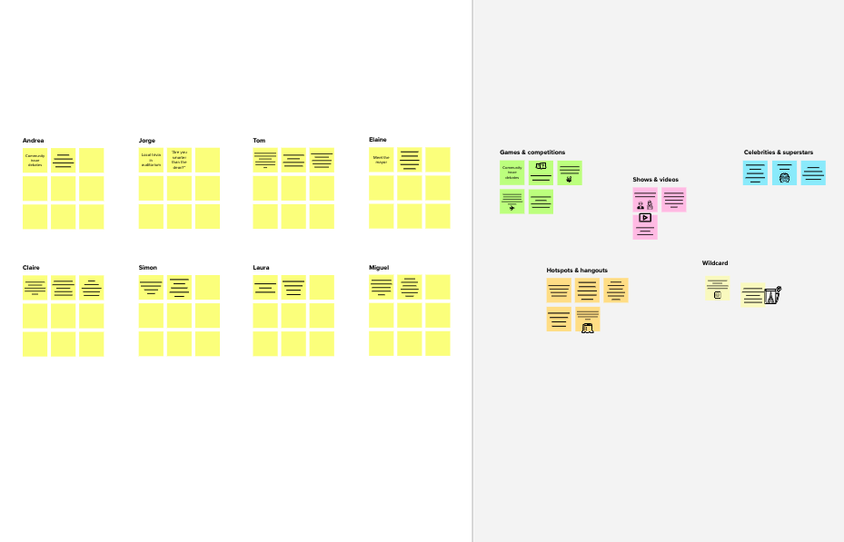

**Template**

**Need some inspiration?**

See a finished version of this template to kickstart your work.

[**Open example**](https://app.mural.co/template/e5a93b7b-49f2-48c9-afd7-a635d860eba6/93f1b98d-b2d2-4695-8e85-7e9c0d2fd9b9)