**Prerequisites**

**Software ( Python 3.6.5 )**

|  |  |
| --- | --- |
| Date | 07 September 2022 |
| Team ID | PNT2022TMID24784 |
| Project Name | Project - Signs with smart connectivity for Better road safety |
| Maximum Marks | 4 Marks |

**Signs with smart connectivity for Better road safety**

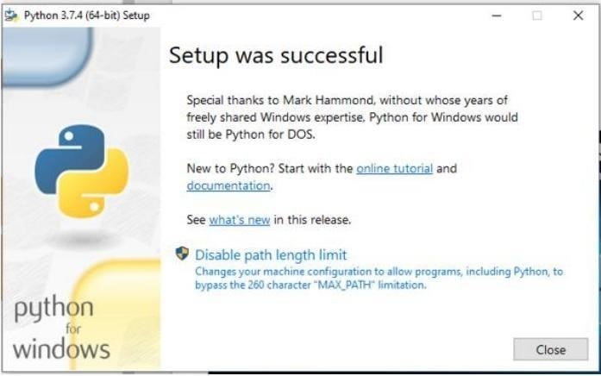

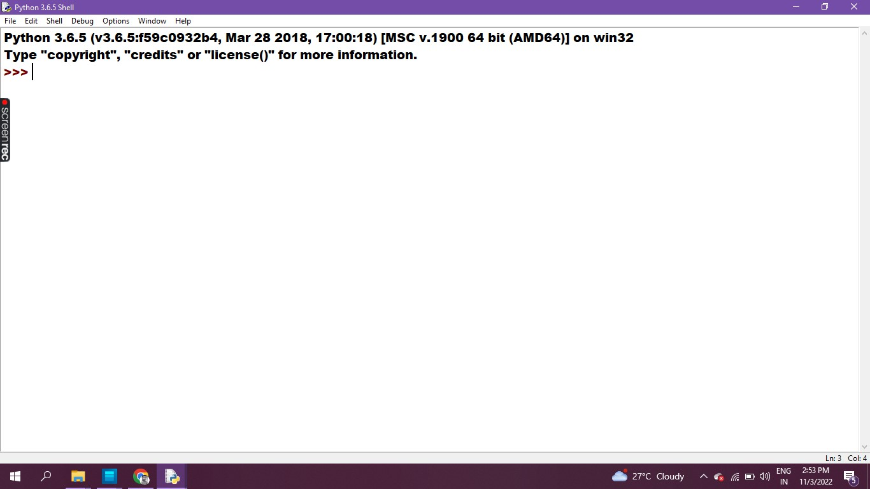

# Program & Output in Python IDLE 3.6.5 - 64bit

