**Brainstorm & idea prioritization**

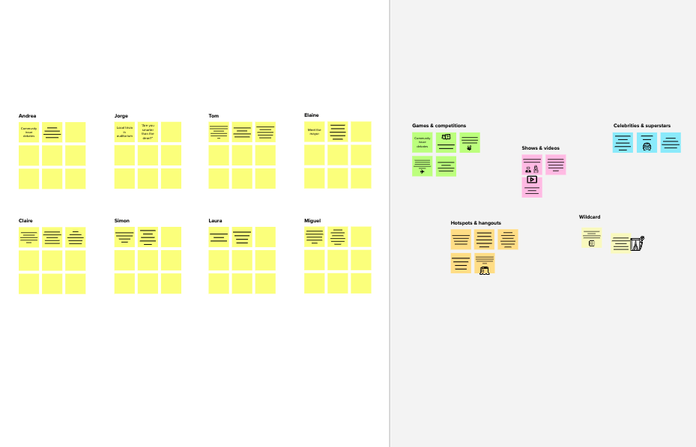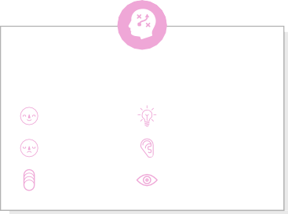

**Template**

# Brainstorm

**PROBLEM**

**How might we [your problem statement]?**

1Define your problem statement

#### What problem are you trying to solve? Frame your problem as a How Might We statement. This will be the focus of your brainstorm.

##### 5 minutes

|  |
| --- |
| Team ID: PNT2022TMID37965 |

**2**

## Brainstorm

#### Write down any ideas that come to mind that address your problem statement.

##### 10 minutes

**3**

## Group ideas

#### Take turns sharing your ideas while clustering similar or related notes as you go. Once all sticky notes have been grouped, give each cluster a sentence-like label. If a cluster is bigger than six sticky notes, try and see if you and break it up into smaller sub-groups.

##### 20 minutes

**4**

## Prioritize

#### Your team should all be on the same page about what's important moving forward. Place your ideas on this grid to determine which ideas are important and which are feasible.

**20 minutes**

# & idea prioritization

Use this template in your own brainstorming sessions so your team can unleash their imagination and start shaping concepts even if you're not sitting in the same room.

**Abirami-Team leader**

Picture

accessibility

Animated GIF for symbol

represent

-tion

Translations

ADA

Caption

**Karthika**

Different Handgestures

Audio descriptions

Sign language

Under

standable

**Sandhiya**

Priority

Neural network

**Compatibility**

* Compatibility

Lip reading

Emojis

Roger

voice

**Suryakala**

Picture of short Video

Communications

Soundscope

Evelity

Algorithms

Read adjustments

Challenges

Facial recognition

how could AI be used for person with sensory disabilities

How AI can improves lives of disabled peopled

what is aim of AI for disabled people?

Identify the details about realtime communication

user friendly

**10 minutes** to prepare

**1 hour** to collaborate

**2-8 people** recommended

**Key rules of brainstorming**

To run an smooth and productive session

productivity for disabled people

To increase independence

small description about realtime communication

add alerts

Stay in topic. Defer judgment.

physical and cognitive challenges

physical mobility microsoft

AI powered self driving car

increase employment and communication

Encourage wild ideas. Listen to others.

### Importance

If each of these

Go for volume. If possible, be visual.

tasks could get

done without any difficulty or cost, which would have the most positive impact?

Device related function

###### TIP

Participants can use their cursors to point at where sticky notes should go on the grid. The facilitator can confirm the spot by using the laser pointer holding the **H key** on the keyboard.

how the communication and human connection for disabled peoples?

what are the advancement of AI technology?

What is the AI challenging opportunities?

[**Share template feedback**](https://muralco.typeform.com/to/CiqaHVat?typeform-source=app.mural.co)

### Feasibility

Regardless of their importance, which tasks are more feasible than others? (Cost, time, effort, complexity, etc.)

**Need some inspiration?**

deaf and mute.

describes photos to people.

lip reading algorithm.

speech-to- text and text-to- speech

AI-voice assisted technology

recognizing faces and emotions.

See a finished version of this template to kickstart your work.

###### [Open example](https://app.mural.co/template/e5a93b7b-49f2-48c9-afd7-a635d860eba6/93f1b98d-b2d2-4695-8e85-7e9c0d2fd9b9)