### Assignment -1

#### Python Programming

|  |  |
| --- | --- |
| Assignment Date | 19 September 2022 |
| Student Name | Ranjani.V |
| Student Roll Number | 211419205137 |

**Question-1:**

## Split this string

|  |
| --- |
| **Solution:** |
| s = "Hi there Sam!" print(s.split()) |
|  |

**Question-2:**

## Use .format() to print the following string.

Output should be: The diameter of Earth is 12742 kilometers.

|  |
| --- |
| **Solution:** |
| planet = "Earth" diameter = 12742  print("The diameter of {planet} is {diameter} kilometers.") |

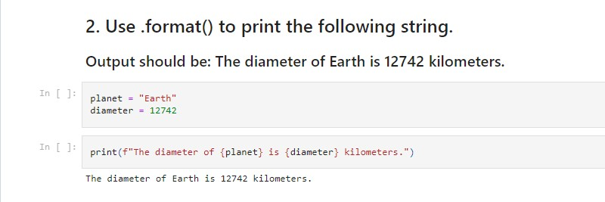

**Question-3:**

## In this nest dictionary grab the word "hello"

##### Solution:

d = {'k1':[1,2,3,{'tricky':['oh','man','inception',{'target':[1,2,3,'hello']}]}]} print(d['k1'][3]["tricky"][3]['target'][3])

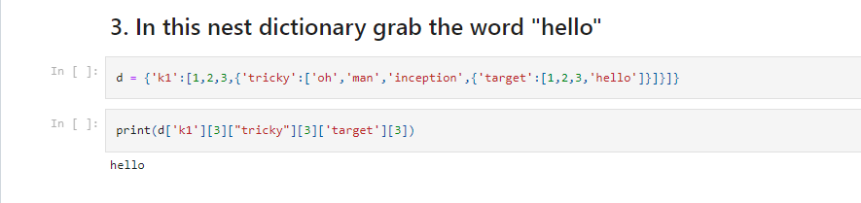

**Question-4:**

**Numpy**

##### Solution:

import numpy as np

# Create an array of 10 zeros?

* 1. **Create an array of 10 fives?**

##### Solution:

arr0 **=** [0] **\*** 9 print (arr0)

[0, 0, 0, 0, 0, 0, 0, 0, 0]

array**=**np**.**ones(10)**\***5 print("An array of 10 fives:") print(array)

An array of 10 fives:

[5. 5. 5. 5. 5. 5. 5. 5. 5. 5.]

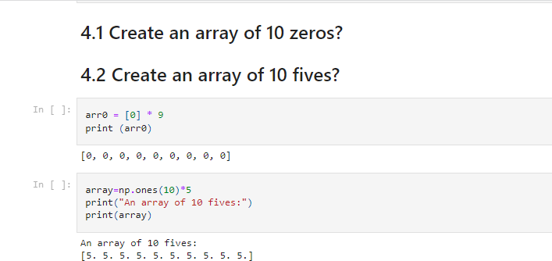

**Question-5:**

# Create an array of all the even integers from 20 to 35

##### Solution:

import numpy as np array**=**np**.**arange(20,36,2) print(array)

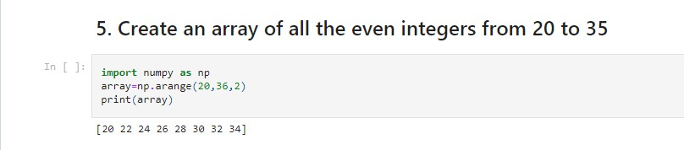

**Question-6:**

# Create a 3x3 matrix with values ranging from 0 to 8

##### Solution:

np**.**arange(0,9)**.**reshape((3,3))

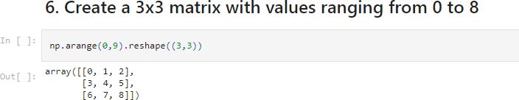

**Question-7:**

# Concatenate a and b a = np.array([1, 2, 3]), b = np.array ([4, 5, 6])

##### Solution:

a **=** np**.**array([1,2,3])

b **=** np**.**array([4,5,6]) np**.**concatenate((a,b))

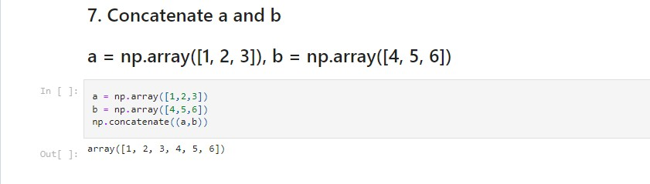

**Question-8:**

**Pandas**

# Create a dataframe with 3 rows and 2 columns

##### Solution:

import pandas as pd

data **=** {'Name':['Tom', 'nick', 'krish', 'jack'], 'Age':[20, 21, 19, 18]} df **=** pd**.**DataFrame(data)

print(df)

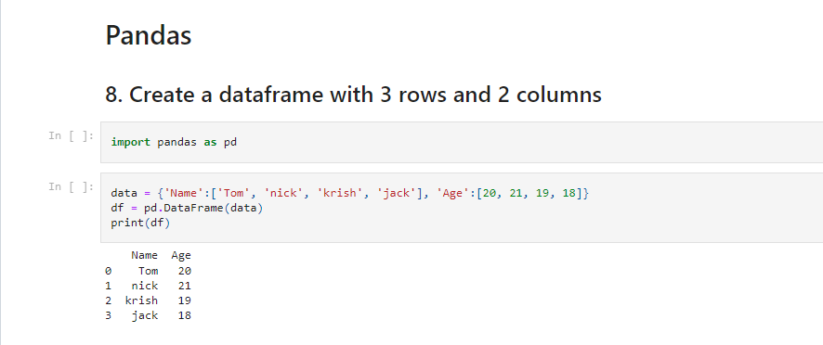

**Question-9:**

# Generate the series of dates from 1st Jan, 2023 to 10th Feb, 2023

##### Solution:

dates **=**pd**.**date_range('2023-01-01','2023-02-10') pd**.**Series(data**=**dates)

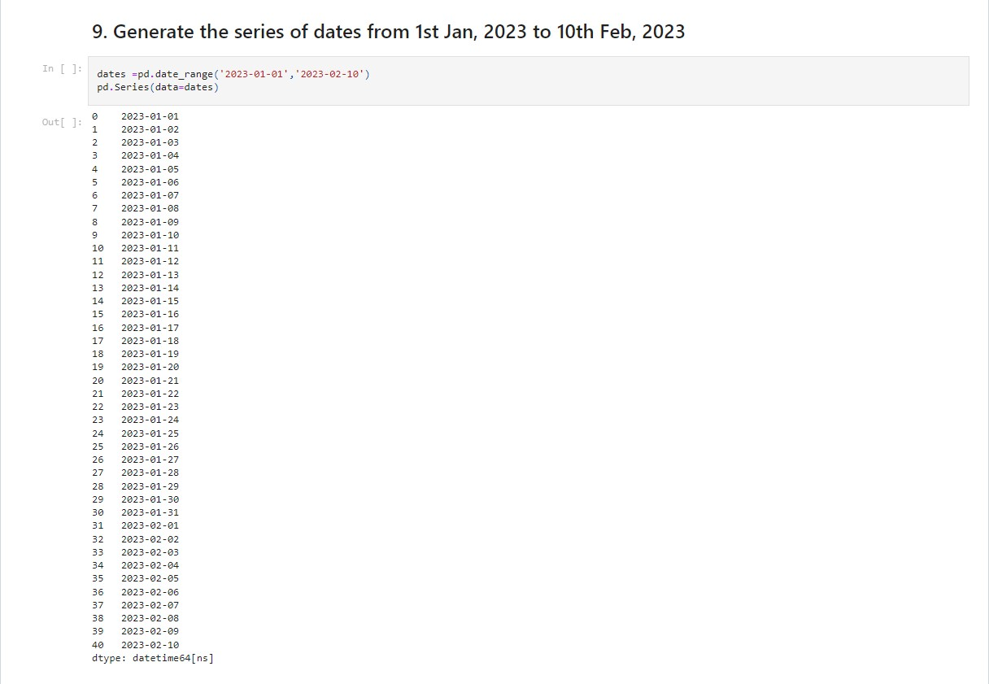

**Question-10:**

# Create 2D list to DataFrame

#### lists = [[1, 'aaa', 22], [2, 'bbb', 25], [3, 'ccc', 24]]

##### Solution:

lists **=** [[1, 'aaa', 22], [2, 'bbb', 25], [3, 'ccc', 24]]

values**=**lists pd**.**DataFrame(values)

