**Prerequisites**

**SOFTWARE**

|  |  |
| --- | --- |
| Date | 19 OCT 2022 |
| Team ID | PNT2022TMID37462 |
| Project Name | Project-Industry-specific intelligent fire management system |

**Submitted by:**

Team Leader: S.A.suffiyan

Team member:Asif

Team member: Akib

Team member: Taheer

**IBMIOTF IS INSTALLED ON PYTHON IDLE**

**CMD PROMT INSTALLAZATION:**

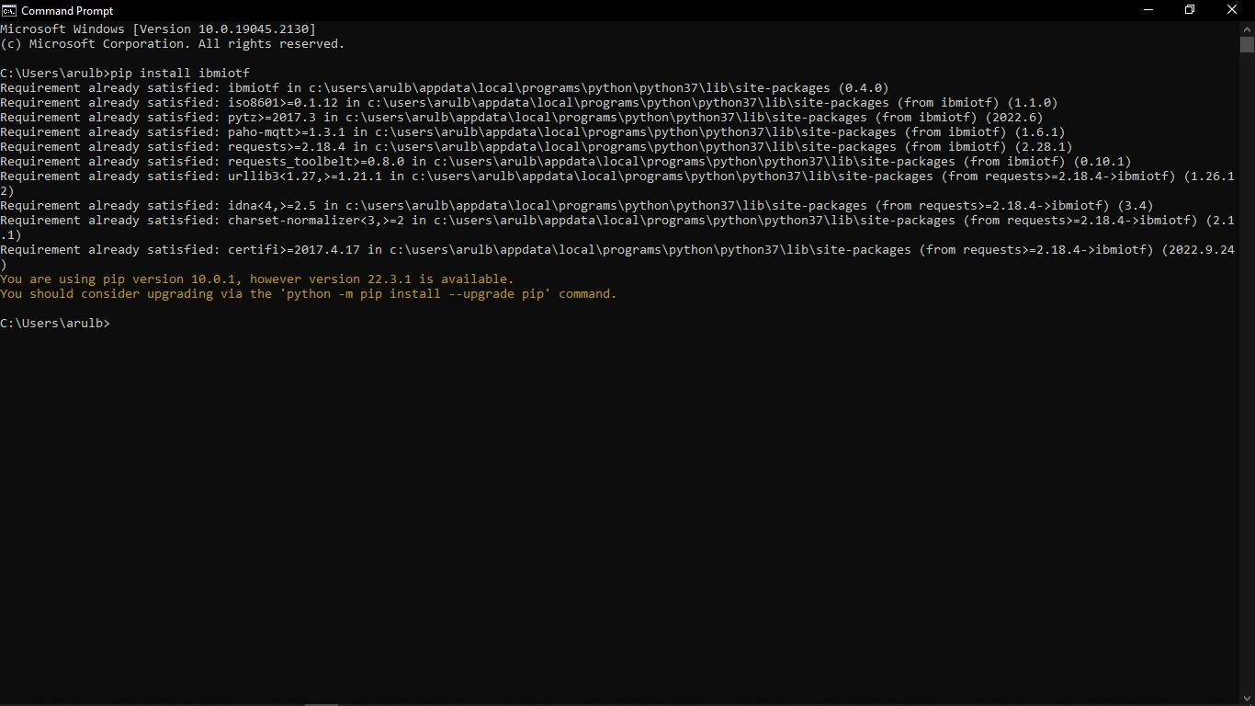

**INSTALLED PYTHON IDLE:**

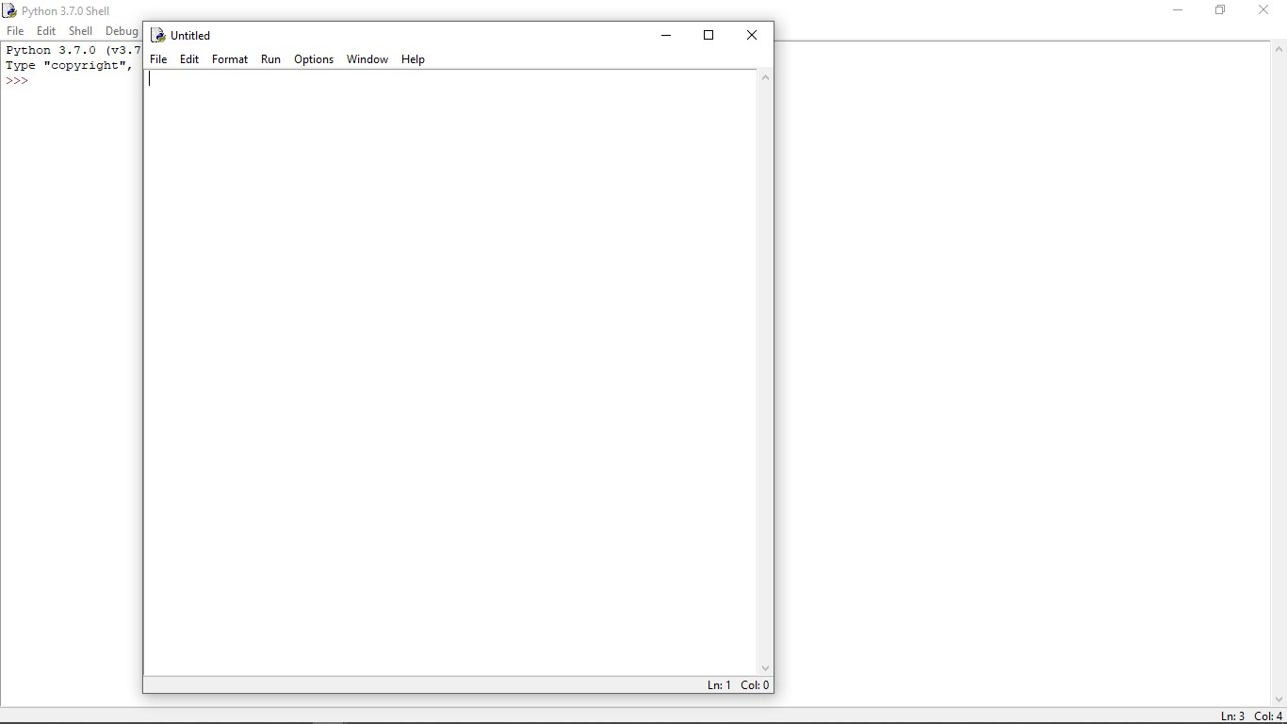

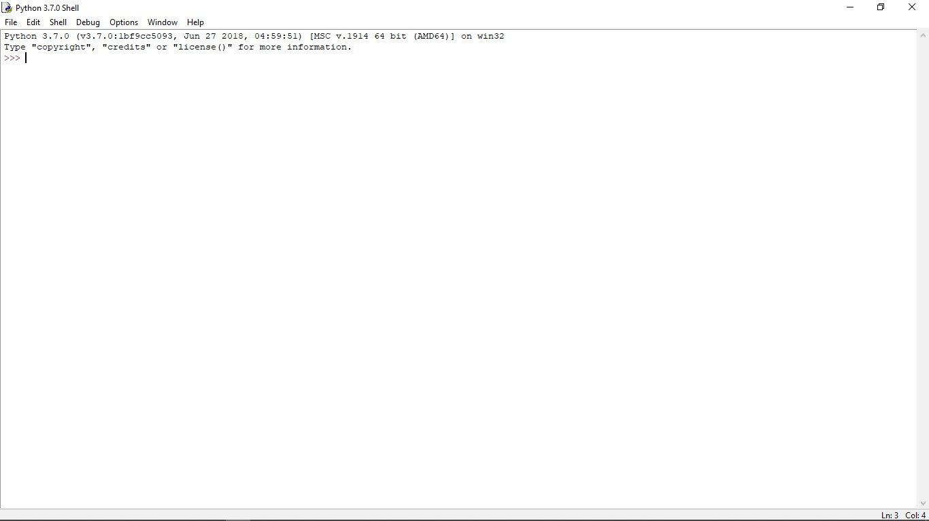

**RESULT:**

**THE PYTHON SOFTWARE IS INSTALLED..**