**PREREQUISITES**

**IBM CLOUD SERVICE**

|  |  |
| --- | --- |
| Team id | PNT2022TMID50683 |
| Project name | Real Time River Water Quality Monitoring And Control System |

* IBM Watson IoT Platform
* Node-RED Service
* Cloudant DB

IBM Watson IoT Platform:

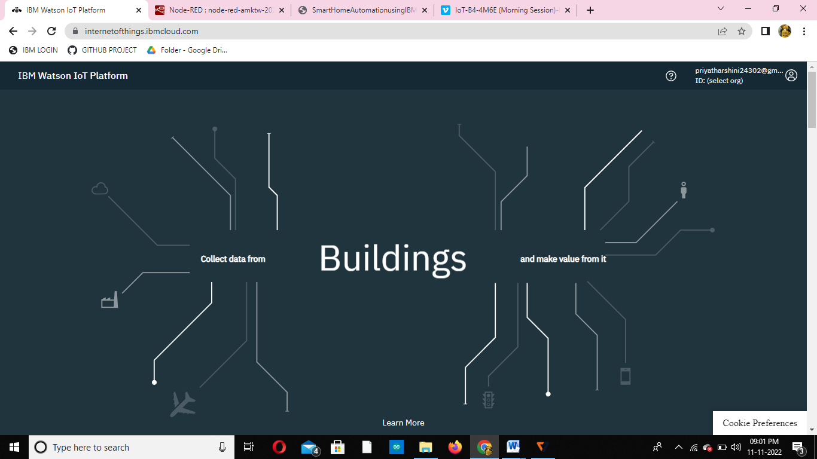

Node-RED Service & Cloudant DB:

