INSTALLATION OF PYTHON 3.9.8

|  |  |
| --- | --- |
| **Date** | 26 OCTOBER 2022 |
| **Team ID** | PNT2022TMID30400 |
| **Project Name** | IOT- BASED SMART CROP PROTECTION SYSTEM FOR AGRICULTURE |

Step 1: Type python in google and click on the first link

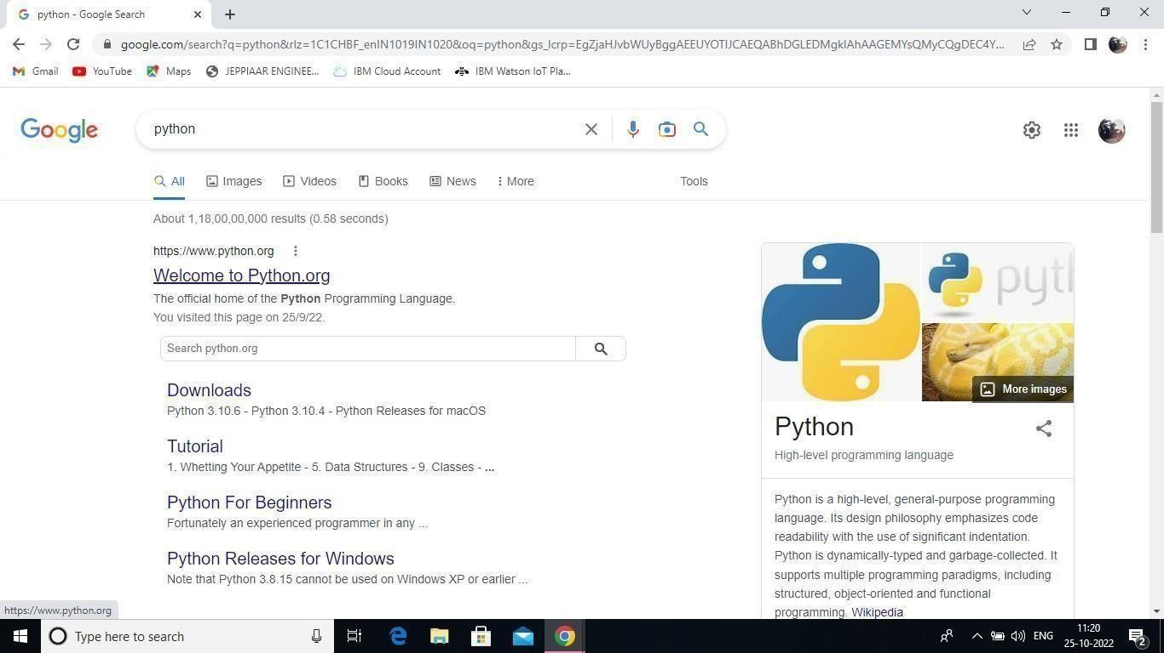

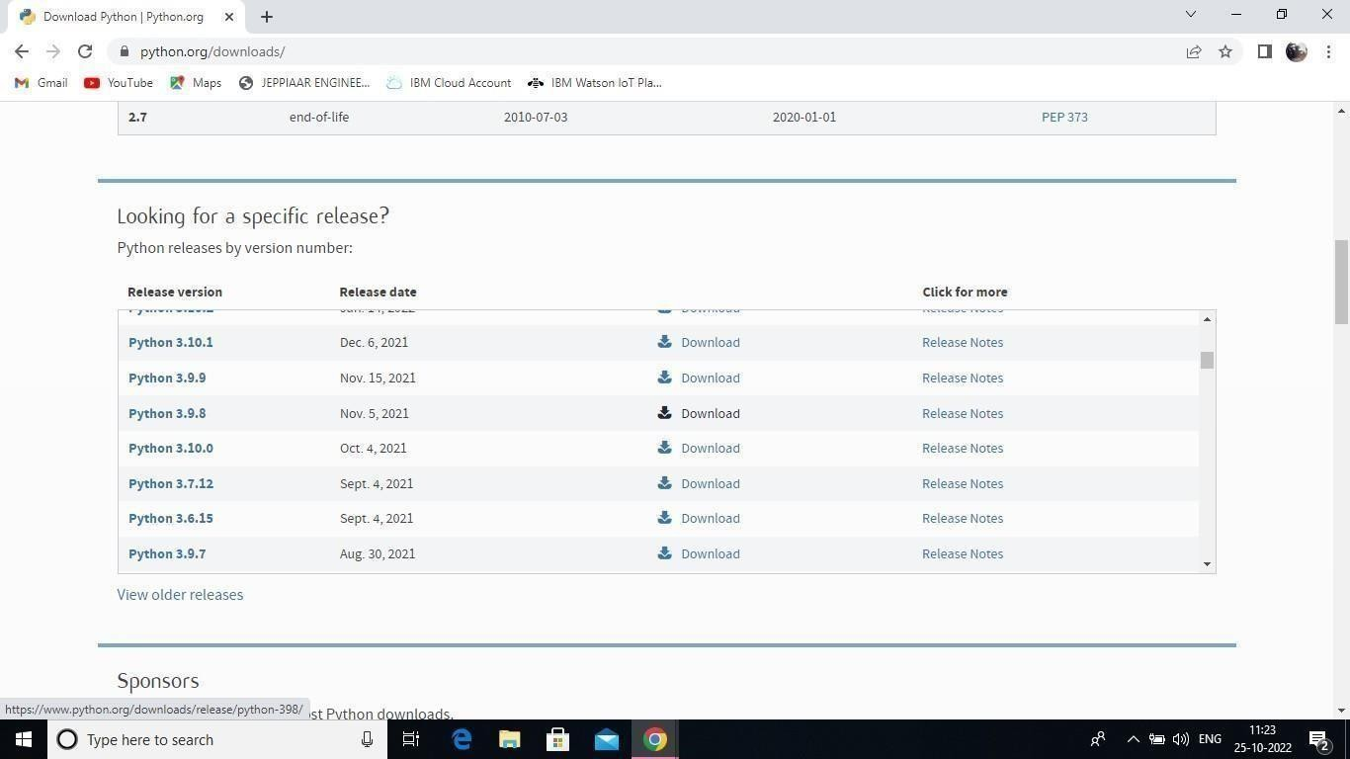2: Click the python 3.9.8

Step 3: Scroll down to reach Files and click on “Window installer (64 bit)

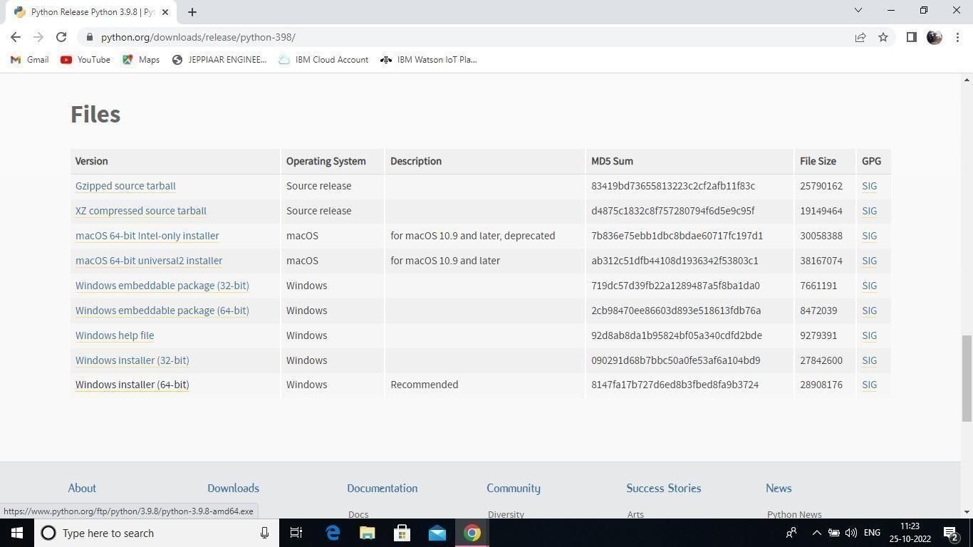

4: Click onthe Install button.

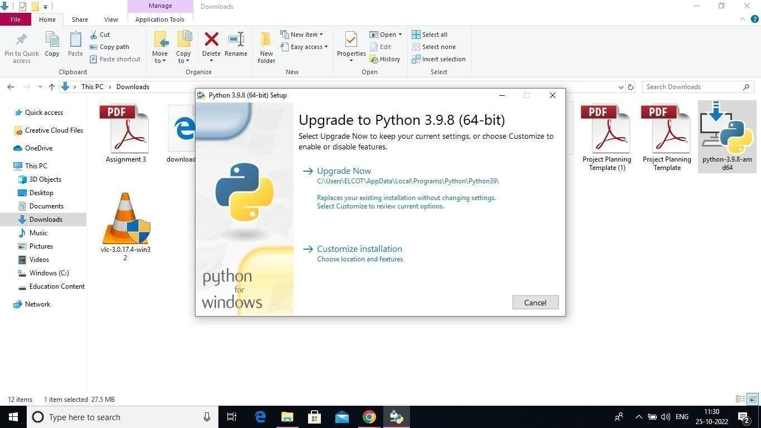

Step 5: Installation on progress

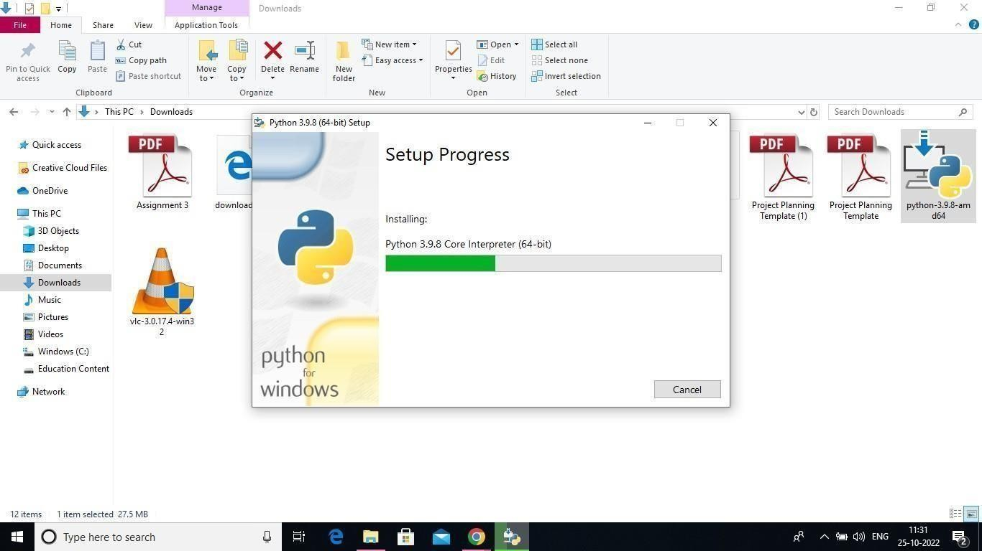

6:Close the button

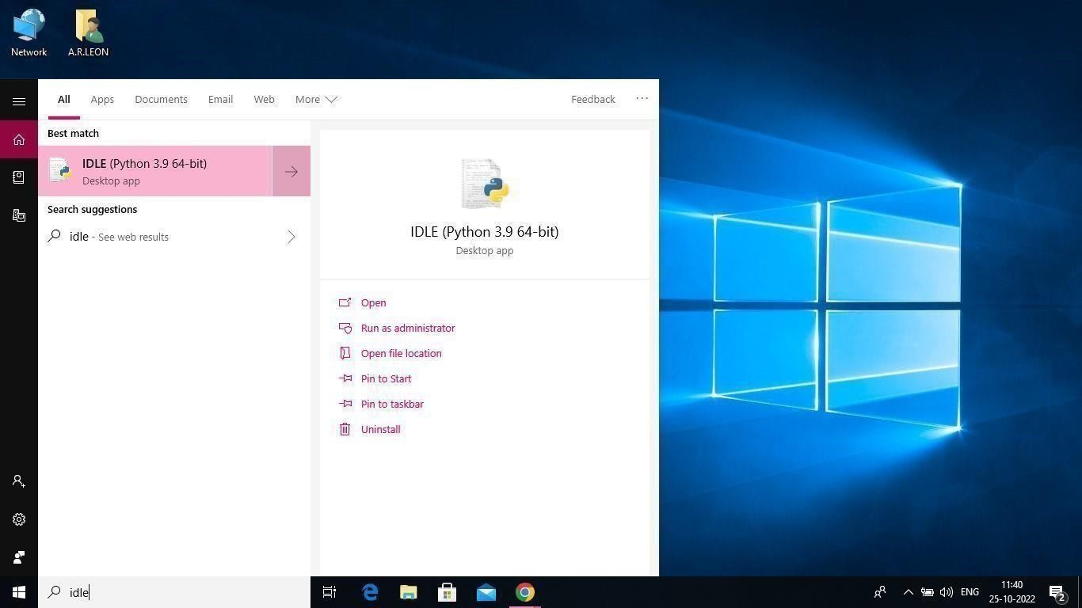

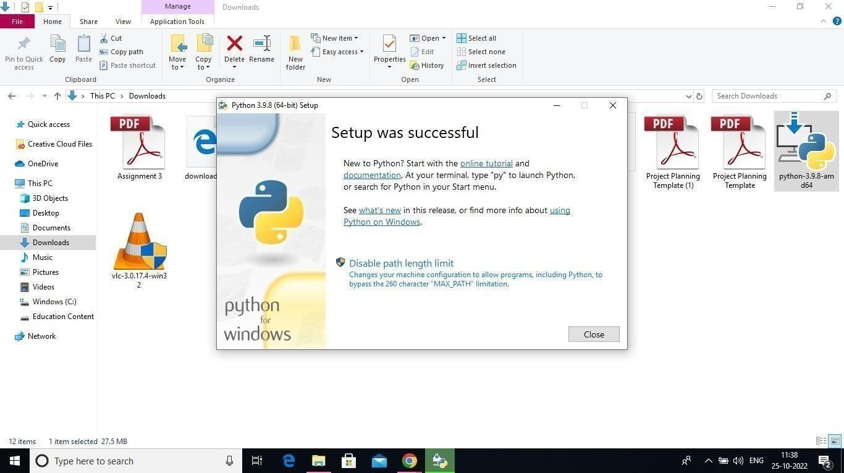

Step 7: Search IDLE8: Open it

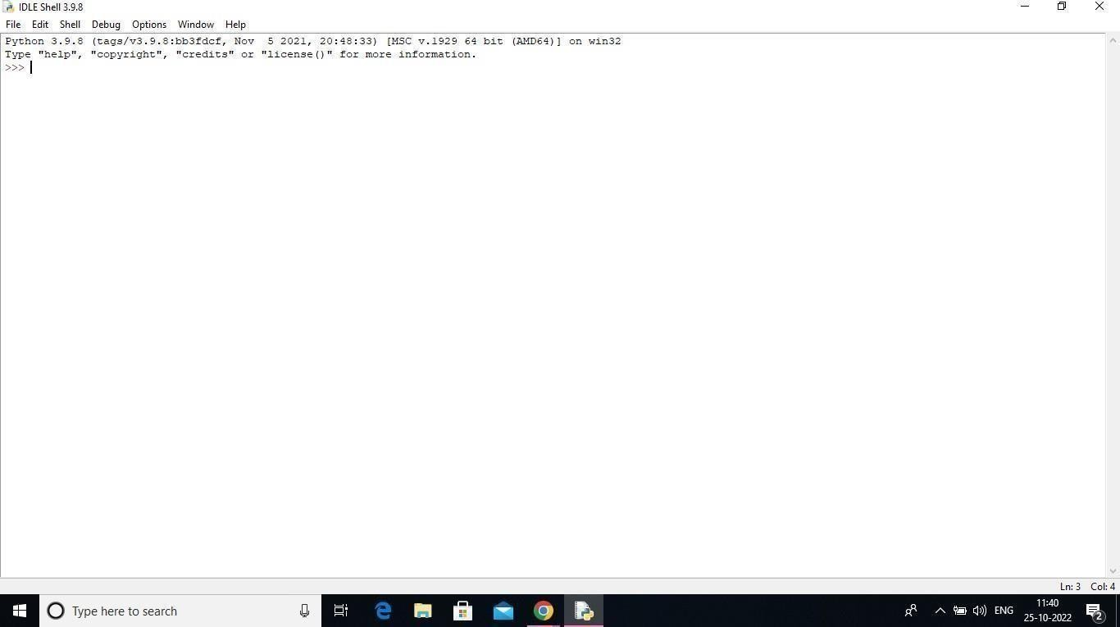

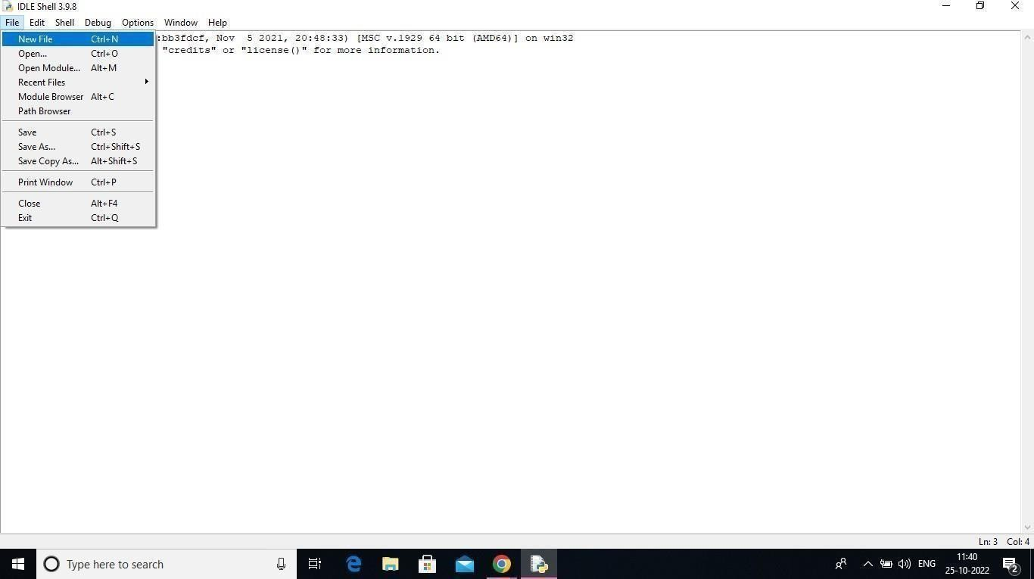Step 9: Go to file and click on New File

10: Open it

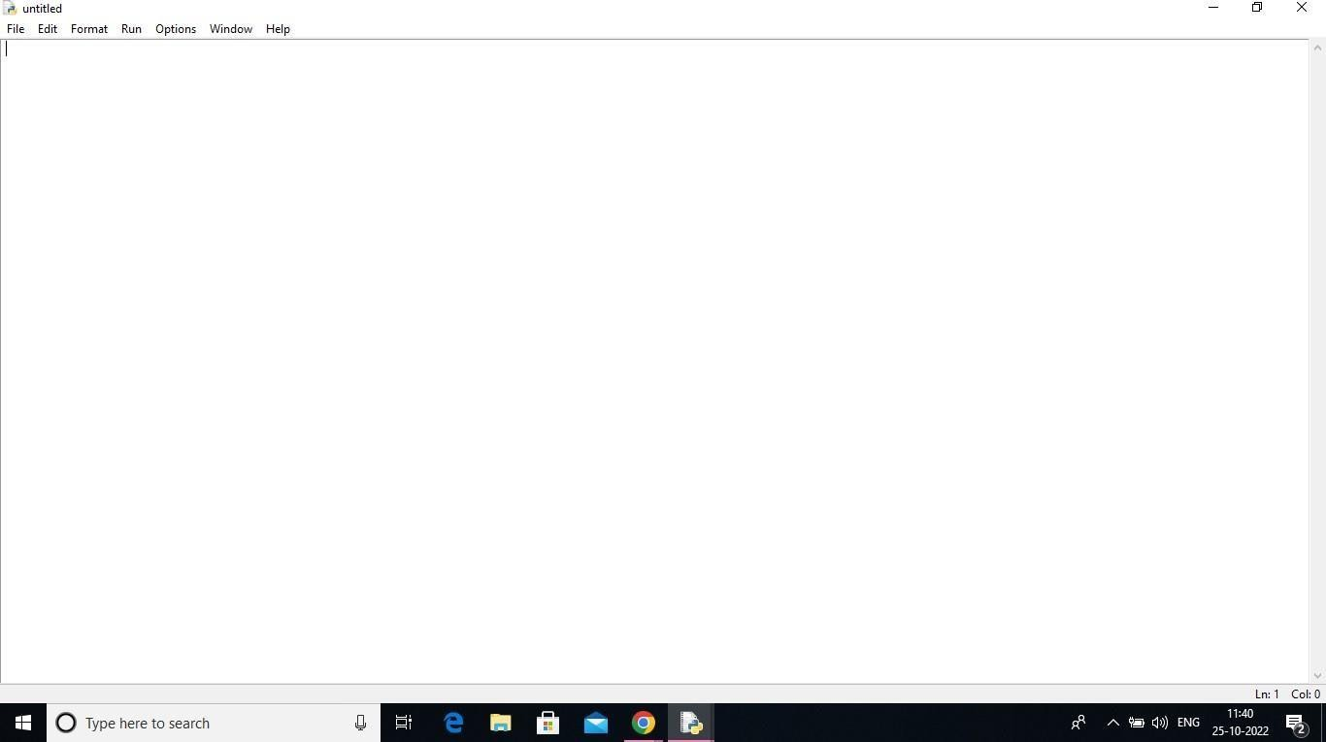

A Python 3.9.8 is installed successfully.