**IBM ASSIGNMENT- 1**

**TEAM ID :**

**NAME: ABITHA .K**

**ROLL NO: 963019106001**

**Make a smart home with sensors using Arduino UNO**

**LPG Gas leakage detector using arduino Components Required** ∙ **Arduino UNO**

∙ **MQ-6 gas sensor**

∙ **16×2 LCD module**

∙ **10K potentiometer**

∙ **Red and green LEDs**

∙ **220 ohms resistors**

∙ **Jumper wires and a breadboard**

∙ **USB cable for uploading the code**

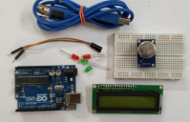

**CIRCUIT LAYOUT:**

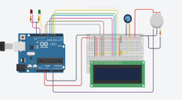

**CODE :**

**#include "LiquidCrystal.h"**

**LiquidCrystal lcd(9,8,7,6,5,4);**

**int GAS_VAL = 0;**

**void setup()**

**{**

**pinMode(A0, INPUT); // MQ-6 A0 Pin**

**Serial.begin(9600);**

**lcd.begin(16,2);**

**pinMode(11,OUTPUT); // LED Green**

**pinMode(12,OUTPUT); // LED Red**

**lcd.setCursor(0,0);**

**lcd.print(" GAS SENSOR ");**

**}**

**void loop()**

**{**

**GAS_VAL = analogRead(A0);**

**Serial.println(GAS_VAL);**

**if (GAS_VAL > 500)**

**{**

**lcd.setCursor(0,1);**

**lcd.print(" LPG Detected ");**

**digitalWrite(11,HIGH);**

**digitalWrite(12,LOW);**

**}**

**Else**

**{**

**lcd.setCursor(0,1);**

**lcd.print("LPG Not Detected ");**

**digitalWrite(11,LOW);**

**digitalWrite(12,HIGH);**

**}**

**delay(10);**

**}**

**Output:**

