**APPLIED DATA SCIENCE**

**CAR RESALE VALUE PREDICTION**

**LITERATURE SURVEY**

# PRICE PREDICTION OF USED CARS USING MACHINE LEARNING:

# PUBLISHED IN: [2021 IEEE International Conference on Emergency Science and Information Technology (ICESIT)](https://ieeexplore.ieee.org/xpl/conhome/9696356/proceeding)

# This study seeks to develop a model to forecast used car acceptable pricing based on a number of variables, such as engine size, fuel type, gearbox, road tax, and vehicle mileage. In the used car market, models can help vendors, purchasers, and automakers. Based on the data that users submit, it can eventually output a price prediction that is reasonably accurate. Machine learning and data science are utilized during the model development process. Used automobile listings were scraped for the data collection. To attain the highest accuracy, a variety of regression techniques were used in the study, including linear regression, polynomial regression, support vector regression, decision tree regression, and random forest regression. This project visualized the data to better comprehend the dataset before beginning to develop the model.

# VEHICLE RESALE PRICE PREDICTION USING MACHINE LEARNING

# PUBLISHED IN: 2021 Juni Khyat ISSN: 2278-4632 (UGC Care Group I Listed Journal)

# 

# The primary goal in this research is to analyze the Vehicle Resale Predict and then predict the outcomes using training data. The trade-in automobile market is a steadily expanding industry, and during the past few years, its accurately assessed value has practically quadrupled. With the growth of online marketplaces like CarDheko, Quikr, Carwale, and Cars24, among many others, it is now more important than ever for both the buyer and the seller to understand the trends and case studies that determine the value of the prospective used car. A vehicle's retail value can be predicted using AI computations based on a certain configuration of features. Various websites use different calculations to determine the retail price of There is therefore no comprehensive computation for determining the cost for the trade-in automobiles. One may surely acquire a good sense of the cost without really entering the fine details into the ideal site by creating quantifiable models to predict prices. The main goal of this research is to compare the degrees of precision of three different expectation models to predict the retail price of a used car. The informative index primarily consists of qualitative attributes, two quantitative traits, and test data from academics, including not just results from external tests but also each student's total academic success. When the academic performance test is completed in a large number of universities, there is no system in place that anticipates the understudy's performance in advance. If the understudy fails the exam. Here, we examine an understudy's academic performance in the classroom using SVM analysis and then linear regression analysis, taking into account both internal and external influences. The previous outcomes of the preceding data set were used to make these forecasts.

# USED CAR PRICE PREDICTION USING K-NEAREST NEIGHBOR BASED MODEL

PUBLISHED IN: 2020 International Journal of Innovative Research in Applied Sciences and Engineering (IJIRASE).

One of the important and fascinating areas of investigation is the estimation of used car prices. The market for used cars has seen a surge in demand, which has boosted sales for both consumers and sellers. The price of automobiles depends on a number of significant elements, therefore dependable and accurate predictions demand comprehensive understanding of the subject. In order to examine the cost of used automobiles, this research proposed a supervised machine learning model utilizing the KNN regression algorithm. We used data on secondhand automobiles that we downloaded from the Kaggle website to train our model. Through this experiment, several trained and test ratios were used to analyze the data. As a consequence, the proposed model is fitted as the optimum model and has an accuracy of about 85%.

1. **PREDICTION OF USED CAR PRICE BASED ON SUPERVISED LEARNING ALGORITHM**

PUBLISHED IN: [2021 International Conference on Networking, Communications and Information Technology (NetCIT)](https://ieeexplore.ieee.org/xpl/conhome/9731096/proceeding).

In order to produce more objective results, they apply machine learning techniques in this work to anticipate the price of secondhand cars with minimal human participation. The dataset is preprocessed using Python's Pycaret module, and the performance of each algorithm is compared using the algorithm comparison function. Extra Trees Regressor and Random Forest Regressor both perform rather well in this study. Using the hyper parameter function, the algorithm was then optimized. To arrive at the final algorithm model, the algorithm was acquired and validated with fresh data. The workflow of the used vehicle market will become faster and more competitive as a result of this algorithm, which will automatically produce used car prices when new used car data enters the used car system. The annual growth rate for new cars in China will be 3.5% in the upcoming five years, while the annual growth rate for used cars will be 5%. The annual growth rate of autos and used cars is rising. Customers believe that when purchasing a new car, they will also take into account the cost of a comparable used vehicle. Particularly, they believe that some value-preserving brand vehicles are more deserving of their attention because they have a changed value and offer customers the best return on their investment. When faced with this circumstance, businesses operating the used automobile market turn to traditional marketing techniques (such as often consulting pricing) to conduct business, which significantly raises the company's running costs.

1. **PRICE EVALUATION MODEL IN SECOND-HAND CAR SYSTEM BASED ON NEURAL NETWORK**

PUBLISHED IN: [2017 18th IEEE/ACIS International Conference on Software Engineering, Artificial Intelligence, Networking and Parallel/Distributed Computing (SNPD)](https://ieeexplore.ieee.org/xpl/conhome/8013514/proceeding).

Second-hand vehicles are now the most popular option for consumers looking to purchase cars due to the rapid increase in the number of private vehicles and the rise of the used vehicle market. The internet marketplace for used cars offers both buyers and sellers the opportunity for online P2P exchange. In such systems, whether the seller and the buyer may have a more effective trading experience is largely determined by the accuracy of the second-hand automobile price evaluation. The price evaluation model based on big data analysis is put forth in this research. It makes use of widely disseminated vehicle data as well as a sizable amount of vehicle transaction data to evaluate the pricing data for each type of car using the BP neural network method that has been tuned. In order to determine the price that best fits the car, it attempts to build a model for evaluating used car prices. In this study, the optimal number of hidden neurons in the BP neural network is chosen using the optimized BP neural network algorithm, which increases the prediction model's precision and the network topology's speed of convergence. The fitting curve of the forecast price is compared with the actual transaction price produced from the improved model through the sample simulation experiments. As a result, the accuracy and fitting of the optimized model are both improved.

**PROJECT DESCRIPTION**

It is expected that sales of old cars and second-hand imported (reconditioned) autos will rise in tough economic times. Leasing a car rather than purchasing one entirely is typical in many affluent nations. After the lease term is up, the buyer will have the option of purchasing the vehicle for its residual value, or anticipated resale value. Therefore, being able to accurately anticipate the salvage value (residual value) of cars is in the best interest of sellers and financiers from a business standpoint. We suggested an intelligent, adaptable, and efficient method that is based on applying regression algorithms to forecast the resale value of the vehicle. A regression model needs to be constructed that would provide the vehicle's closest resale value, taking into account the key variables that would impact this value. The method with the highest accuracy will be chosen from among the several regression algorithms we employ, and it will then be implemented into the web-based application that notifies the user of the status of his product.

**ARCHITECTURE:**

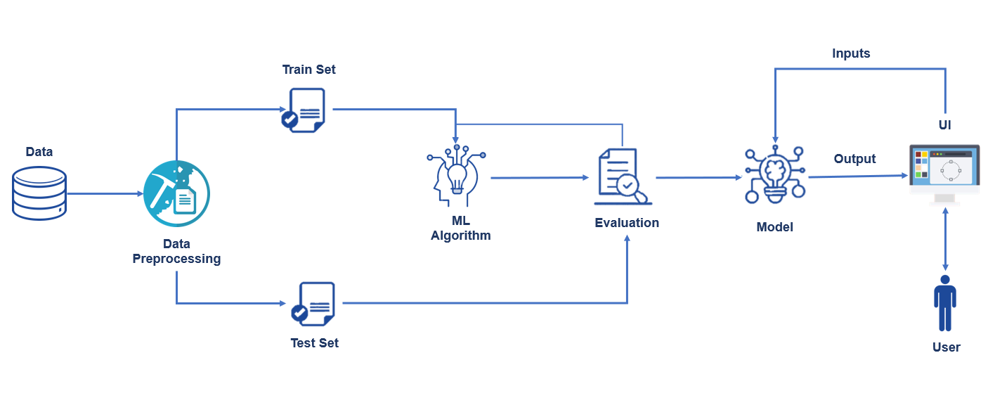

**SOLUTION:**

Nowadays, the demand for pre-owned or "used" cars all around the world. The customer should be able to determine whether the price afford to the car is accurate before purchasing a vehicle. Before purchasing a used car, a number of factors, including mileage, year, model, make, run, and many more, must be taken into account. A fair bargain should be made for both the buyer and the seller. In this study, a system that has been used to estimate a reasonable price for any used car is presented. The method effectively predicts the cost of used cars. The **Random Forest Algorithm** and **eXtreme Gradient Boost** are two ensemble machine learning approaches that are used to build models and predict the cost of used cars.